Uploaded Files:
- Statehood.dc.gov
- Mota.dc.gov
- DC Flag Image
  - 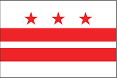
- Red, White & Blue Color Codes
  - Red: rgb(233,27,55)
  - Blue: rgb(45,70,137)
  - White: rgb(255,255,255)
- Current DC Statehood logos
  - 

