BRIEF DESCRIPTION
We need a new logo design for our existing company based in Swindon, UK. Our legal and current brand, company name is Select Support IT Ltd often abbreviated to just ‘SELECT’ we would like a new logo designed for the new brand we are calling “We Are Select”. We would like a logo design similar concept to the WE ARE CHANGE.ORG example (Screen shots below) this brief is purely for the logo design but does refer to 2 further briefs for a video animation and a website menu, these are not part of this initial requirement but may influence the initial design and logo concept so included purely for information at this stage, we will tender these brief’s as separate projects once we have the logo design completed. Some of this detail may be overkill, its just there to show the vision and direction we would like to take, if things just fit and it all works then great, however we are open to fresh ideas and where the logo design isn’t so heavily used in brief 3 – website menu if it doesn’t feel right.
WHAT WE DO
All our services sit in two core areas of the business, in many cases these are often two distinct business, (IT Managed Service Provider) & (Data Management / Data Bureau). They can operate isolated to each other but there are some synergies between them and we do have some clients who have both areas supported by us. We want our brand and design not to be too heavily focused specifically on any one of these areas and for the logo design and website to showcase all services cleanly.
IT MSP
Classic IT Managed Service Provider offering reactive and proactive IT support services from single desktops to servers and virtualisation along with all the related IT services and cloud offerings, backup and disaster recovery etc.
Data Bureau
Data processing and cleansing, we process small (1,000 records) and large (many millions of records) volume data files, this could be a client’s database, or a charity wanting to produce a clean mailing file, taking multiple files and ultimately deduping to a unique level, standardising, cleansing and reformatting data for export. Both B2C and B2B data removing deceased and gone away records, tracing new addresses for moved customers and enhancing with additional data, standardising address to UK Royal Mail standards.
More info on these and the cross over areas can be provided if further info is needed. At this stage I just wanted to show the company build up range of services so that it’s not purely IT support focused. – hence the reason we are rebranding to We Are Select and dropping the Support IT aspect!

PROJECT REQUIREMENTS & DELIVERABLES
Happy to explore all concepts here but if we were to give any steer on this I would say a fresh and fun feel to it. The logo should be of circular nature. Logo design concept, some flexibility to explore this and other ideas but like the concept of a circular logo with WE ARE SELECT.UK in the centre and a top and bottom image, this image doesn’t need to directly reflect our services or sector, neither does it need to be roots. Below is more detail aligned to tree/root concept, not that I’m dismissing a tree/root design but would like some creative ideas submitted here. Ultimately as part of the other briefs for a video animation and website menu we would like
Exact Text to be used for the Logo Design: WEARESELECT.UK
Upper case seems to work well and we have attached the last iteration of our current logo as am example, freedom to change this but like the idea of keeping it in capitals with some visual prominence to SELECT. Not overly concerned about with or without the .UK, may end up with two verisons?
REQUIREMENTS
- We would like 2 Tone Colours.
- Freedom to explore colours but would like two versions, one in colours provided below and one of your colour choice.
- Our current colours are: #EEA124 & #131F45
TREE / ROOT SCENARIO - EXAMPLE
- Top section – (Branches, sub branches and leaves) represent the products and services we offer to our clients, core categories being (IT Services | Data management | Security & Compliance) with many sub services branching out from these core trunks.
- Middle section – WEARESELECT.UK across the middle with SELECT prominent, want it to be readable at a reasonable size.
- Lower section - (Roots and fibres) represents the foundation and anchor for all the knowledge, experience, systems and solutions WE ARE SELECT use to support our clients.
DELIVERABLE:
- The Logo deliverable in a high-resolution vector.
- Provide all font files used

TARGET AUDIENCE
- In our case, we are dealing with a variety of B2B clients varying in sizes from 1-2 man band setups, SOHO and larger SMB clients
- We deal with:
- CEO’s
- Shareholders
- Directors
- Managers
- Staff/Team Members
STYLE & INSPIRATION

Example 1
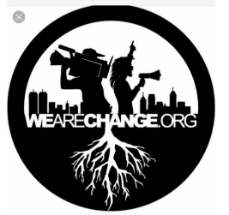
Example 2
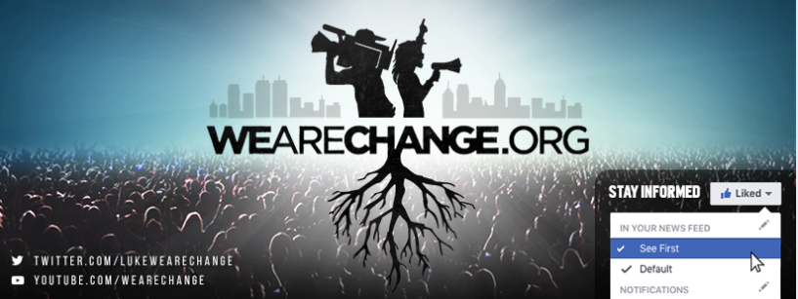

Example 3
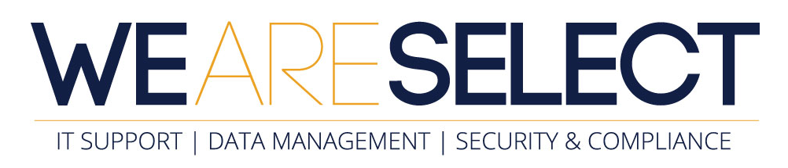

WHERE WE SEEING THE LOGO BEING USED
- Office Walls – For this idea, there could be scope to pull the branding out of the circle and evolve this and create a full wall piece, with some form of imagery in the background (See example2)
- Potential Vehicle
- Promo goods
- Clothing
- Stationery
- BRIEF 2 - Website logo reveal, video. (There will be a separate brief and project to this logo design brief for an animated logo reveal project – we want to take the logo design and animate this in a cartoon / animated video showing customers a story of what we do at We Are Select, using animation to show this story ending up with the logo reveal.
- BRIEF 3 – Website Menu, (v1 website will make use of the static logo design) whilst we develop the third brief – so that the video reveal shows the logo but the logo is the site menu. Key to this will be that we can possibly add items to the website menu version if we need to, or we have the core areas of the company covered from the start! “The original logo design and use won’t change outside the use of the website menu”

