We would like a Bi-Fold / 5”x6.5” (Give or take, this size is a bit flexible dependent on what works best from a design standpoint – making sure everything is large enough to read easily)
(Not in this design, just size)
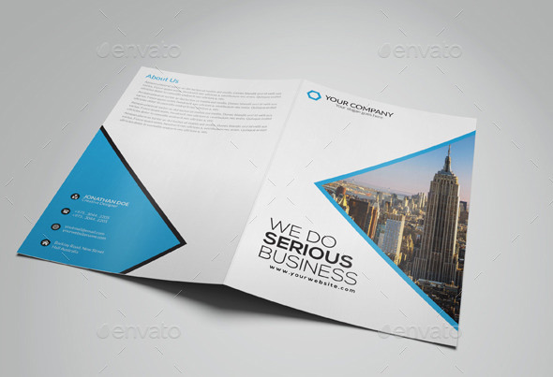

Needs to tie in more with our website we are launching in the next couple of weeks.
http://4coloradokids.sites.webriqs.com/

COVER:
We will need to use the photo of these kids, since that is the main image on our website.
I’ll send this as an attachment as well. I like how the image is all-inclusive.


Statistic on Cover:
1 in 6 Colorado Kids Are Living in Poverty or Homeless Situations.
Together, we can make a difference.

I like how this below style looks for the Together, we can make a difference/ the softness makes it feel more organic – does not need to be this color though:
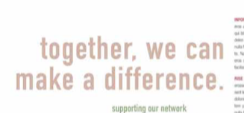

Our Mission Statement on the Cover:
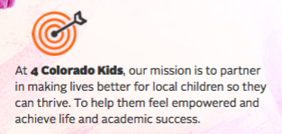

Left Side to be ABOUT 4COKIDS:
Color blocking to separate information – see example below.

Similar to this left side of the brochure, with a photo/description/icon/color blocking –
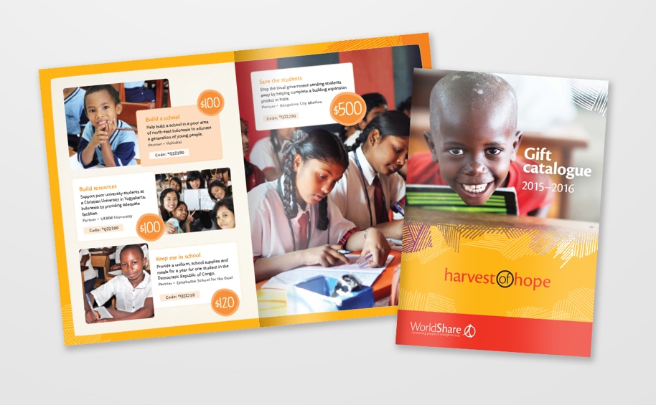

Help us, help Colorado Kids. (Maybe over the lifestyle image?)

In one of the blocks:
4 Colorado Kids was founded in Colorado for Colorado
Created by local business owners, teachers, therapists, parents and advocates who saw a need. Our local children need food, clothing, education, and above all – a chance to succeed and thrive!
Icon - 

2nd Image/Block:
Volunteer Opportunities – (over the lifestyle image if it’s not too busy…)
Volunteers are the core of 4 Colorado Kids. We have an array of volunteer opportunities to choose from for individuals, corporate groups, community organizations – all of which directly benefit children in need.
Icon (Can change colors, shouldn’t stay black) - 

3rd Image/Block:
Business Sponsorships
We have several outreach programs throughout the year. Each outreach event would be advertised on social media, on our website, in flyers distributed, at the events, etc. We will have the business name out in the public as a company that gives back to Colorado kids! We know we could not help these kids living in poverty without the support of company sponsorships.
Icon - 
Visit our website for detailed information.
www.4ColoradoKids.org

Right Side to be About the Programs:
Our Founder LOVES icons, and actual images of what the programs are about. This is something that was started, he doesn’t like the design/format, but he likes how the images represent each program.
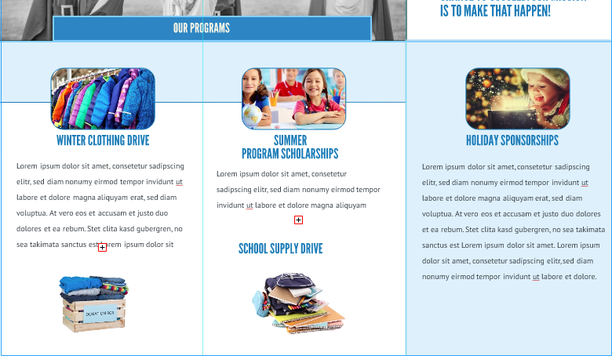

Need this somewhere on the page (does not to need to be in this format or colors, just the information):
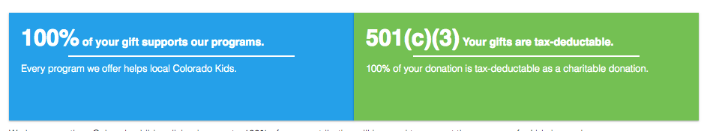

Our Programs:
This is the style we will be updating the website with for Our Programs, so please use a layout as close to this for the programs on the right side of the page as possible. I’ll send over lifestyle imagery that coincides with the website as well.
The wording can be tweaked if it sounds off, I’m not the best at copy writing…just get the overall idea, and love to work with others to make it sound and flow best.
I quickly created this for a visual, everything else is pretty much exactly how we want it – just a bit more polished.
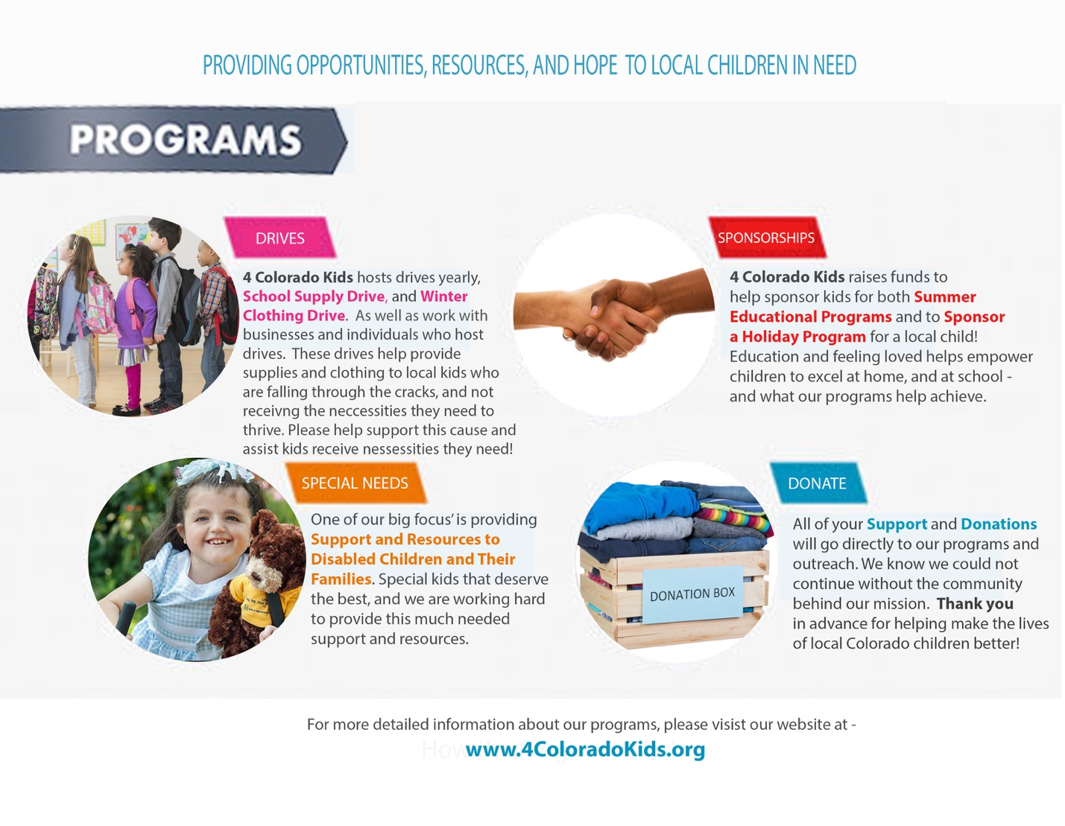

BACK:

I love this concept for the back page, what do you think – would need to stretch the yellow background to make it work in the below image?
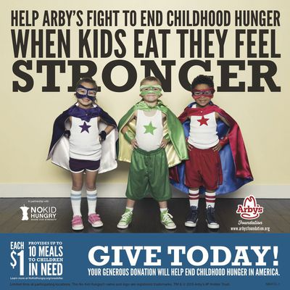

With this wording:
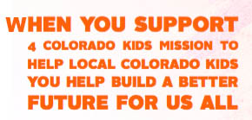
And this image:
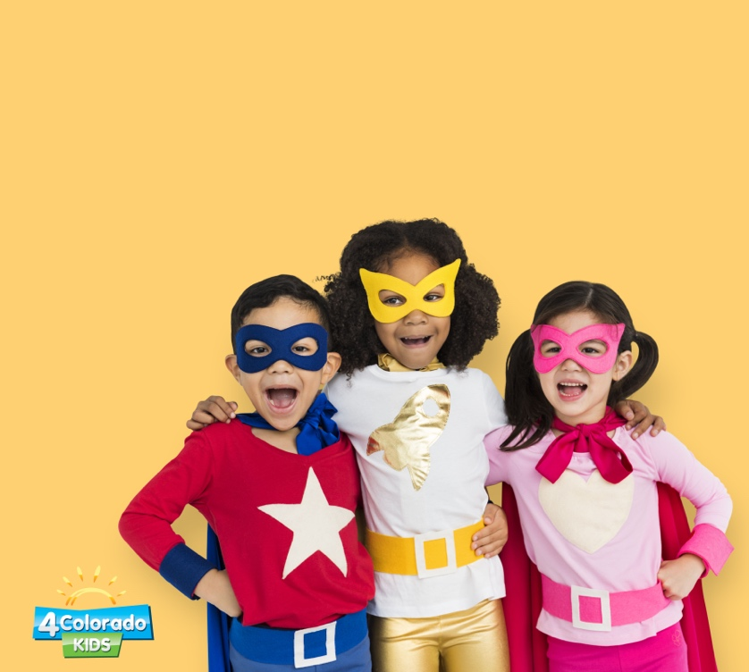

Below Contact Info would be in a solid color bar at the bottom of the page, with a sort of reversed speech bubble (like we have on our website) – founder loves the icons, so if you have ones that look better together for the phone, address, and website – please use:



(like this below vibe)
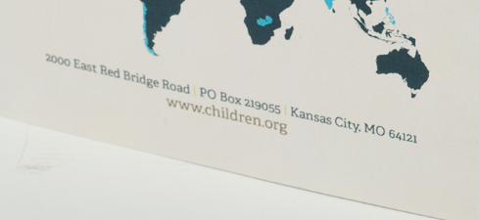
 719-598-8888  5446 North Academy Blvd, Colorado Springs, CO 80918
 www.4ColoradoKids.org

