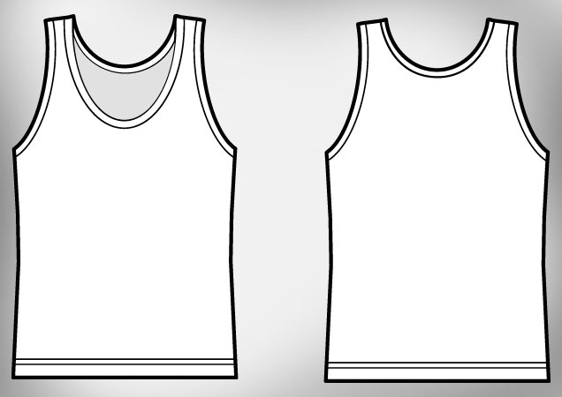
Guidelines-
• Must contain ACV logo
• Stay within stich line (not too close to the edges)
• 5 Color max
• Designs must be legible once printed
• Design may include both front and back designs or only one side if you choose

