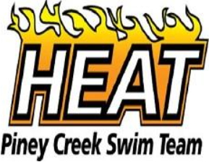 | Current Logo
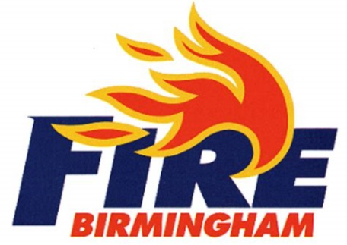 | Similar look and feel with a refreshed design. Heat in black instead of navy and Piney Creek Swim Team below in red.  Like: Font, fire integrated into the design  Dislike: Flames wrap around the R, but it may be difficult to do with a letter that’s not rounded (E or A)
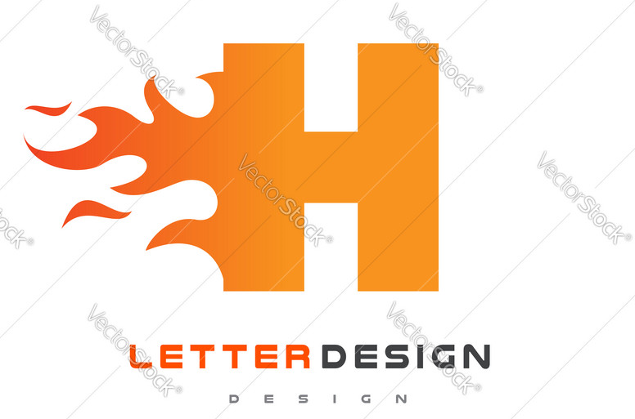 | This design with Piney Creek Heat written below. Keep color scheme.  Like: Simple design, would look good on suits, hats and other merchandise.  Dislikes: Doesn’t specifically say “Heat” in the design although it could be written below.
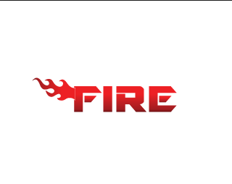 | Another option on the design above.  Like: Full name (HEAT) instead of just the first letter.  Dislike: Flame design and font. Like above design better. Possible combination of the two.

