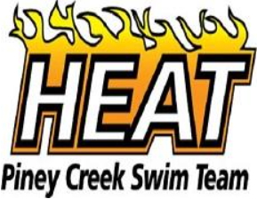 | Current Logo
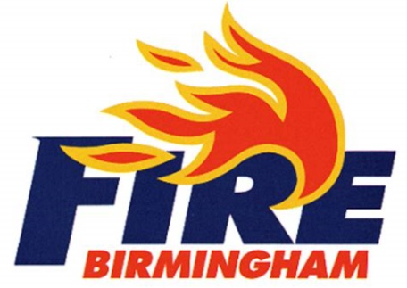 | Similar look and feel with a refreshed design. Heat in black instead of navy and Piney Creek Swim Team below in red.  Like: Font, fire integrated into the design  Dislike: Flames wrap around the R, but it may be difficult to do with a letter that’s not rounded (E or A)
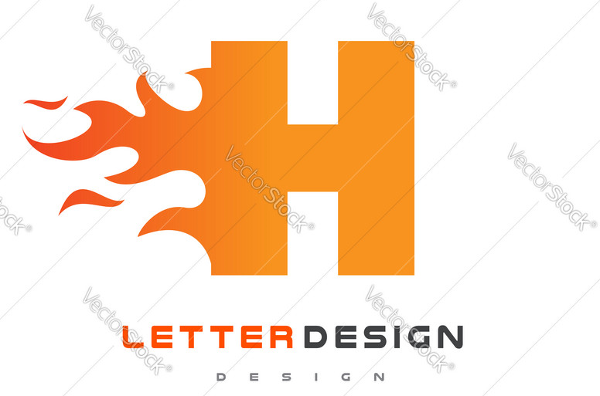 | This design with Piney Creek Heat written below. Keep color scheme.  Like: Simple design, would look good on suits, hats and other merchandise.  Dislikes: Doesn’t specifically say “Heat” in the design although it could be written below.
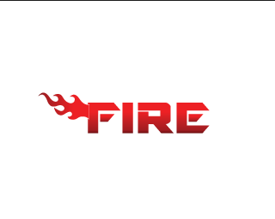 | Another option on the design above.  Like: Full name (HEAT) instead of just the first letter.  Dislike: Flame design and font. Like above design better. Possible combination of the two.

 | In Heat color scheme (red, orange, yellow and black) with Piney Creek Heat written above or below.  Like: Abstract swimmer and water  Dislike: May look like swimming into fire (i.e. roasting kids)
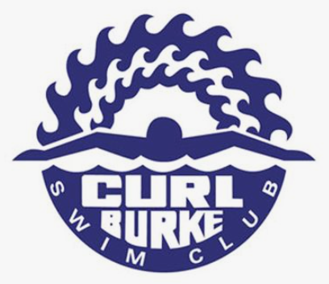 | In Heat color scheme (red, orange, yellow and black). Replace waves above with flames or a sun.  Like: Swimmer with flames above. Will fit well on suits, hats and other merchandise.  Dislike: Font
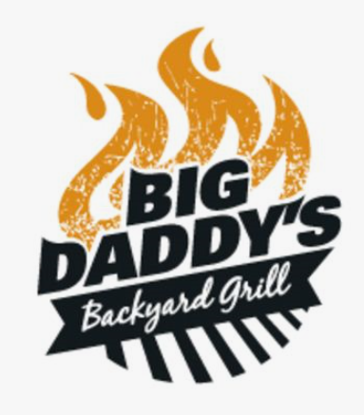 | An updated version of a design similar to our current design. Remove grill. Maybe Heat where “Big Daddy’s” is and Piney Creek below.  Like: Simple, easy  Dislike: Font
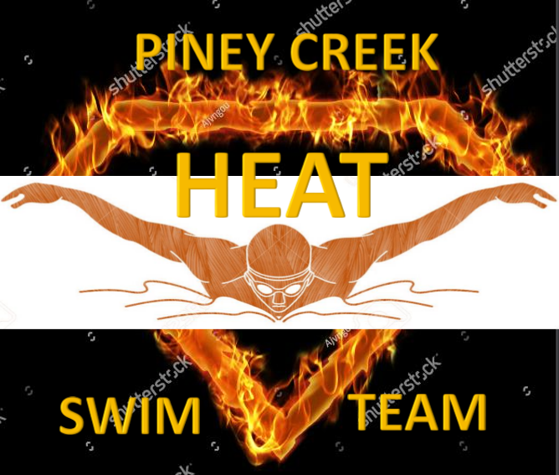 | Like: Superhero theme is great with kids. Incorporates swimmer.  Dislike: Might be hard to incorporate in suits, caps/hats and other merchandise.  Submitted by Mary S.  Note: Mary – Let us know what you like or dislike about this logo.

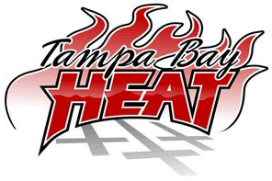 | An updated version of a design similar to our current design.  Like: Font, flames  Dislike: Religious (remove crosses)  Submitted by a Piney Creek Heat Parent
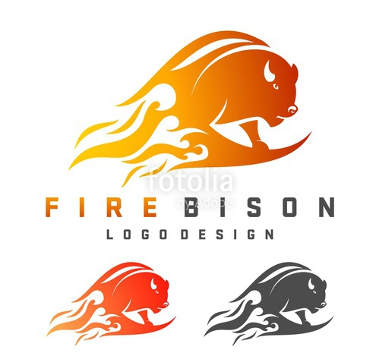 | Incorporate a swimmer into the design.  Like: Flames, color scheme  Dislike: Roasting kids again (?)  Note: Goofball husband is suggesting a flaming pine cone instead of a swimmer (insert eye roll here).

