POSTCARD FOR MAILING to Rivertowns (Tarrytown, Irvington, Dobbs Ferry & Hastings)

SIDE 1: CO-WORKING
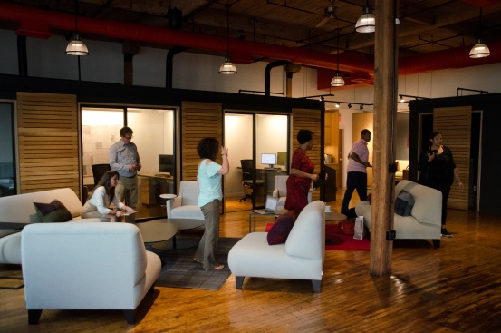
Your mindful, shared workspace on the waterfront
A state-of-the-art co-working space:
- beautiful, light-filled common work space
- private offices
- conference room
- a private meditation room
- a riverfront balcony with stunning views of the Hudson River

Imagine your private or co-working office space in one of the most beautiful settings in Westchester County, amongst a group of open minded, open hearted, creative, very successful individuals.
Now add an array of high-quality courses and events, and you’ve found a working environment second to none.
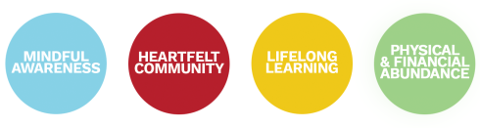
SIDE 2: EVENTS
THE ALIGNED INSTITUTE
A unique, tranquil space to explore heartfelt community, lifelong learning, mind-body awareness, and financial abundance with people who value personal growth, connection, and living an aligned life.
Join us for our upcoming diverse range of classes, talks and workshops:
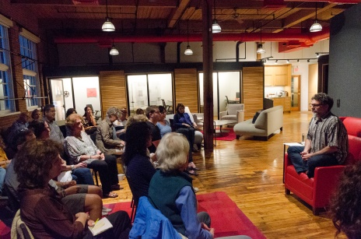
Wake Up Wall Street!
with Evan Wildstein and Matt Ludmer
Thursday, March 15th, 6 pm
Experiential Philosophy Series with Jeff Carreira
Mondays: March 19 & April 16, 7 pm

Literary Salon and Book Signing
Moderated by acclaimed author and 3-time Emmy winner, Allison Gilbert
Thursday, March 22nd, 7 pm

Psychotherapy & Kabbalah: a Two-Part Workshop
Wednesdays, March 28th & April 25, 6:30 pm

Four Dimensions of Wealth
with Owner Matt Ludmer
Thursday, April 12, 7 pm

