I will be adding content per section. First there will be a screen capture of the paragraph, and then directly below it will be my content.

I would appreciate it if we could align our Website Design with the designs from our Logo Designer.
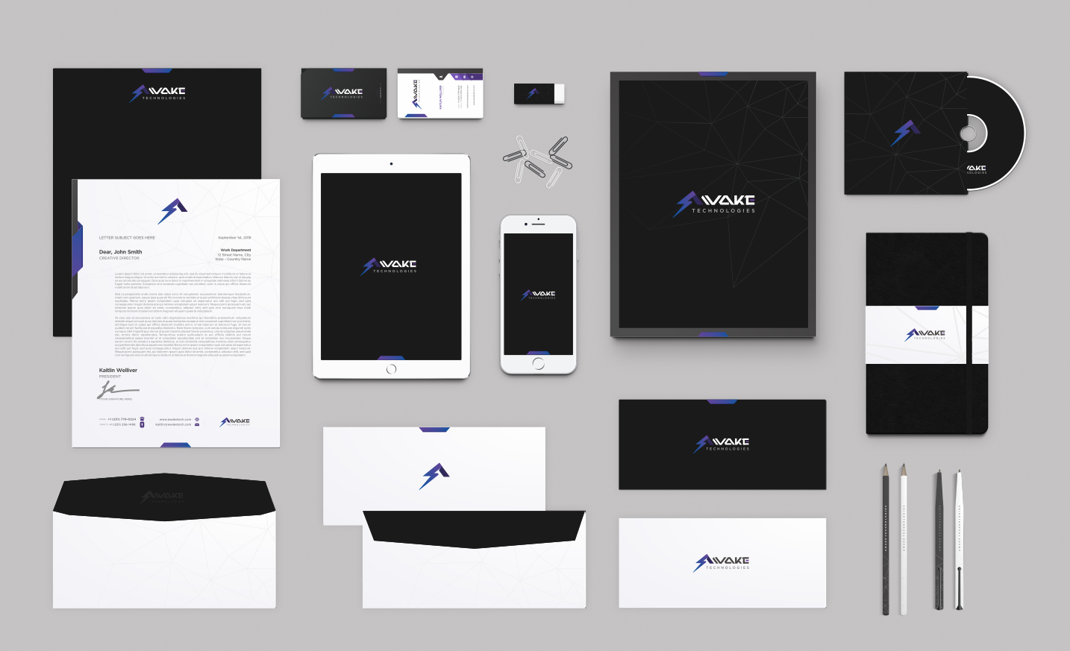

Home Page

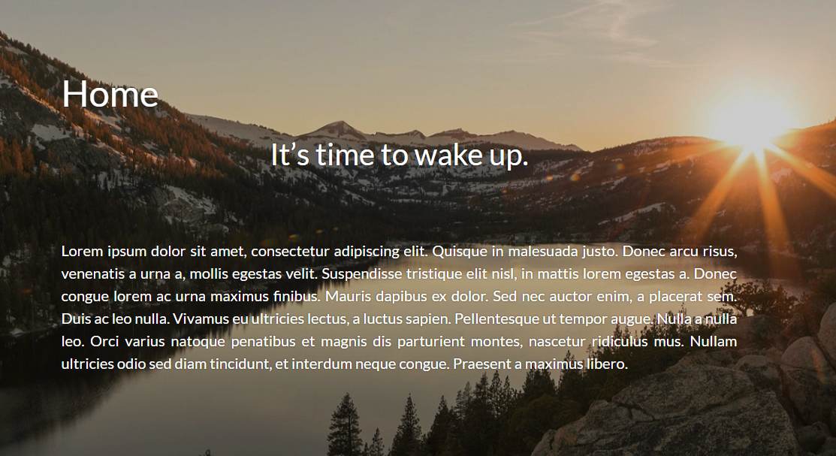

It’s time to wake up with Awake Technologies.

Disruption isn’t just coming – it’s already here and it’s time to wake up to the new world we live in. Here at Awake Technologies, we embrace the future that disruption brings and make it our aim to assist the world in embracing this bright future with us. We help bring businesses and people adapt to new approaches to old problems.

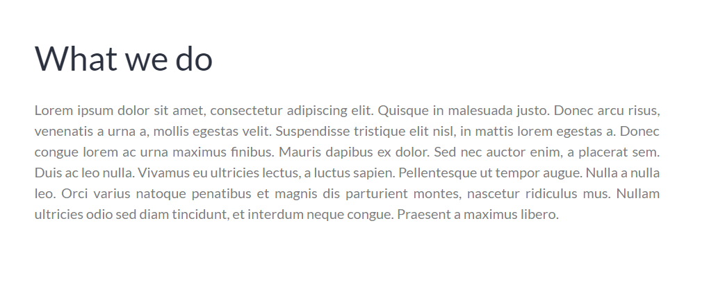

What we do

We are engineers, problem-solvers, people persons, and a friendly face. We want to solve your problem in a way that won’t break the bank, give headaches, leave you with a smile on your face, and keep you smiling throughout our relationship.
We predominantly work in the healthcare IT industry assisting hospitals and clinics with their IT infrastructure and information workflows. We provide software solutions and interoperability services to connect platforms and give care givers a simple view of patient records.
Awake Technologies is also exploring the world of 3D printing and how it can fully affect the healthcare industry and small businesses with Awake3D. 3D printing is a great solution to what used to be a very niche industry.

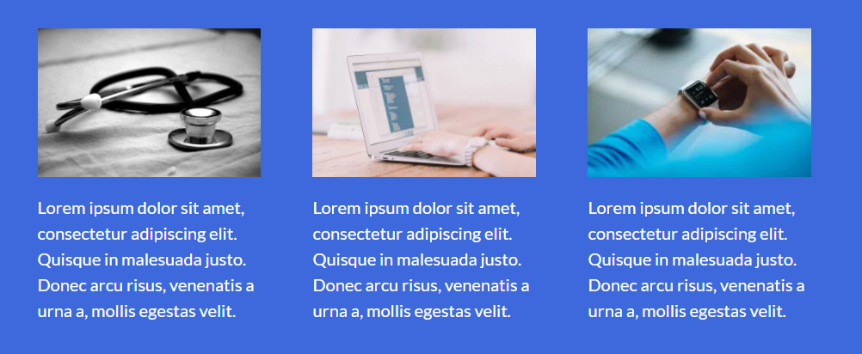

[IMAGE 1] – Old computer mainframe
<bold> Computer Archeology </bold>
Need data off a legacy system that you would like to sunset? We can help you with that.
[IMAGE 2] – Tablet in a waiting room
<bold> Digital Check In </bold>
Still using clipboards to check people into your facility? Struggling to get that paper-based information into your system? We can help you with that.
http://www.bestconsent.com
[IMAGE 3] – 3D Printer
<bold> Awake3D </bold>
Have something in mind that you need printed, but don’t have a 3D printer? We can help you design it, and print it for you.

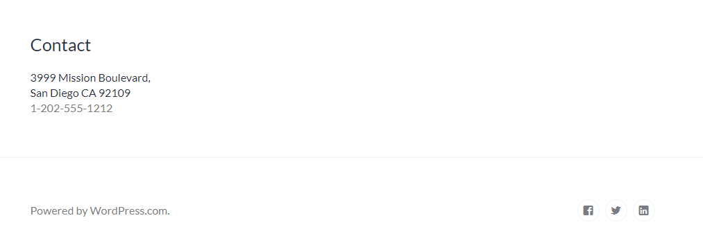

FOOTER

[Site map] [Social Media]

About
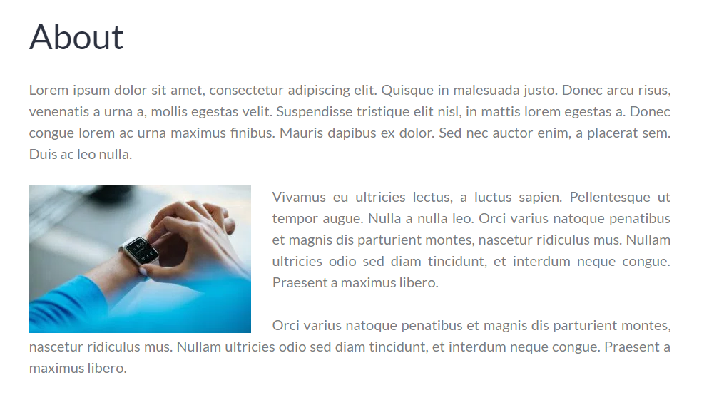
Awake Technologies was founded in January 2018 in hopes to be an active part of the technology disruption that is already here but not fully embraced. It’s our aim to give small businesses, major corporations and the general public more access to the awesome technologies that are here today from 3D printing, to virtual reality, to the internet of things.

Services
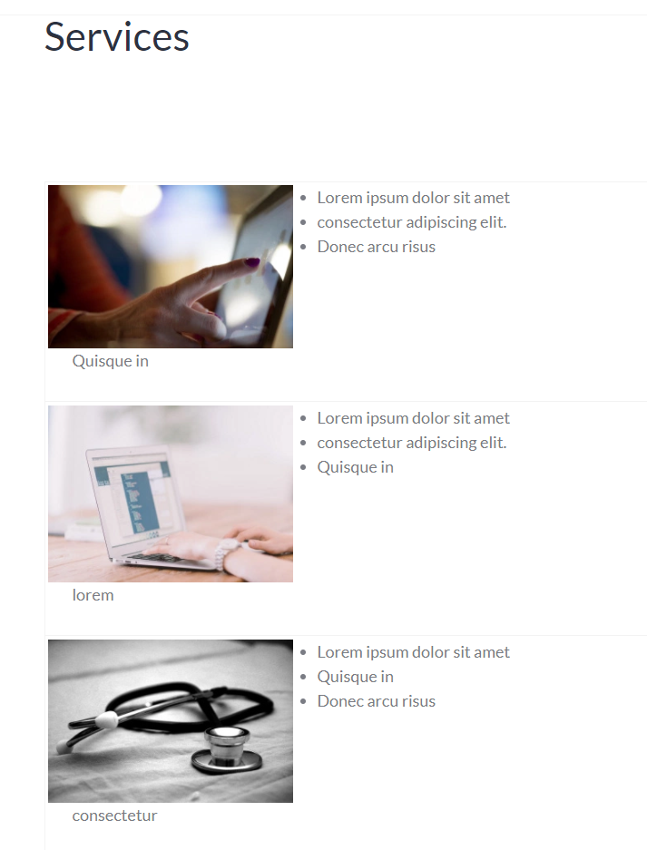
[IMAGE 1: TABLET]
Digital Check in and E-Forms Solution

BestConsent solves the problems of busy waiting rooms, registration paperwork and puts the focus back on the patient’s care through electronic check in workflows and electronic signature capture.
- Browser based, choose your own device
- Streamless workflow into your EMR and HIPAA compliant
- Easy e-form editor tool, so you control your forms

[IMAGE 2: COMPUTER w/ RECORDS]
Clinical Portal and Document Repository

The BestBond Clinical Portal is a healthcare specific graphical user interface (GUI) to the main electronic document management system. The clinical portal can be rendered to meet the needs of clinicians, medical records users, nurses, and administration. The clinical portal also has extensive healthcare functionality built in.
- HIPAA Compliant
- Document viewer allows for any type of document
- Single view of the patients health across multiple systems

[IMAGE 3: DATA FLOW / abstract]
Data Migration of Legacy Systems
We at Awake Technology pride ourselves on being information archeologists. That is, we can migrate data from legacy systems into a portal that meets today’s standards in information technology.
- Affordable
- Experts in the industry
- Quick turnaround

Contact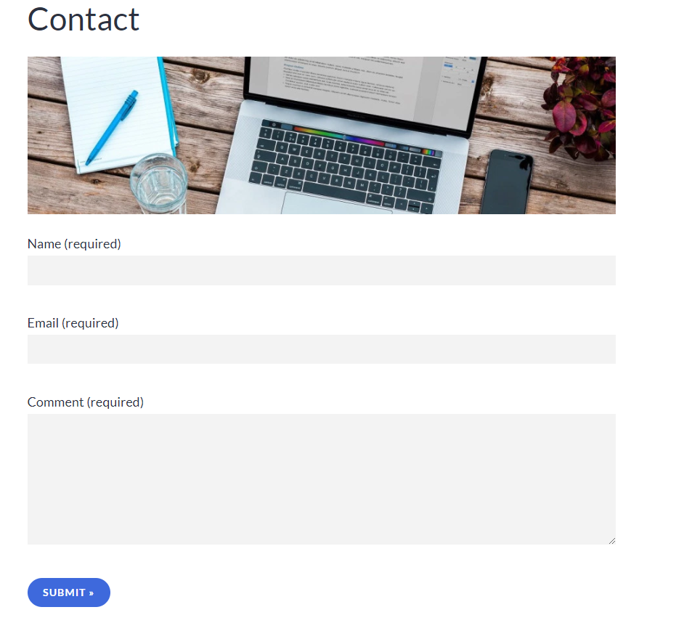
First Name*, Last name*, Email*, Phone number
What can we help you with? *
[Dropdown menu:
Product Demo
Employment
General Inquiry]
Comment / Question*

Employment
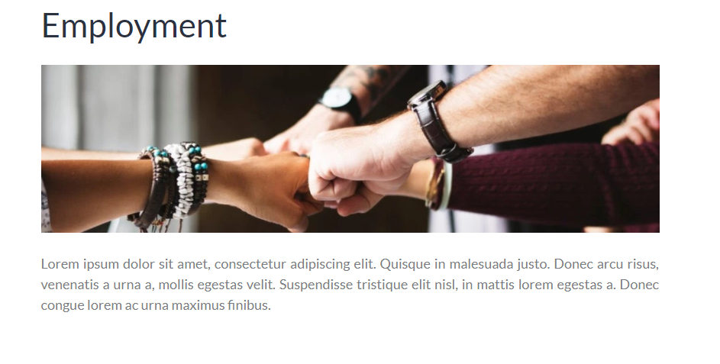

Join the Awake Technologies team!
First to market, visionary leadership, fast-growing organization. . . we are no strangers to dedication and innovation. Our mission is to help extend the longevity of mankind worldwide by making the technology of tomorrow affordable today. We’re big enough to make a huge impact in the world, and small enough to make every contribution a significant one.
Whether you’re the first voice our customers hear when they call or you’re working behind the scenes, your work will contribute to our customers’ experiences. We’re always looking for great people who want to make the world a better place by contributing their time and talents to a greater cause. If you are a collaborative, forward-thinking professional and an advocate for change, we want to talk with you.

Your Information
Name *
FIRST
LAST
Email *
Address *
LINE 1
LINE 2
CITY
STATE
ZIP CODE
COUNTRY
Phone Number *
Which Awake Technologies location are you applying for? *
[Drop down options to match: Cadillac, Michigan OR Work from home: ONLY 2 OPTIONS]
Job Position *

If you listed "Other" above, please describe.
Can you start working immediately? *
YesNo [RADIO BUTTON]
If you answered "No" to the question above, briefly describe why.
Can you travel? *
YesNoUnsure at this time [RADIO BUTTON]
If you answered "Yes" to the question above, please specify

Desired Yearly Salary *
Are you a military veteran? *
YesNo [RADIO BUTTON]

Experience
Previous / current experience. Please list the most recent first.
Company 1
Company *
Position *
Supervisor's Name *
FIRST
LAST
Supervisor's email
Address *
LINE 1
LINE 2
CITY
STATE
ZIP CODE
COUNTRY
Phone Number *
Date Hired *
Date you left. If you still work there, enter "Present". *
Can we call them? *
YesNo [RADIO BUTTON]
If you answered "No" to the question above, briefly describe why.

Company 2
Company *
Position *
Supervisor's Name *
FIRST
LAST
Superviser's email *
Address *
LINE 1
LINE 2
CITY
STATE
ZIP CODE
COUNTRY
Phone Number *
Date Hired *
Date you left. If you still work there, enter "Present". *
Can we call them? *
YesNo [RADIO BUTTON]
If you answered "No" to the question above, briefly describe why.

Resume / CV / Cover Letter
Upload Cover Letter [UPLOAD]
Max file size: 20MB
Upload Resume / CV * [UPLOAD]
Max file size: 20MB
College or University Grade-Point-Average (GPA)
School transcripts may be required.
Upload School Transcript (optional) [UPLOAD]
Max file size: 20MB

References
Reference #1
Name *
FIRST
LAST
Company *
Phone Number *
Email *
How do you know this person? *
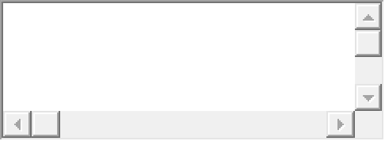

Reference #2
Name *
FIRST
LAST
Company *
Phone Number *
Email *
How do you know this person? *

Do you consent to a background check prior to employment? *
YesNo [RADIO BUTTON]
Why are you qualified to work for Awake Technologies?
How did you find out about Awake Technologies?

