Chaos reigns in an ever-changing world
Today’s business world is chaotic. Business models, individual expectations and technology are creating more opportunities and challenges than ever. Amid higher expectations, complexities of generational transition, the growing skills gap, increased employment costs, new ways to communicate and workforce expectations, companies must find a way to stand above the fray.

Overcoming these challenges
To position your company to compete in this new world, you need to:

Address the skills gap
- Mid to lower skilled labor resources are becoming more scarce, and
- Those that are available (Millennials) have a different work ethic

Enable knowledge transfer to a new workforce
- Baby-Boomers and Gen-Xers are rapidly departing the workforce, and
- Millennials learn and communicate best using technology

Overcome increasing employment complexity and cost
- Skills scarcity, wage expectations (and laws), healthcare and other employment costs are forcing process efficiencies that optimize reliance on human labor

Eliminate the chaos of this environment
- By communicating better,
- assuring traceability & accountability and
- Measuring to enable constant improvement

What if you could
- Capture every single activity, locate and prioritize every action, delegate to the right people at the right time, and assure that everything gets done right, and right on time
- Be on-site 24/7 without ever leaving your office, with the clarity and visibility provided by complete traceability

Get it Done with Curo

Curo’s geo-productivity platform locates the work, centralizes communications, and makes it easy to get work done right the first time. Curo improves the performance of your entire business.

- One app that eliminates ambiguity by linking what needs to be done with when, where and how (graphic showing map and checklist to highlight where and how)
- Assures adoption and performance with ease of use and job-specific guidance
- Connects everybody with live in-app communication
- Enables traceability and verification by capturing every step in every activity
- Measures performance with analytics to help you stay on track
- Manages facility-specific activities with patented geo-located floorplan precision
- Mobile (iOS, Android, mac, PC) platform that allows you to be on-site 24/7 using media, monitoring and metrics

Use website icons and arrange the following similarly to site https://www.curoglobal.com/

SIMPLIFY ACTIVITIES

Geo-location task icons identify what needs to be done, where, and when on your map or floor plan.

AUTOMATE ASSIGNMENT

Your work requests are digitally transmitted to the person with the skills fit to that task.

CHECKLIST TASKS

Required steps are identified so you can assure proper execution and track progress throughout the work.

IN-WORK GUIDANCE
Task specific training on demand, to upskill the workforce and mitigate the pain of turnover

DIGITAL VERIFICATION
Require sign-off via in-app, mobile or other digital notification.

DONE RIGHT. FIRST TIME.
Lost requests, fragmented communication, and rework are eliminated, allowing you to overcome the burden of multiple platforms, messy whiteboards, and
you can just forget about paper!

Proven Process (new diagram)
If we have room…
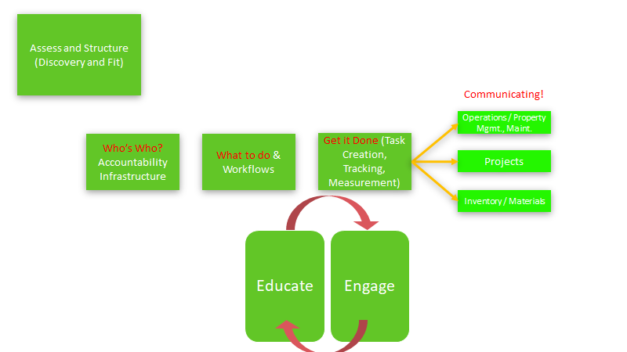
we’ve learned from hundreds of implementations what it takes to make sure you’re successful

Proven results
- For example, one of the world’s largest online retailers:
- Reduced number of Project Managers required for projects
- Increased contract laborers’ throughput and done-right, first-time performance
- Managed effective 7-month delivery of dozens of facilities from start up to launch

Who we are:
Name
Address
Phone
Website
Handles

