Design brief for Mandala Mongolia logo

Panoramic Journeys is a tour operator who offer wonderful journeys to all parts of Mongolia. Our guests travel from all around the world to enjoy meeting the people of Mongolia, learning about the culture, seeing the wildlife and experiencing the freedom of the vast landscapes.

The company has an office in Mongolia and in the United Kingdom.

Mandala Mongolia is to be a new brand within Panoramic Journeys that offers luxurious experiences in the Mongolian countryside. The name is inspired by the Buddhist Mandala art.
We need a logo for this brand.
It is a separate brand but it must sit alongside our Panoramic Journeys brand in a complimentary way.
The logo and typeface(s) need to reflect the luxury, high-end nature of this product whilst relating to the Mandala element of the brand – that is universal, transient and spiritual.

This is our logo:

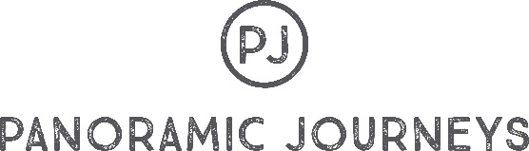

We use the logo with the words or just the logo roundel by itself.

We use the following fonts for the Panoramic Journeys brand – we do not wish to use these for Mandala Mongolia:

True North Textures As seen in logo and for titles
Wayback For highlights and titles
Avenir LT For website text only

And the following colours:
Dark Grey  CMYK 65:57:56:35  RGB 80:80:80  #505050 | Green  CMYK 52:0:50:0  RGB 120:205:188  #78CDBC
Light Grey  CMYK 3:1:2:0  RGB 245:247:246  #F5F7F6 | Pink  CMYK 7:96:30:0  RGB 222:41:113  #de2971

Our website is www.panoramicjourneys.com Here you can see how we use the brand.

We are inspired by some of the motifs found on Mongolian materials. We would use the new logo motif on our products like soap, labels, uniforms, gifts and more. Also inspired by Celtic designs

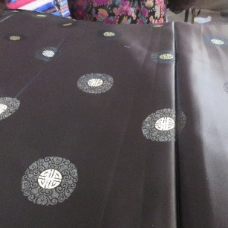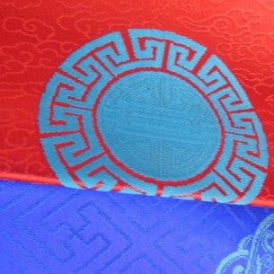

Practicalities
We would need to have this logo as a range of digital files suitable for printing, online and embossing onto materials like leather.

File formats : EPS, JPG, PNG and PDF in CMYK, RGB and Pantone

We need to have it for light backgrounds and dark backgrounds. Our Panoramic Journeys logo is available in White on a transparent background and dark grey on transparent background and dark grey on white background.

Like the Panoramic Journeys logos we will need:

- Full logo with Roundel and the wordmark – Mandala Mongolia
- Just the Roundel

We do NOT want to look too much like this – They are one of our competitors



We want it to compliment but not match our current identity – It is a stand-alone brand.

We have an interim identity and brochure – The brochure gives a better feel for the product.
And can be seen here http://www.mandalamongolia.com/wp-content/uploads/2018/02/Mandala-Mongolia-Brochure-High-Quality.pdf

