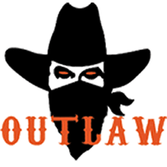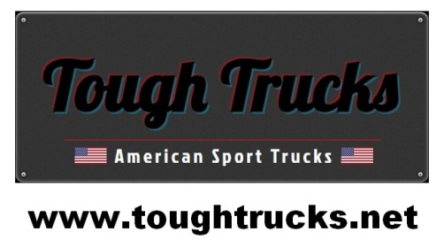

Tough Trucks Ram Outlaw Edition
Package Inclusions
Standard Outlaw Features
Tough Trucks True 4 Inch Suspension Lift
20 x 9 Fuel Octane Wheels
35 x 12.5 x 20 Fuel MT Tyres
AMP Research power running boards
Pocket style fender flares colour matched to truck
Blacked Out badges & grille
Bilstein suspension front
Rear suspension upgrade
Outlaw custom stitched headrests
Hypertech Speedo Calibrator

Total Package Cost $136,500 + On Roads
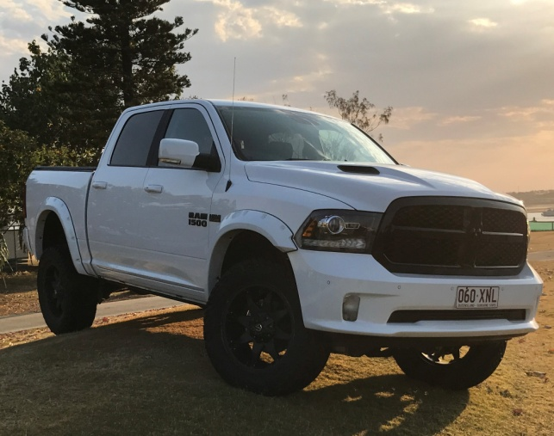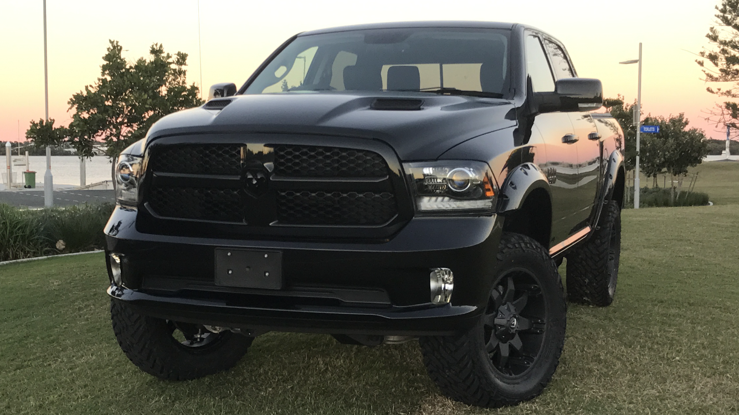

Standard Outlaw Features
Tough Trucks Dodge RAM 1500 Sport Sport Hood
Convenience Group Hayman Reece tow hitch
Sport Premium Group Spray in bedliner
Remote start & security alarm group Rollup Tonneau Cover
4 Year 100,000 km Australia wide warranty 9 speaker alpine stereo
4 Year roadside assistance Australia wide Leather seats heated/cooled

Optional Equipment Upgrades
Full Size spare wheel Magnaflow CAT back exhaust
ARE Hard Lid painted to match truck Blacked Out exhaust tips
Trailer brake controller 120 Litre Fuel Tank
Magnum Front Bar & Vision X Lights AFE Cold Air intake
Vision X LED light bar Sprint throttle controller
Magnum Rear Bar On board compressor
Loadlifter 5000 airbags Fuel Vapor Wheels

Contact: Mark Ritson
Phone: 0438800015
Email: mritson3@bigpond.com

