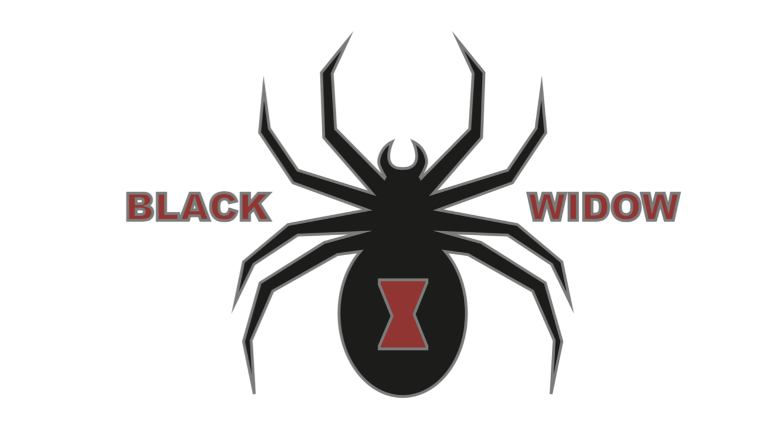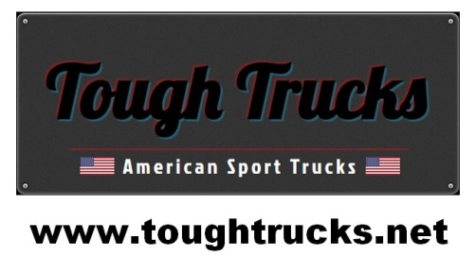

Tough Trucks Ram Black Widow
Package Inclusions

Standard Black Widow Features
Tough Trucks True 6 Inch Suspension Lift Vision X LED light bar
20 x 9 Fuel Octane Wheels Magnum Front Bar
35 x 12.5 x 20 Fuel MT Tyres Vision X Driving Lights
AMP Research power running boards Magnum Rear Bar
Pocket style fender flares colour matched to truck Magnaflow CAT back exhaust
Blacked Out badges & grille AFE Cold Air intake
Fox Coil over race suspension front Sprint throttle controller
Fox race suspension rear On board compressor
Black Widow custom stitched headrests Loadlifter 5000 airbags
Hypertech Speedo Calibrator
Total Package Cost $179,500 + On Roads
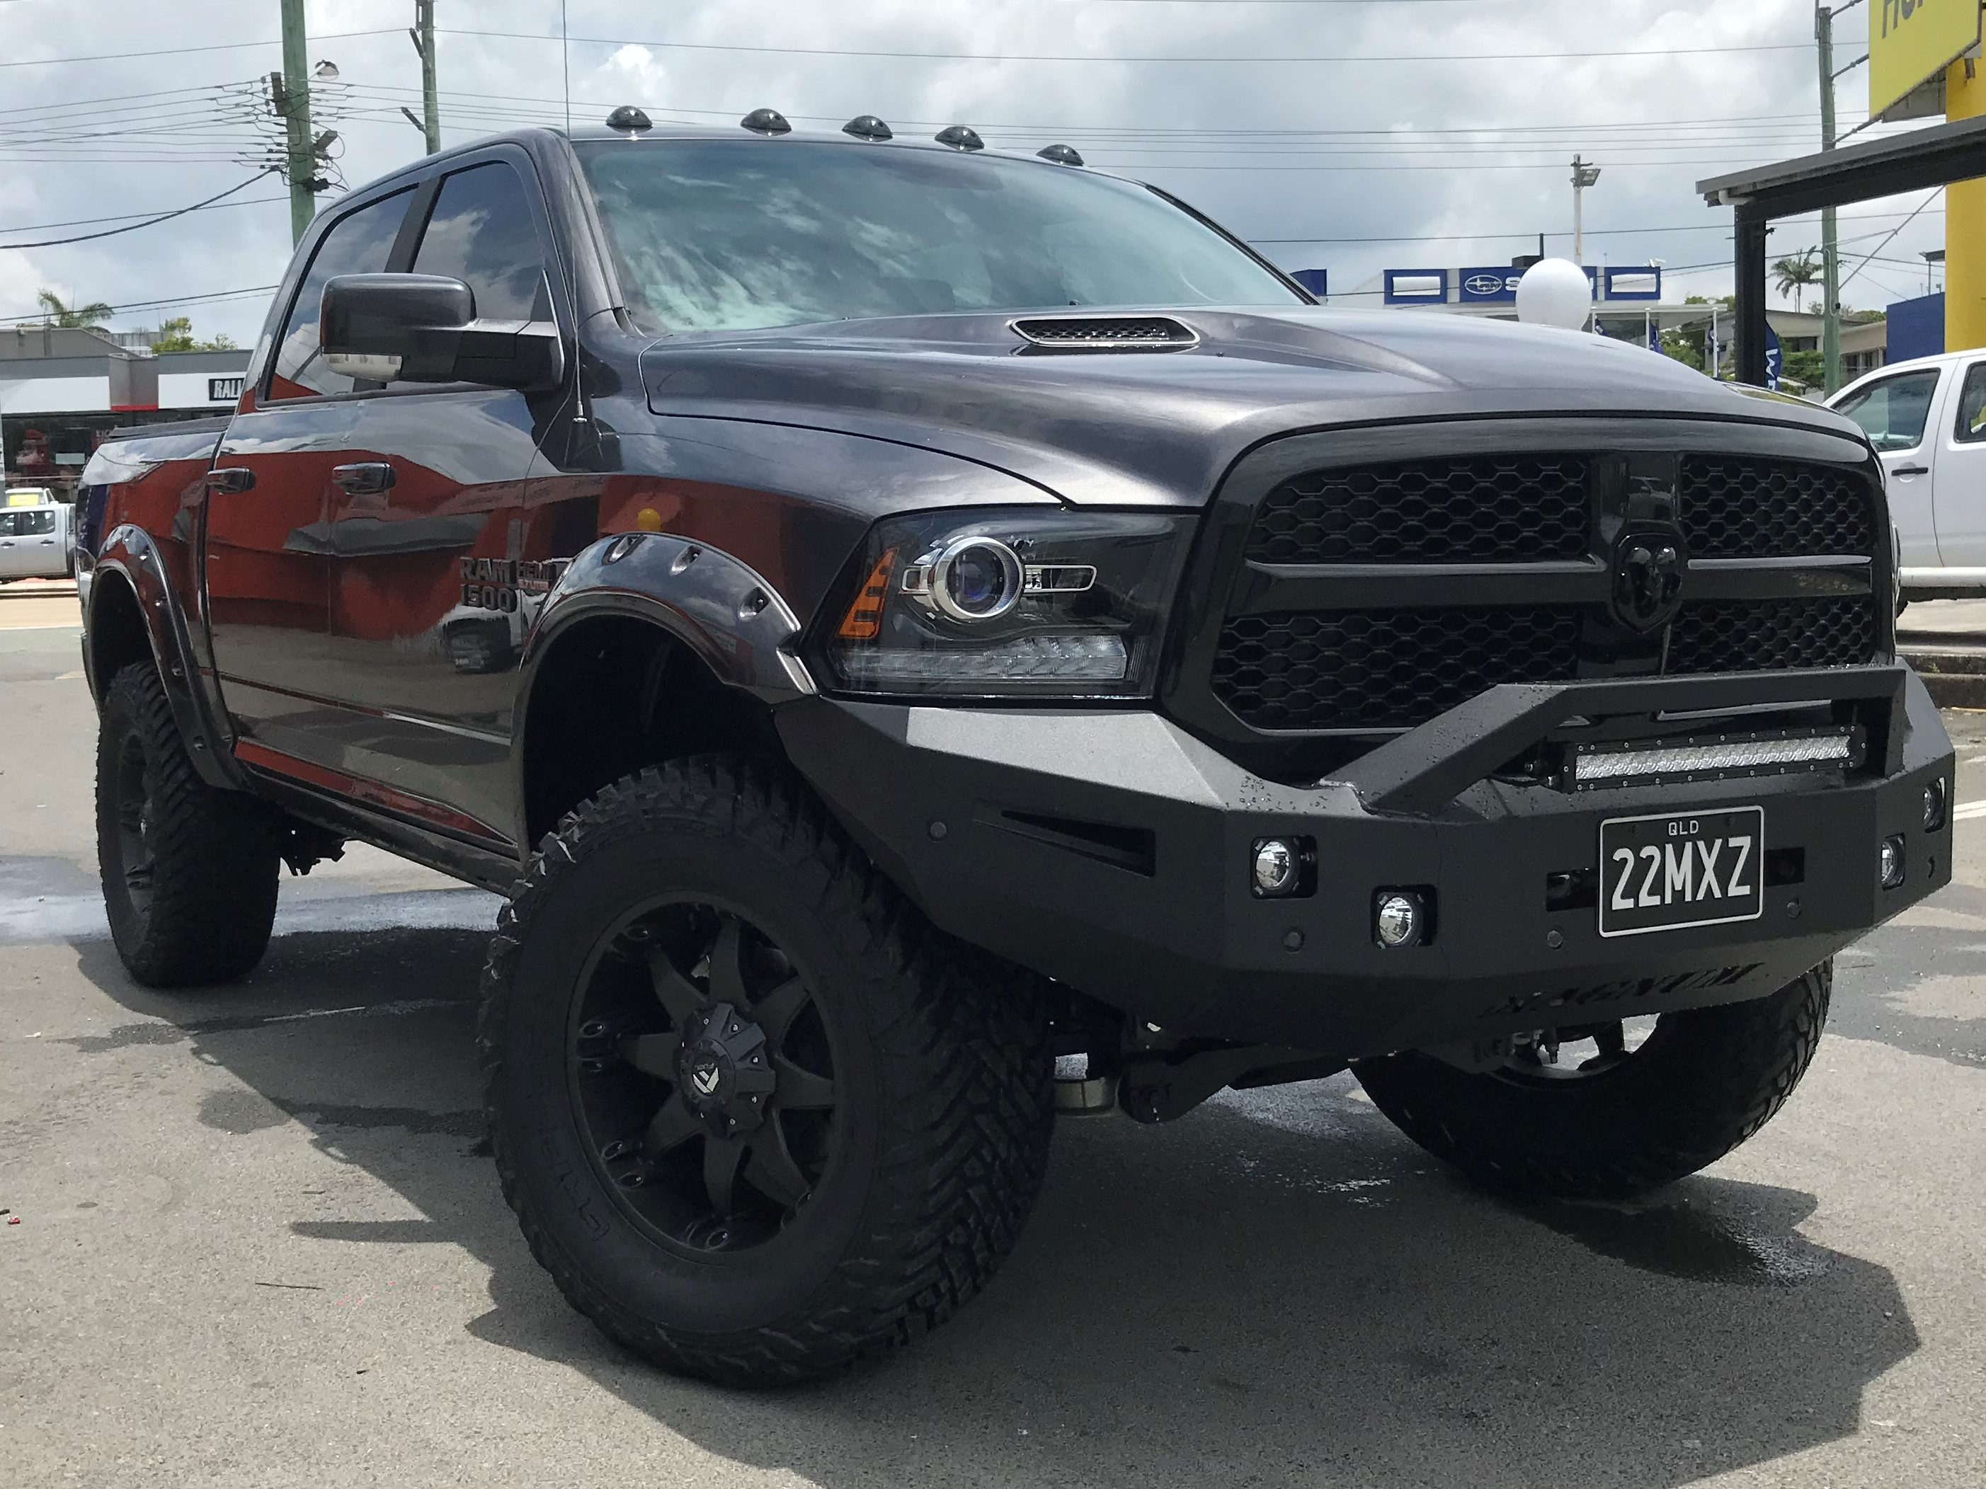

Standard Black Widow Features
Tough Trucks Dodge RAM 1500 Sport
Convenience Group 120 Litre Fuel Tank
Sport Premium Group Spray in Bedliner
Remote start & security alarm group Blacked Out exhaust tips
Leather seats heated/cooled Trailer brake controller
9 speaker alpine stereo Hayman Reece tow hitch
Sport Hood Rollup Tonneau Cover
4 Year 100,000 km Australia wide Warranty
4 Year roadside assistance Australia wide

Optional Equipment Upgrades
Full Size spare wheel
ARE Hard Lid painted to match truck
Fuel Vapor Wheels

Contact: Mark Ritson
Phone: 0438 800 015
Email: mritson3@bigpond.com

