EARLY College High School Summit:

I am extremely pleased to announce that we have secured Dr. Joe Murphy as our keynote at the ECHS Summit on May 1st and May 2nd in ABQ.
DATE: May 1st and May 2nd

Where : Albuquerque Marriot

2101 Louisiana Blvd Ne, Albuquerque, New Mexico 87110

Time: May 1st 9:00 AM until 4:30 PM
May 2nd 8:00 AM until 1:30 PM

SUMMARY NOTES FOR THE ECHS MEETING:
We will be spending our time looking at Professional Standards for Educational Leaders (PSEL) and we are pleased to have the author of the standards as our guest. Dr. Murphy will be taking us through each standard as we develop a deep understanding of what it means to lead in education.

PSEL Defined: The Professional Standards for Educational Leaders provide guideposts that will help school leaders make a difference every day in the learning and well being of students. Grounded in current research and the real-life experiences of educational leaders, they articulate the leadership that our schools need and our students deserve. They are student-centric, outlining foundational principles of leadership to guide the practice of educational leaders so they can move the needle on student learning and achieve more equitable outcomes. They’re designed to ensure that educational leaders are ready to meet challenges of the job today and in the future as education, schools and society continue to transform.

FACT SHEET: How they were developed. The Council of Chief State School Officers (CCSSO) and The National Policy Board for Educational Administration (NPBEA) guided the two-year development process. It involved a thorough review of empirical research and included the input of researchers and more than 1,000 school and district leaders through surveys and focus groups to identify gaps among the 2008 Standards, the day-to-day work of education leaders, and leadership demands of the future. After a lengthy comment and review period, CCSSO and the NPBEA boards approved the Standards

Who they are for
The Standards are foundational to all levels of educational leadership but apply particularly to principals and assistant principals.

What is new?
The Standards recognize the central importance of human relationships not only in leadership work but also in teaching and student learning. They stress the importance of support and care required for students to excel as well as academic rigor. The Standards recognize the central importance of human relationships not only in leadership work but also in teaching and student learning.

How they will be used
The PSEL are “model” professional standards that communicate expectations to practitioners, supporting institutions, professional associations, policy makers and the public about the work, qualities and values of effective educational leaders.
As a way of background, the Professional Standards for Educational Leaders have been adopted by:
- American Association of Colleges of Teacher Education (AACTE)
- American Association of School Administrators (AASA)
- Council for the Accreditation of Educator Preparation (CAEP)
- Council of Chief State School Officers (CCSSO)
- National Association of Elementary School Principals (NAESP)
- National Association of Secondary School Principals (NASSP)
- National Council of Professors of Educational Administration (NCPEA)
- National School Boards Association (NSBA)
- University Council for Educational Administration (UCEA)

PSEL Standards

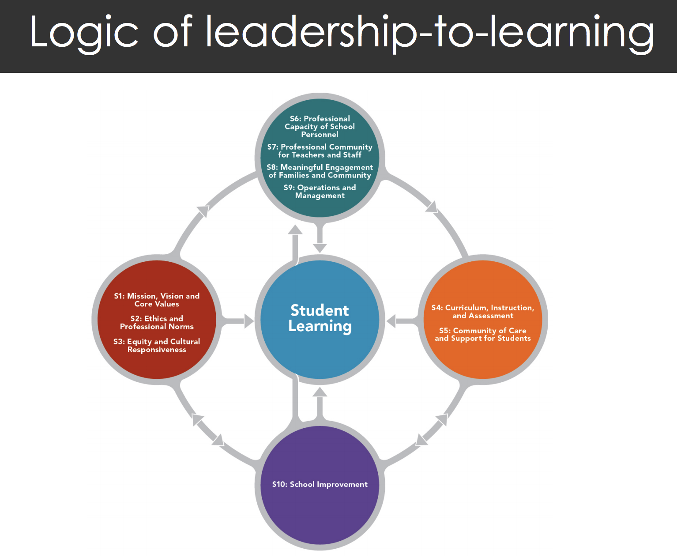

Dr. Joe Murphy’s Bio:

Associate Dean Vanderbilt University, Special Projects, Office of the Dean
Professor of Education; Endowed Mayborn Chair, Dept. of Leadership, Policy & Organizations
Joseph Murphy is the Frank W. Mayborn Chair of Education and Associate Dean at Peabody College of Education of Vanderbilt University. He has also been a faculty member at the University of Illinois and The Ohio State University, where he was the William Ray Flesher Professor of Education.
In the public schools, he has served as an administrator at the school, district, and state levels. His most recent appointment was as the founding President of the Ohio Principals Leadership Academy.
He is a past Vice President and a Fellow of AERA.
His work is in the area of school improvement, with special emphasis on leadership and policy. He has authored or co-authored 25 books in this area and edited another 12. He has an h index of 65, an i 10 index of 178, and his work has been cited over 15,000 times in the research literature.
Murphy was the Founding Chair of the Interstate School Leaders Licensure Consortium. He also chaired the teams that produced revisions to the national Standards in 2008 and 2015 (Professional Standards for Educational Leaders). He led the team that developed the specifications with ETS for the School Leaders Licensure Assessment(SLLA). He is also one of the four co-creators of the Vanderbilt Assessment of Leadership in Education (VAL-ED).

