Trifold design details: use company colors
Use font: Pro Sans 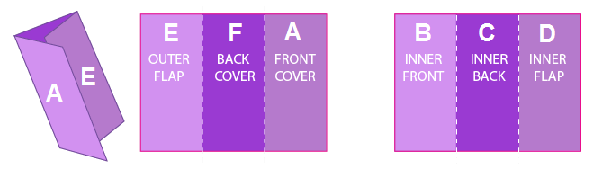

Panel A (outside front panel)

Chuck this flier in the trash if
- You have website and you’re happy with the amount of revenue it generates for you
- There’s no way marketing on google or bing can bring increase your business
- Your website is awesome, current, and represents your business well
- Lots of the right people are actually liking, sharing, and commenting on your social media posts
- You already have and in-house team of certified specialists handling your marketing
Otherwise, flip the page to see if we can help you

Panel B (inside left panel)

We help people find your business when they Google your services and we increase the number of website visitors that become paying customers.

Panel C (inside middle panel)
Web Design and Development – We build custom, award-winning, persuasive websites that convert visitors into paying customers. Our websites are well worded, expertly coded, and beautifully designed to make an outstanding first impression and most importantly – to sell your services.
Search Engine Marketing – Using both ads and organic search techniques, when people search in Google, Bing, or Yahoo for your products or services, we ensure they find you above your competitors. Results are 100% guaranteed or your money back.
Social Media Marketing – We target the right people for your business, engage with them to create authentic conversations and interactions, and we post content and ads that drive likes, follows, comments, and shares.

Panel D (inside right panel)
(Testimonials)
We’ve been working with MerchantSide Marketing Group for about 3 months. When they say they are focused on making you money, it’s no understatement! In these three months, we’ve already seen a significant increase in business -many times more than their fee- so the ROI is incredible and its easily some of the best money I could have spent on my business. Also incredible is our website… if you compare it to that of other catering companies, they really put Cater Tampa on another level! The website they made for us is beautiful, easy to use, and really drives more traffic. MerchantSide has a great process and great staff of people that REALLY know what they’re doing. If you work with them, you won’t regret it!
Adam Harris, Owner & Head Chef of Cater Tampa
MerchantSide delivers! Our leads have gone up 100%. The potential clients that have contacted our firm are serious about hiring. Isham made the process of generating content easy and painless. I would recommend Merchantside to anyone wanting to take their business to the next level.
Christine Smith, Partner at Law Offices of Hernandez & Smith
Read all of our Google reviews at MerchantSide.com/Google

Panel E (outside left – folded in panel)
- Risk-free, 100% money-back guarantee on our monthly marketing plans.
- We have plans for every budget
- On average, our clients make back a 4-12 time return on what they pay us.
- We are the highest rated marketing agency in all of Tampa Bay (see Google reviews) [consider using images]
- Awarded 2017 Best Marketing Firm and Best Web Developer in Tampa Bay by Creative Loafing Magazine’s readers’ poll [consider using images]
- Google Certified Partner and Bing Certified Partner [consider using images]
- Highly active in the local community, involved with several charities,
- Veteran-owned, American-proud company

Request a free, in-depth, professional analysis of your company’s digital foot print with actionable feedback. We’ll tell you what good, what needs improvement, how to improve it yourself, and a custom proposal if want to hire us.
(Please note that it takes an average of 11 hours / 2 days to complete)

PANEL F (outside back panel)
Include Logo (https://drive.google.com/file/d/0B6HPKMeWRCyLTnZ2LVFtc0paVWM/)
Include URL (http://MerchantSide.com)
Include 2-line Address (650 E. Bloomingdale Ave, Brandon, FL 33511)

Include Sale Rep Name (Isham Harris)
Include Sales Rep Phone Number (813) 602-1308
Include Sales Rep Email Address (Isham@MerchantSide.com)

