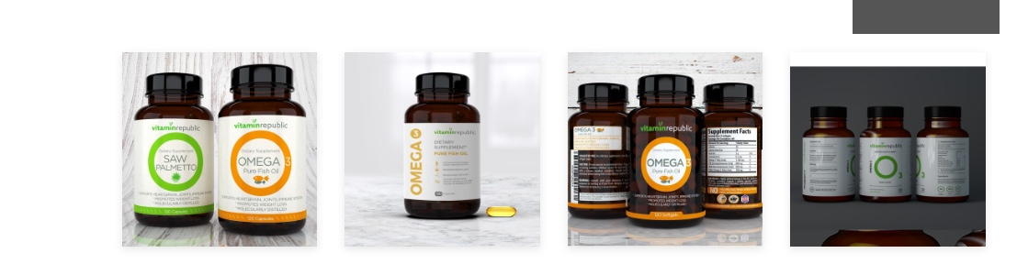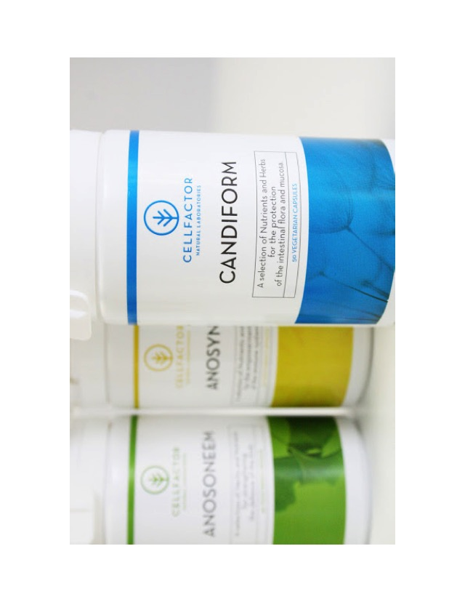
Please use this style design concept for “ARCTIC OMEGA” inside of letter “O” please type “ARCTIC OMEGA”, and below OMEGA, please type EPA+DHA+DPA Marine Lipids.

Furthermore, below letter “O” please type:
- 100% Seal oil Pharmaceutical Grade * No Fishy Burps
- 500 mg per Softgel
- Support Heart, Joint, Brain Function, Cognitive Health

Please use this design concept, intergraded the Seal picture on the left side, please keep the same “Blue Colour” above, use the same “Blue Colour” over laps the Seal pictrure.

