
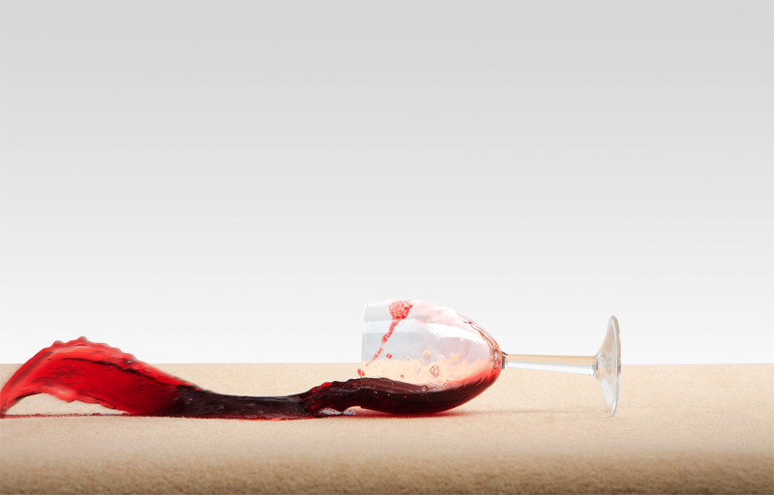
Please see BOOKLET before use
- It’s what the professionals use.
- Covers red wine, cordial, coffee, pet spots, soft drink, juices, and more.
- keeping your carpets forever clean.
- Removes over 30 household stains.
- Simple, effective, and user friendly.
- Highest quality cleaning products.
- INSTRUCTION BOOKLET inside!
Carpet STAIN REMOVAL kit

