REFUEL

7-days on my plate
Nourishing recipes to feed your tired and hungry muscles.

MONDAY
Breakfast
Power Protein Smoothie
I blend up 1 serving of protein powder, ½ tsp. of ground cinnamon, 1 tbsp. of chia seeds, ½ cup frozen berries, ½ frozen banana, ½ cup spinach leaves and 1 cup of nut or coconut milk.

Lunch
Superfood Bowl
I chop and roast sweet potato and eggplant; steam shredded kale and chopped broccoli; and mix chopped coriander and mint through cooked quinoa. Add all cooked ingredients to a bowl, drizzle with tahini, top with chopped almonds and a tbsp. of sauerkraut. It’s a big dose of vitamins, protein and gut lovin goodness.

Dinner
Soba Noodle Special
I steam snow peas and frozen green edamame, spiralise a fresh carrot, and mix it all through cooked buckwheat soba noodles. I make a yummy Asian dressing by mixing ¼ cup tamari, 1 tbsp peanut butter, 1 tsp ginger, 1 tsp seasame oil, and the juice of a lime, and then I stir it through the noodles and veg and season with chopped coriander and toasted sesame seeds. Add some cooked tempeh or wild caught grilled salmon for extra protein.

……….

TUESDAY
Breakfast
Overnight Oats
The night before I blend 1 banana with 1 tbsp. chia seeds, 1tsp. cinnamon, 1 serving of protein powder, ½ tbsp. of cacao powder and 1 cup of nut milk or water. Then I pour it in a jar and stir through ½ cup of oats. After letting it soak overnight, I enjoy it after my morning run.

Lunch
Falafel Wrap
I spread beetroot and hummus dip on a Lebanese bread wrap, and then I fill it with lots of salad goodness (spinach, tomato, cucumber, sauerkraut, pickles, grated carrot) and 2-3 warm falafel balls. Wrap, eat and enjoy!

Dinner
Mexican Bowl
I cook brown rice and my red kidney bean chili (1-can red kidney beans, ½ diced brown onion, 1 tsp. garlic, 1 grated zucchini, 1 grated carrot, 1 can of diced tomatoes, ½ tsp. chili powder). I fill a bowl with a serving of cooked brown rice, kidney bean chili, a handful of spinach leaves, chopped coriander and a huge dollop of my famous guacamole!

……….

WEDNESDAY
Breakfast
Toast and Banana
I toast some soughdough bread and top it with with peanut or almond butter and sliced banana. Easy peasy!

Lunch
Salad and Mixed Bean Wrap
I spread beetroot and hummus dip on a Lebanese bread wrap, and then I fill it with lots of salad goodness (spinach, tomato, cucumber, sauerkraut, pickles, grated carrot) and any leftover beans I may have (the four-bean mix is great!).

Dinner
Roast Veggie Red Curry with Quinoa
I chop and roast sweet potato and sliced red capsicum, then I steam green peas and broccoli florets. I gently fry 2 tbsp. of red curry paste with 1 can of coconut milk then I add all the cooked veggies and let it simmer for 10-mins. Spoon it over cooked quinoa and garnish with chopped coriander.

……….

THURSDAY
Breakfast
Power Protein Smoothie
I blend up 1 serving of protein powder, ½ tsp. of ground cinnamon, 1 tbsp. of chia seeds, ½ cup frozen berries, ½ frozen banana, ½ cup spinach leaves and 1 cup of nut or coconut milk.

Lunch
Stuffed Sweet Potato
I wash a small sweet potato (keep the skin on). With a fork, poke holes all over potato and wrap in a paper towel. I microwave the sweet potato on high for about 8 minutes, or until tender all the way to the center. Cut the potato in half and top it with a handful of rocket and canned lentils. Microwave uncovered for 30 seconds to wilt rocket and warm lentils. Top with cinnamon, dried thyme, dried cranberries, pumpkin seeds and a drizzle of olive oil.

Dinner
Spaghetti with Green Pesto and Roast Cherry Tomatoes
I cook a serving of whole-wheat spaghetti and roast a handful of cherry tomatoes in the oven. In a bowl I add the cooked pasta, the roast cherry tomatoes and stir through 2-heaped tbsp. of my homemade pesto. Add a squeeze of lemon and salt and pepper to finish.

………

FRIDAY
Breakfast
Gluten Free Granola
I start the day with ½ cup of my homemade gluten free granola, topped with fresh berries, seeds, coconut yoghurt and almond milk.

Lunch
Spinach, Roast Pumpkin and Chickpea Salad
I roast chopped pumpkin that has been seasoned with salt, pepper and cumin. Then I mix baby spinach, canned chickpeas, finely sliced red onion, chopped figs and the roast pumpkin in a bowl. After mixing all together, I season with chopped coriander, olive oil and salt and pepper.

Dinner
Veggie Pad Thai
Stir-fry matchstick cut carrot sticks, red capsicum sticks and broccoli florets in coconut oil. Cook rice noodles as per directions and mix ingredients together with my favourite Asian dressing, ¼ cup tamari, 1 tbsp. peanut butter, 1 tsp. ginger, 1 tsp. sesame oil, and the juice of a lime. Then I season with chopped coriander and chopped spring onions. Add some cooked tempeh or lean grilled chicken for extra protein.

……….

SATURDAY
Breakfast
Green Machine
I scramble 2 free range eggs with 1-heaped tbsp. of my homemade pesto. Serve with soughdough toast and avocado, et voila!

Lunch
Sushi
Lunch is on the go today and I choose take-away brown rice and vegetable sushi.

Dinner
Homemade Burger and Chips
I make sweet potato and lentil patties and build a burger on a wholegrain roll with salad greens, sliced tomato, beetroot, pickles and cucumber. You can also roast some homemade potato fries on the side if you’re starving. Every now and then I’ll use lean beef mince instead of the beans if I need more Iron.
……….

SUNDAY
Breakfast
Buckwheat Banana Pancakes
Blend well all ingredients: 1 cup nut or coconut milk, 1 ripe banana, 1/2 tsp. vanilla, 1 tbsp. coconut oil, 1 cup buckwheat flour, 1 tsp. baking powder and a pinch of sea salt. Cook both sides using some baking paper on skillet or pan then top it with maple syrup, coconut yoghurt, seeds and sprinkle with cinnamon.

Lunch
Left Overs
I eat the left over burger patties from last night with a green salad on the side.

Dinner
Roast Veggie Lasagna
This is one for the family. I roast a stack of vegetables (sweet potato, pumpkin, zucchini, capsicum, eggplant). Then I layer a baking dish with the roast veggies, tomato passata sauce, spinach leaves and whole-wheat lasagna sheets. To finish I top with a ricotta and Parmesan cheese.

……….

SNACKS

If I’m on the run or feeling extra hungry I reach for:

- Fresh carrot sticks with hummus
- Brown rice crackers with either almond/peanut butter, avocado or hummus spread on top
- A piece of whole fruit…whatever is in season
- A handful of mixed nuts and seeds
- 2 x fresh dates. I like to take the pit out and stuff a macadamia in the middle.
- A few tablespoons of coconut yoghurt with fresh berries and a sprinkle of cinnamon.

DRINKS

- I drink water, and lots of it.
- Earl grey tea in the morning and decaf green tea in the afternoon.
- On the weekends I usually have a green juice with lots of fruit and veggies for a potent vitamin hit.
- I love a glass of wine with dinner on the weekends.

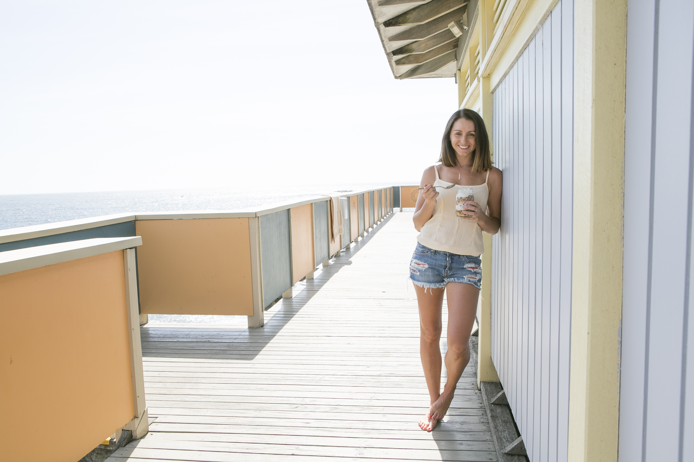

‘Eat food, not too much and mostly plants’ – Michael Pollen

Learn more
www.breecorbett.com

Let’s connect
bree@breecorbett.com |Facebook @BreeCorbett | Instagram @breezacorbett

Let’s work together
1:1 Coaching | Online Coaching | Workshops | E-Resources

