We are a supplier of Electrical Contacts and Materials for the Switchgear manufacturing industry.
Our ISO 9001 manufactured components are engineered to your material and print specifications, and are found in any mechanical or electromechanical switchgear that require the highest quality contact materials, in short lead times and aggressively priced.
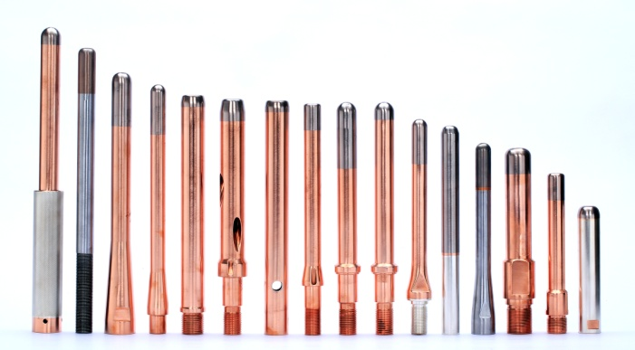
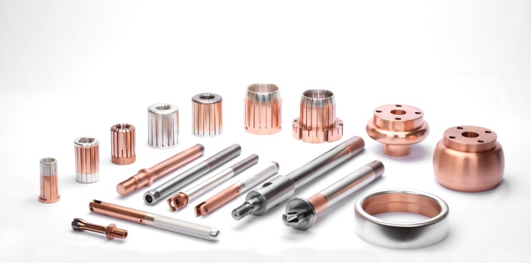
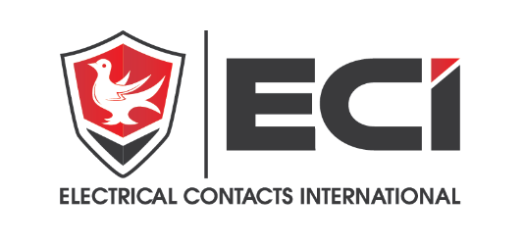

Standard Alloys | Standard Forms by Type
Standard Alloys | Discs/Tips | Wire | Profile | Sheet | Rivets
Ag (99.9% min) | X | X |  | X | X
AgCdO (10-20%) | X | X | X | X | X
AgSnO (10-15%) | X | X |  | X | X
AgCu (3-10%) | X | X |  | X | X
AgNi (10-40%) | X | X |  | X | X
WAg (20-50%) | X |  | X
AgWC (30-60) | X |  | X
CuW (60-80%) | X |  | X
AgC (2-5%) | X
AgMgNi |  |  |  | X
Cu | X | X | X | X | X

We refine, sinter, extrude and process all of our contact materials on-site for the highest alloy purity, and have multiple joining technologies including EB welding, resistance and induction brazing.

Your parts can be plated with Gold, Silver, Electroless Nickel, or Copper and can be all over or selectively plated using either rack and/or barrel process.
ECI’s advantage to you is not only our pricing structure, but our continuous drive to provide you with the highest Quality contacts, through pleasant professional staff, and on time.
Please contact Brett@electricalcontactsint.com to discuss your specific needs.
We look forward to working with you soon.

www.ElectricalContactsInt.com

