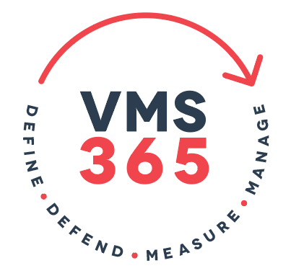

Data. Your Network and your Data is your Business.



Data defines the health of your business and the state of your operations at any moment of any day.


Defending that data, the network on which you move that data and understanding what that data is telling you is key to the success of every business.

VMS 365 enables you to do that – Defend, Define, Measure, Manage – 365 days a year.

Define - Baseline your OT communications with passive capture of your assets
know your topology with confidence

Defend - Be alerted to any change in your baseline OT environment in real-time
Pro-actively manage your threats

Measure - Turn your data sources into powerful Visual Management Tools -
trust your data to inform you

Manage - Customise and present your dashboard in minutes
Start managing, your way, in minutes

These are the core principles that VMS delivers for your Enterprise.

VMS 365 understands that data and networks are valuable and vulnerable so our business-critical software defines your network, the hardware, the interfaces and the protocols it carries.
We understand the core of your network how it operates and then how you need to secure your network, devices and data.

Once the network and data are secure we streamline the decision making process and let you get the heart of your operations
At VMS 365 we help you work smarter not harder every minute of every day across all your platforms and capturing all your business and operational inputs enabling real time decisions and reporting across multiple business levels.

Your role in business success across IT, OT, Construction, Manufacturing, Project Management, Operational Management to the boardroom CIO is about understanding the numbers – because what gets measured gets managed - no matter what level of accountability or granularity you require we help you understand your KPI’s and take control within hours of inception.

VMS 365 enables you to take direct control of all your data streams and visualise these into real time dashboards presenting the data as you need it, when you need it so you can manage across all of your business streams in real time.



VMS 365 makes real time business and operational control a reality, providing reporting and monitoring internally and offering customers a visual portal to measure service delivery and demonstrate key performance indicators whatever your business and data looks like.

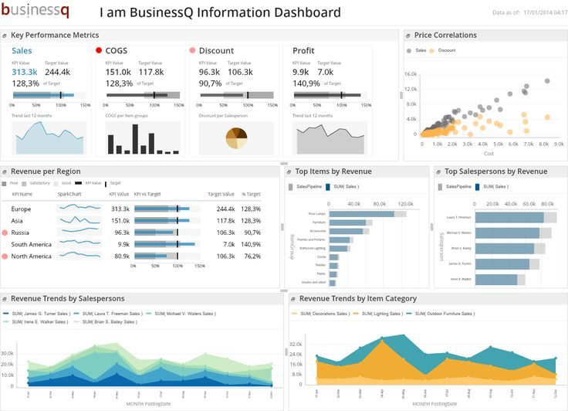

With global experience and success in delivering Major Infrastructure and Operational Programs we have learnt the lessons for you - we help you take control of your data no matter what your business and no matter what size by applying our proven processes with some of the most innovative world class applications available.

VMS 365 are established Global partners with

- Transpara TM - Now You know

- Claroty TM - Claroty for your OT Networks

Contact VMS 365 today and be in control tomorrow

