RENT ME
ride832.com
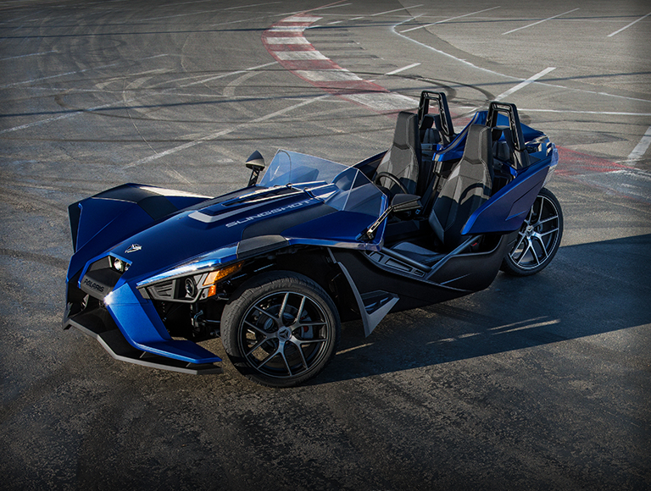
832-680-9513
20% Off for all Sterling Country Club Members
Sign up at www.ride832.com/SterlingCC

