Aayu Clinics
Wicker Park Immediate Care

New Urgent Care
corner of Ashland and Division
next to Division Blue Line El Station
- Open 365 days a year
- Wide Variety of Insurance Plans Accepted & Economical Cash Pay Options
- Monday - Thursday 8am - 7pm
- Friday, Saturday & Sunday 9am - 3pm

365-Day Urgent Careincluding. labs and X-ray
And,
Proactive Primary Care
Convenient, On-Demand Healthcare
Proactive, Lifestyle-Based Primary Care
Regenerative Sports Medicine
Anxiety and Depression Management
Women’s Health
Nutrition
Yoga

Aayu Clinics has expanded to a new Wicker Park/Ukrainian Village location close to you
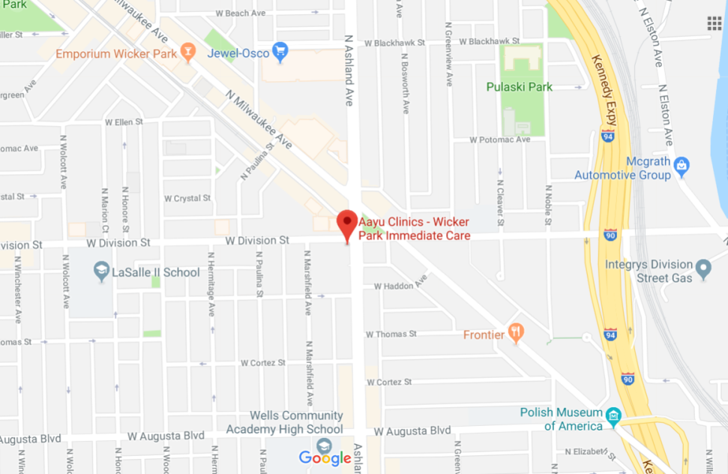
Non-emergency room urgent care
Primary Care
Appointments on evenings and weekends

We look forward to caring for you in an economical manner at times convenient for you.



A fraction of the emergency room visit.

Acute illness - the flu
IV fluids
Injury Medicine

What is Urgent Care and When Should You Use It?
Should the cut on your finger or the pain in your chest send you to the emergency room or an urgent care center? It’s difficult to be sure. So we’re making matters easy by providing this clear-cut description of where to go for the care you need.
Life-threatening emergencies, such as a heart attack or serious head injury, require a visit to the emergency department, also called the emergency room (ER). An illness or injury that does not appear to be life threatening but can’t wait until the next day should be treated at an urgent care center.
Urgent care centers provide easy access to quality healthcare 365 days of the year at a fraction of the cost of an emergency room visit.
At Wicker Park Immediate Care, our medical expertise and commitment to personalized attention ensure that you receive the very best care days, evenings, weekends, and holidays.

