Capability Statement

PAStech is a process control systems company that specialises in the design, programming and commissioning of RTU, PLC, flow computers, SCADA, DCS, SIS and telecommunications systems for the Oil and Gas Industry.

PAStech employ experienced Integrated Control & Safety System (ICSS) Engineers, Instrumentation Engineers, Electrical Engineers, Telecommunications Engineers, Electrical & Instrumentation (E&I) Technicians and Instrument Designers with a proven track record in project delivery and a diverse range of skills.

Safety is our number one priority and “Get It Right First Time” defines our attitude to the work we do and the value we add to our clients’ businesses.

We are committed to working with out clients to achieve the best possible solution for their projects in an honest and transparent way that ensures “No secrets, no surprises”.

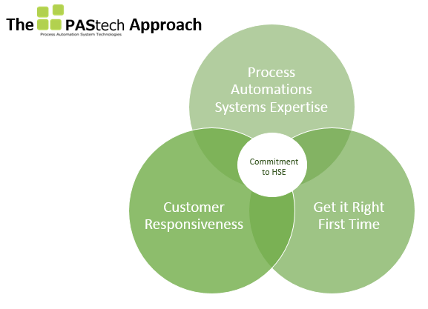

Health, Safety & Environment
- Proven HSE compliance record. PAStech strongly embrace an incident and injury free culture

Commitment and Integrity
- Demonstrated long-term commitment towards project completion
- Proven to deliver high quality ICSS solutions under schedule pressure without compromising safety, quality and technical excellence

Proven Industry Knowledge and Experience
- Can provide a diverse team of experienced industry professionals with hands on knowledge and skills gained from design and commissioning mega projects around the world

- Strong communication skills able to interface and engage at every level within a project team
- Comprehensive project lifecycle knowledge (i.e. design, implementation, construction, factory and site acceptance testing, installation, pre-commissioning, commissioning, start-up, completions management and operational support)
- CHAZOP leaders to conduct and participate in CHAZOP’s
- HAZOP participants

Management, Scheduling & Planning
- Demonstrated experience leading large teams of ICSS engineers
- Experience with managing ICSS carryover scope and interpreting this at schedule level
- Proven experience in leading and supporting multi-discipline commissioning teams
- Staff secondments integral to client operations

ICSS Technical Excellence
- Extensive knowledge of Yokogawa platforms both software and hardware: Centum VP DCS, Prosafe-RS SIS, Stardom RTU and FAST/Tools SCADA
- Extensive knowledge of Emerson platforms both software and hardware: DeltaV, DeltaV SIS, Fisher ROC, Fisher FloBoss and Daniel S600
- Extensive knowledge of Honeywell platforms both software and hardware: Experion and RTU2020
- Experienced with both traditional and advanced instrumentation technologies such as Yokogawa Asset Management Systems (PRM), Emerson Asset Management Systems (AMS), HART, Foundation Fieldbus and Digital Valve Controllers (DVC)
- Trained and certified industry professionals – Registered Professional Engineers of Queensland (RPEQ), Certified Functional Safety Experts (CFSE), TÜV Functional Safety Engineers, Network Specialists, Telecommunications Engineers
- Licensed electricians & instrument technicians
- Licensed security system advisers & equipment installers
- Extensive control system experience including, but not necessarily limited to:
PLC
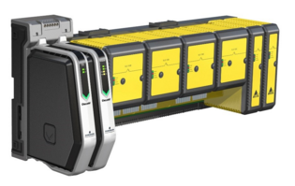
    - Siemens
    - Allen-Bradley
    - Schneider-Electric Quantum
    - Télémécanique
    - Mitsubishi
    - Omron
    - Red Lion Controls
    - GEM80
    - GE Alspa
    - ControlWave Micro
RTU
    - Fisher ROC800
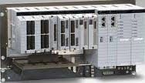
    - Fisher FloBoss 103 & 107
    - Yokogawa Stardom
    - Honeywell RTU2020
DCS
    - Emerson DeltaV
    - Yokogawa Centum VP
SCADA
    - Citect

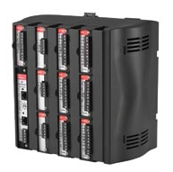
    - Yokogawa FAST/Tools
    - Honeywell Experion
    - Wonderware
    - Siemens WinCC
    - Allen-Bradley RSView
    - GE iFIX
SIS
    - Yokogawa ProSafe-RS
    - Emerson DeltaV
    - HIMA
    - Triconix
    - Pilz
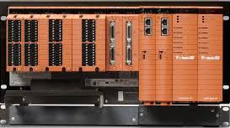
Industrial Communications
    - Foundation Fieldbus
    - Modbus TCP & RTU
    - Profibus
    - IEC61850 & IEC60870
    - DNP3
    - OPC
3rd Party Equipment Interfaces
    - ABB VSDs, Siemens SWBDs, SICAM controllers, Allen Bradley PLCs, ABB SCADA & RTUs, Bentley Nevada System 1, PI Historian
Telecommunications
    - Communications systems concept & feasibility studies
    - Satellite link planning & optimisation
    - Radio & network infrastructure detailed design
    - Telecommunications installation & commissioning support
    - Radio coverage planning & licencing
    - Communications Infrastructure project management, auditing & maintenance

Completions
- Proven ability to develop and administer completions systems
- Proven ability to manage and apply changes to completions systems under Management of Change (MoC) policies & industry best practices
- Proven ability to develop all required documentation to support completions and commissioning including ICSS SAT, Inspection & Test Plans (ITP), SIS C&E verification, Functional Test Procedures (FTP)
- Experienced with the care custody & control process and the expectations for handover to operational groups
- Ability to apply ‘lessons learned’ to the overall commissioning process in support of aggressive start-up schedules

Track Record
- PAStech prides itself on building relationships with its clients to achieve optimum performance and results throughout the project
- PAStech clients include some of Australia’s largest Oil & Gas Companies including Santos and Origin Energy
- PAStech staff have been integral to control system development & commissioning for well sites, pipeline main line valves (MLV’s), pig launcher & receiver stations and water gathering stations for two of Australia’s largest multi-billion dollar Coal Seam Gas (CSG) projects

Industry Association Memberships

- Electrical Contractors License (#82334)
- Achilles HSE prequalification
- Member of Security Providers Association of Australia Ltd (Security Firm’s License – Class 2, SPAAL Member No:GM4314)
- Member and sponser of the IICA

Contact Us

Steve French
Director
+61 (0) 408 586 286
steve.french@pastech.com.au

Ian Davies
Director
+61 (0) 437 839 912
ian.davies@pastech.com.au

Sion Bowen
Engineering Manager
+61 (0) 439 620 730
sion.bowen@pastech.com.au

Steve Glock
I&E Manager
+61 (0) 404 667 144
steve.glock@pastech.com.au

Level 1, 18 Little Cribb Street
Milton, Queensland, 4064
Australia

www.pastech.com.au

ABN: 26 169 304 036

