Mobile Corrections

HOME PAGE MOBILE CORRECTIONS

- Menu – Open above the hero picture transparent and looks confusing. Can something be done of this?
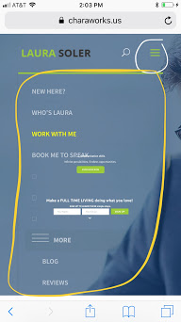
CAN THE MENU LOOK LIKE THIS ?-->> 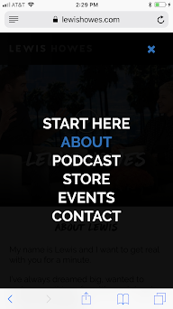

  - The text in the middle of the hero pops up very little
  - The “Make a Full Time Living” Subsciption Bar open up on the middle. It should go lower and bigger on the mobile.
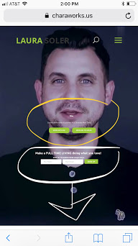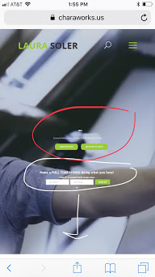

IT SHOULD LOOK MORE LIKE THIS (LOOK bELOW)
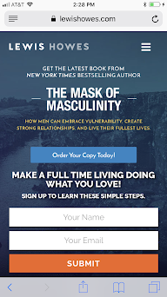

- The Options boxes Under the “How can we help you?” and the “What people are saying about “ section come up squished together and vertically long. (Look Below)

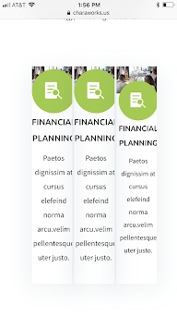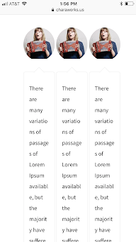

- Hoover over options squares
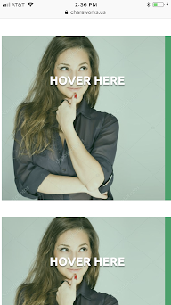 CAN IT LOOK MORE LIKE THIS? ( SMALLER MOBILE SQUARES?-->> 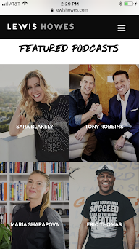
- End of page newsletter Your Name & Your Email is shown on top of each other. 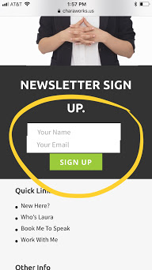

Who’s Laura Mobile Page Corrections
- Half of the text does not appear of the screen. Font very tiny
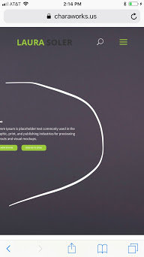
- The white boxes with the green line in the body of the page , ( above Mission) Half of the boxes do not appear on the mobile screen
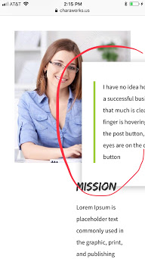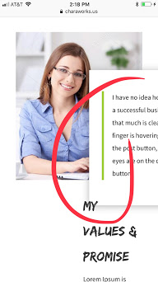

- And the same newsletter issue as the home page.
WORK WITH ME PAGE MOBILE CORRECTIONS

- Same Issue as the about Laura page
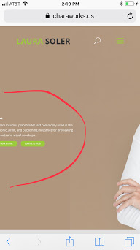

- The newsletter bar under the hero
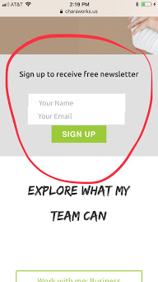

- Can you reduce some of the white spaces in the desktop version so it help in the mobile version ?
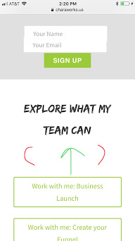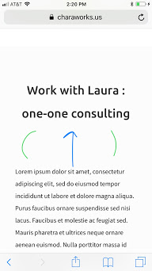

- The “Watch a free training bar” gets cut off
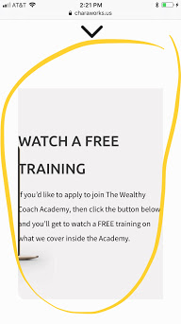

MOBILE CONTACTS PAGE CORRECTIONS
- The Contacts Page Tabs
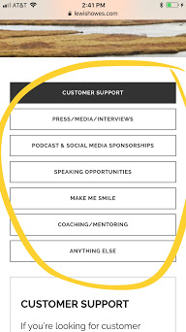
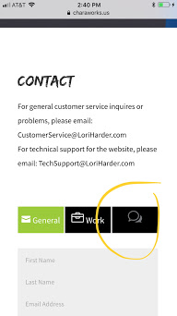 CAN IT LOOK
MORE LIKE THIS? ----->>>>>

- Make the form have space in between required fields. Like below
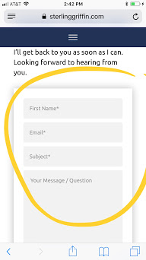

- Fix the Submit button. It shows the start of a second button.

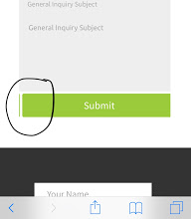

- Same Newsletter issue
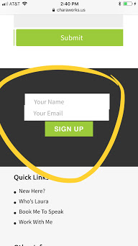

- Fix the footer on each page
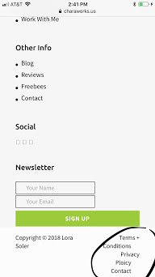 to this 