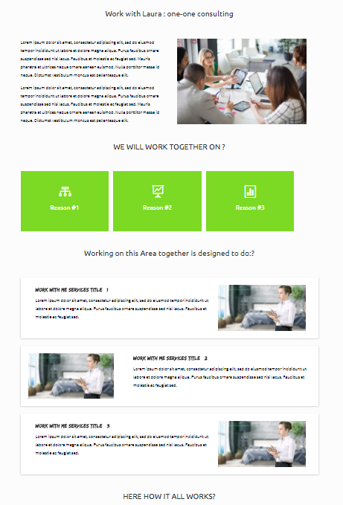
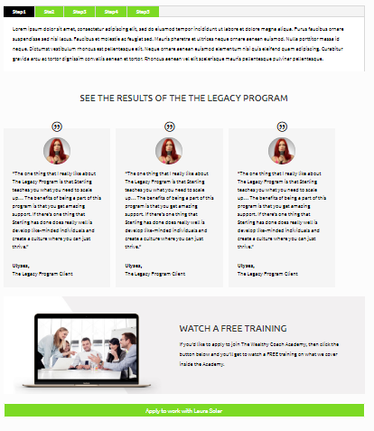

THIS IS ALL ONE SERVICE
So ALL OF THIS this needs to be COPIED AND ADDED 2 times more. one under the other
- The first one with a cream/grey background (Already Done)
- The second layout With a white background
- The third layout exactly like the first one With the Cream/ grey background

2. Add the Downward arrow after section until you get to the the Apply to work with laura button


3. Make sure the Boxed Options Start and End aligned to how the boxes below it start and end.
a.
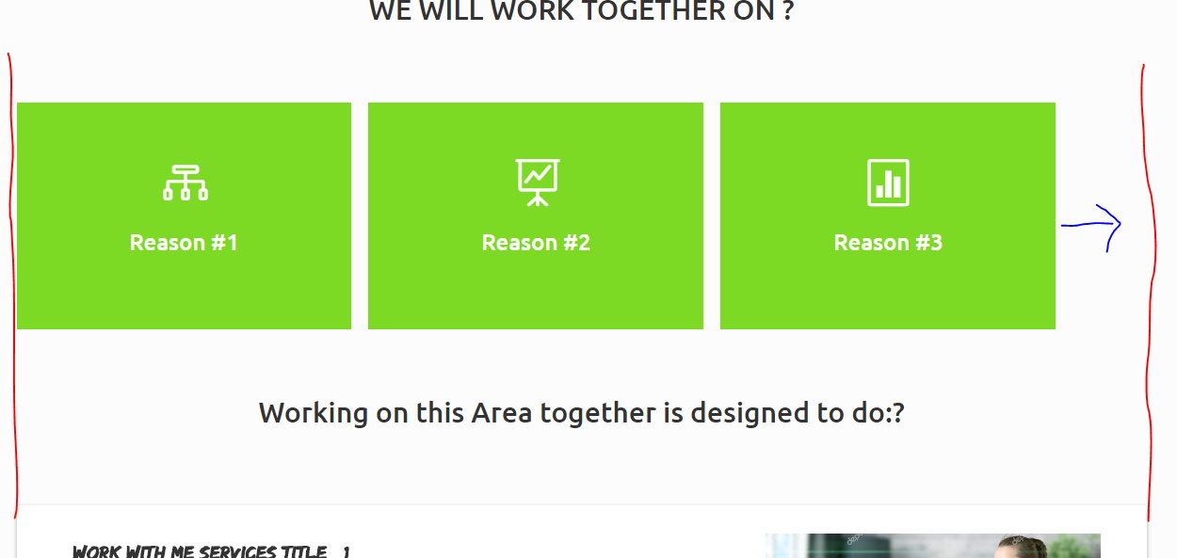

b. ( ALSO ADD SHAWDOW TO THE ONE BELOW)
