Blog Page: (Exactly like this one)
https://www.sterlinggriffin.com/blog/

Contact Page:
https://www.sterlinggriffin.com/contact/
With Contact Options like in the following page
Options on Top
https://www.loriharder.com/contact/
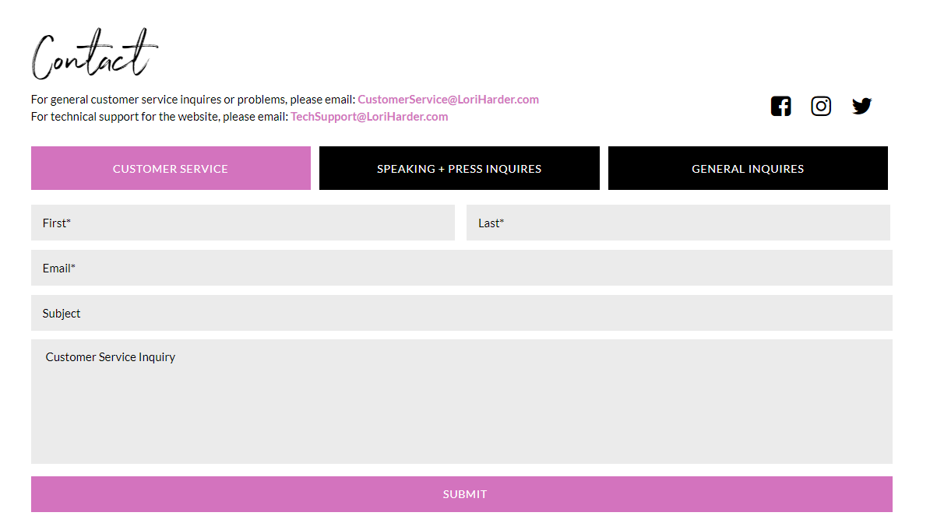
or Options on the Side like in (In the Bottom of the Page)
https://lewishowes.com/contact/
