About me Page

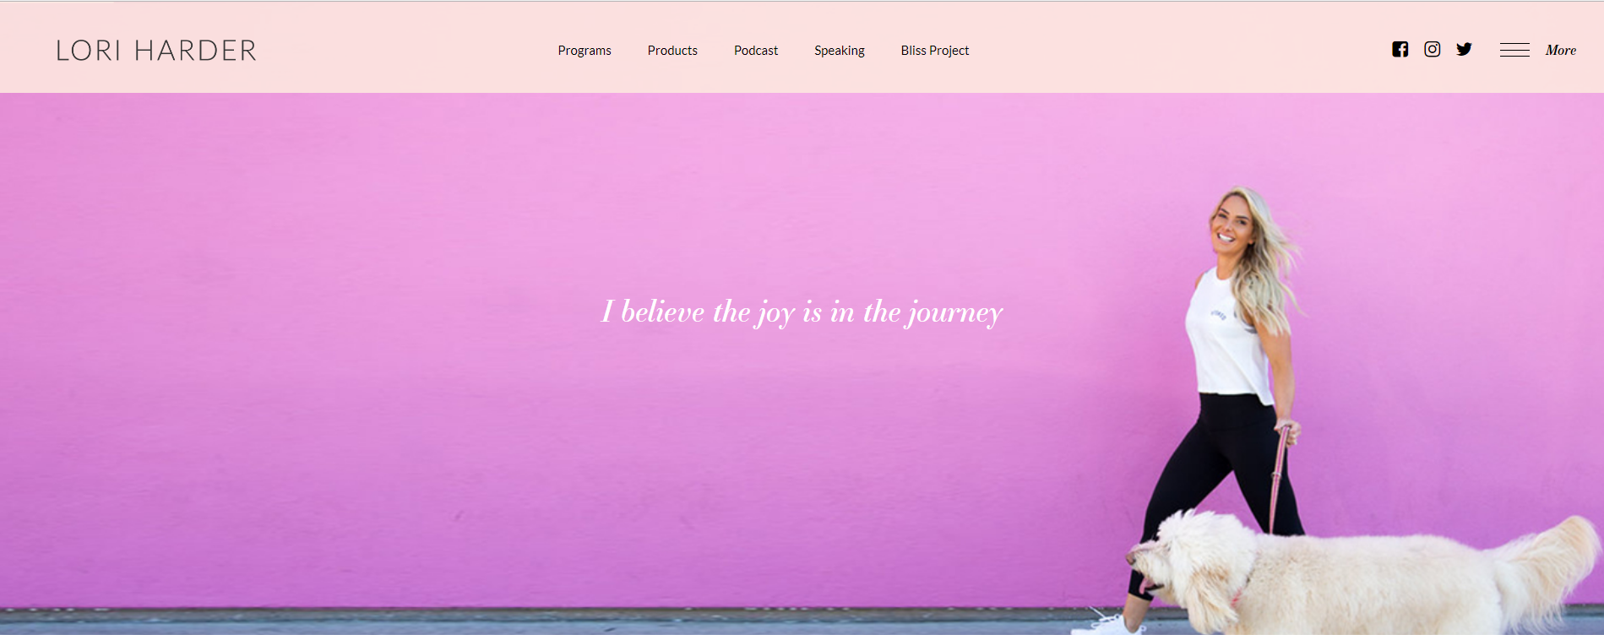
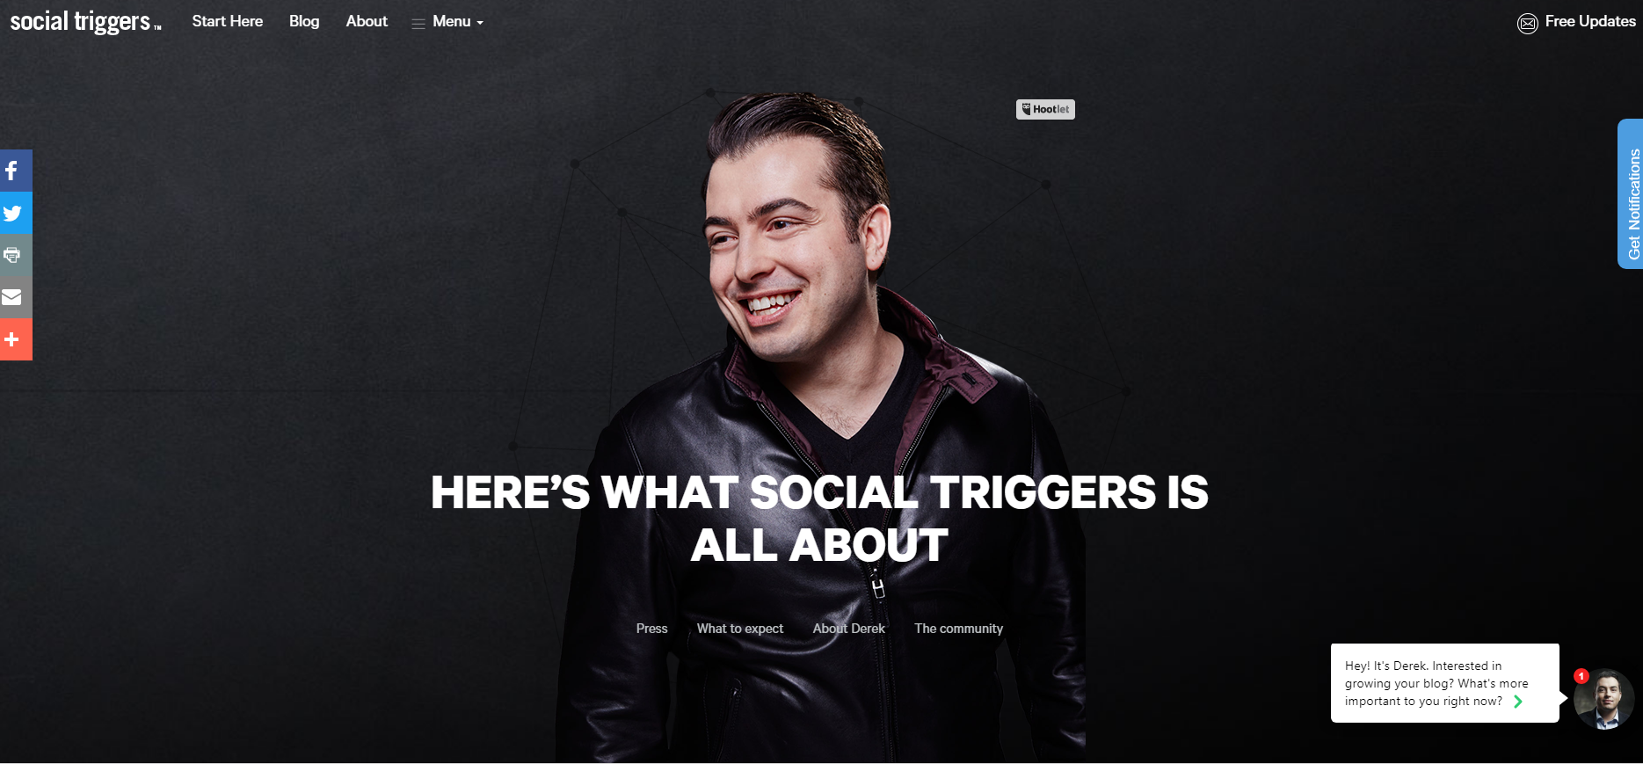
Big Hero With Text

Then a body of Text With Different Headlines and Texts – With Pictures in each Sub areas

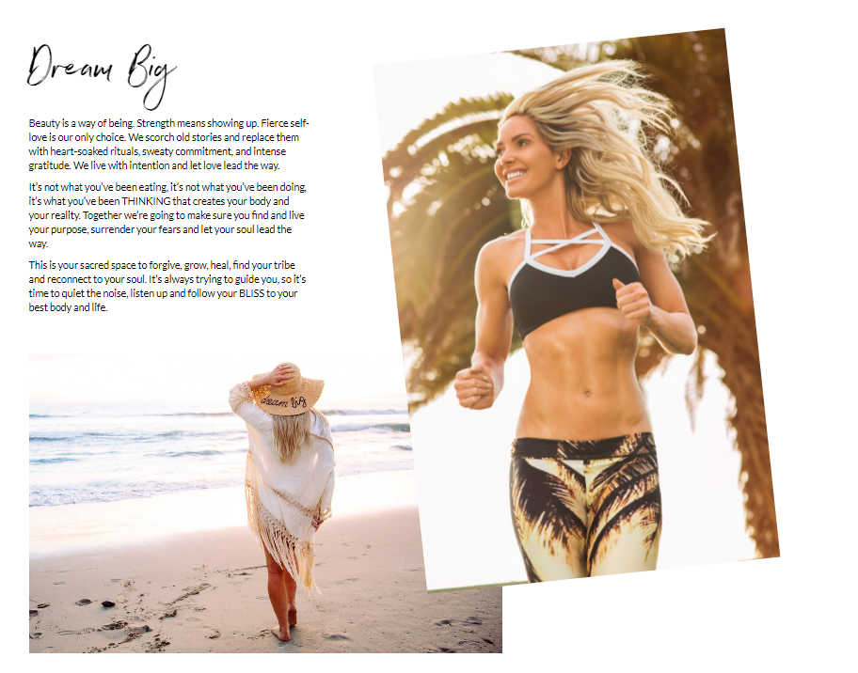
https://www.loriharder.com/meet-lori/
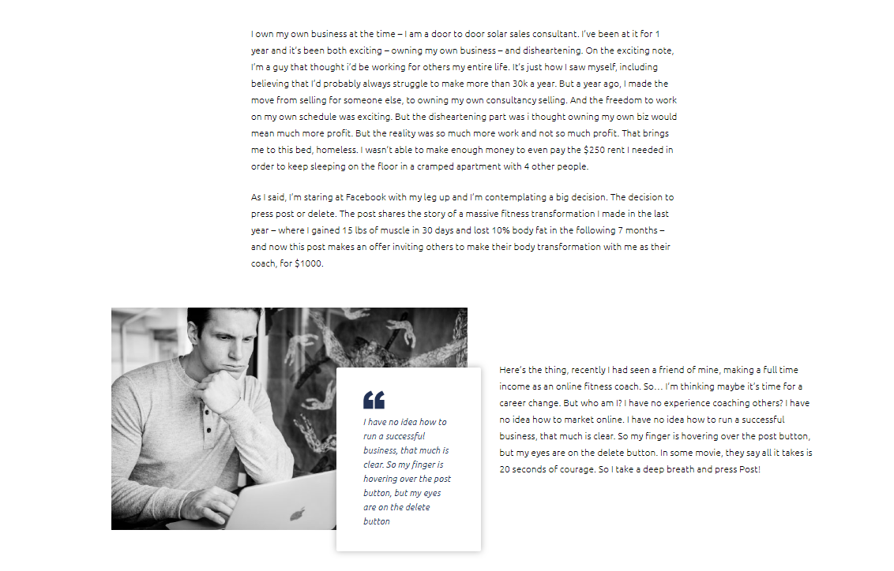
(https://www.sterlinggriffin.com/about/)
Subareas in the Body
- Hi My Name is Laura :
- My story..
- My Mission
- Who I can Help
- How can I help
- My Values & Promise

After the body

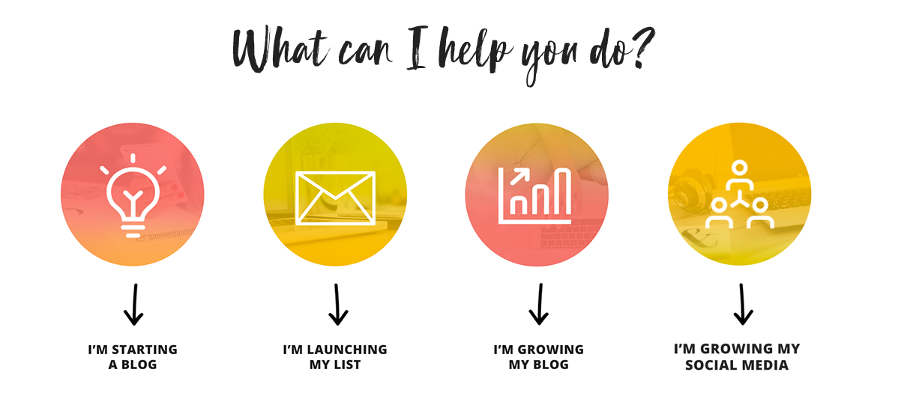

Keep the Same footer from the main page
- Instagram Plug in
- Subscription bar
- Footer

