Work With Me Page (Very important Page) aside main page
Hero Banner with Text – Plus Free Content , Subscribe bar in the Bottom.
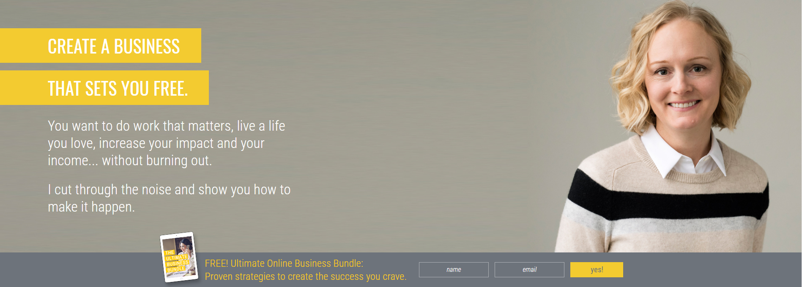

Place to put a video underneath.
https://charliepage.com/lp/social-sales-funnels/
https://theconfidenceblueprint.com/masterclass-opt-in

OR Hero Banner
And Video rectangle in the Right Side



Under the Video Area

Put a Banner similar to the one below (not in a black background) that will take you to the corresponding options


Body:

Is sub areas for each option showcased above ( With the background being one white, one that greyish background, then white then greyish)

Each subarea will have

- Heading
- Body of text
- What is offered
- For who it is
- The process
- See results
- Free training
- Apply here button

https://www.sterlinggriffin.com/work-with-me/
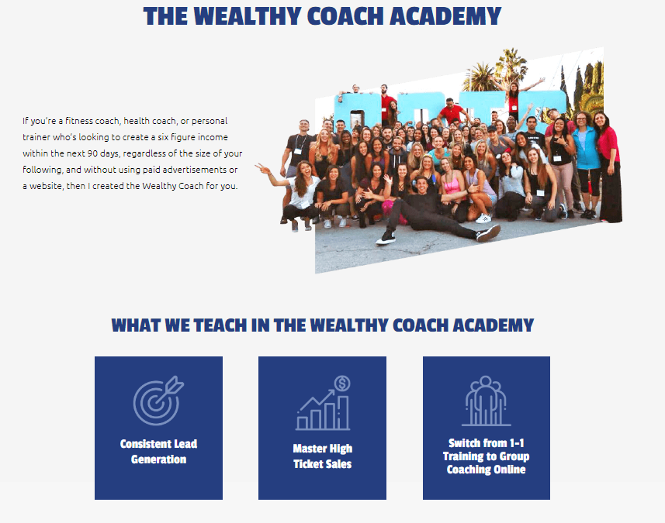
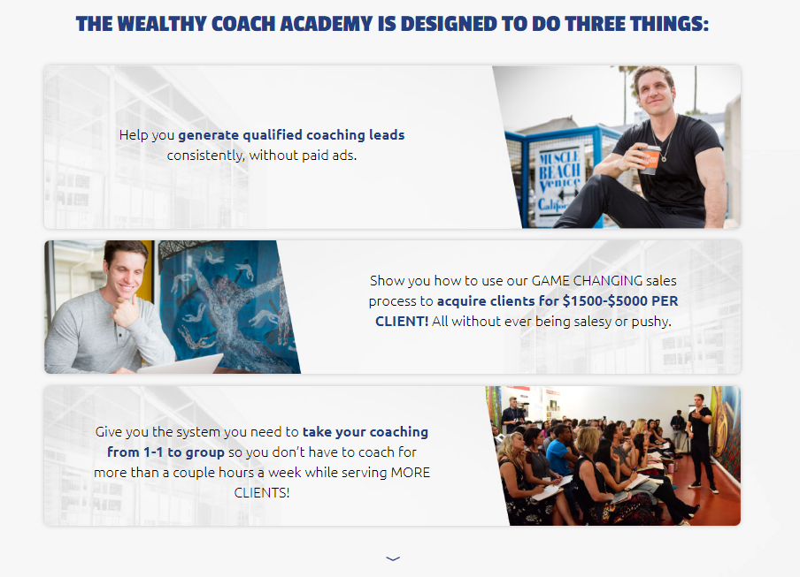
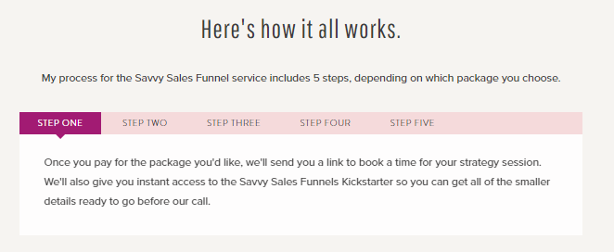
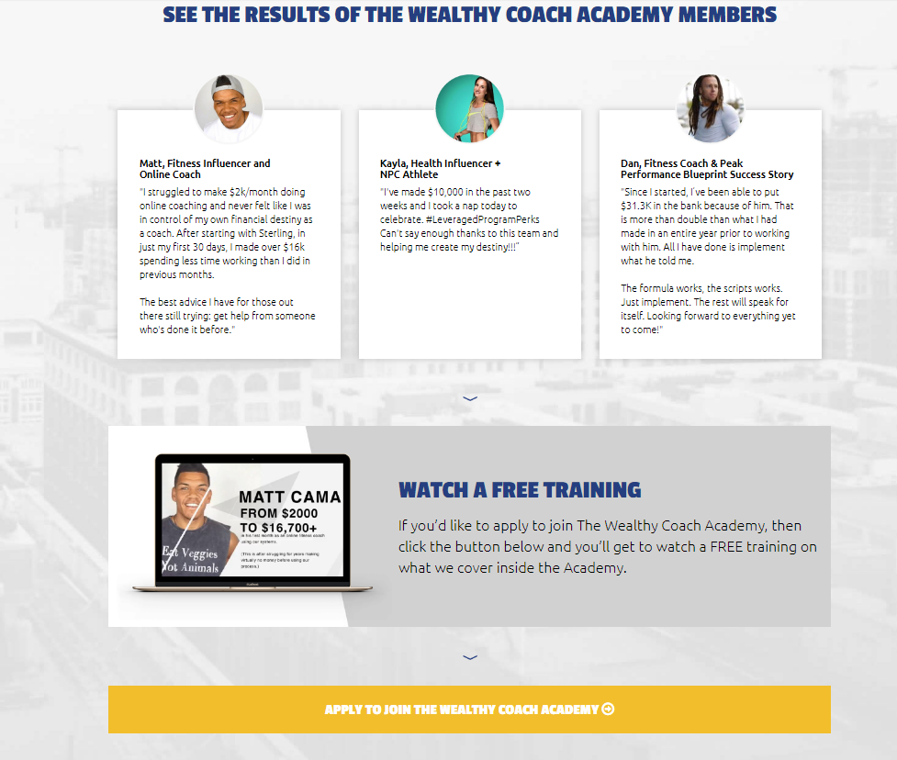

After all the Services
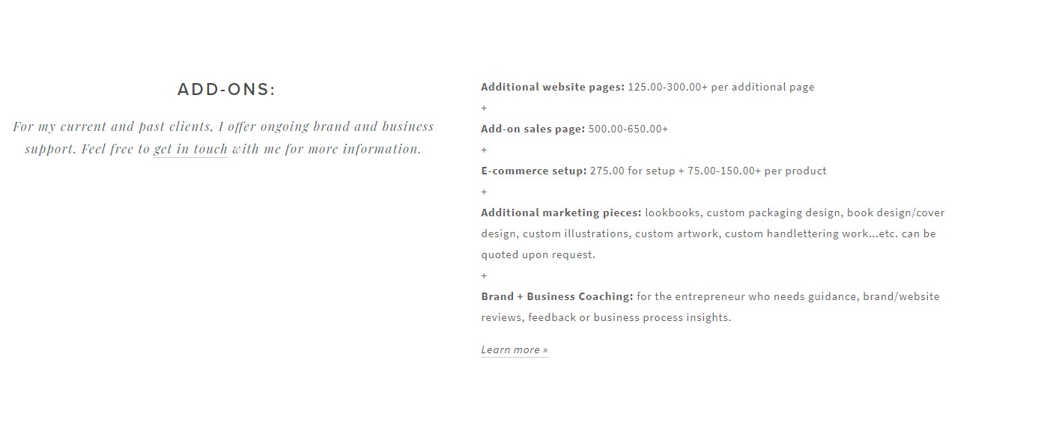
I want to have an area for “Add-ons” Something Similar to below ( You can be creative with this)

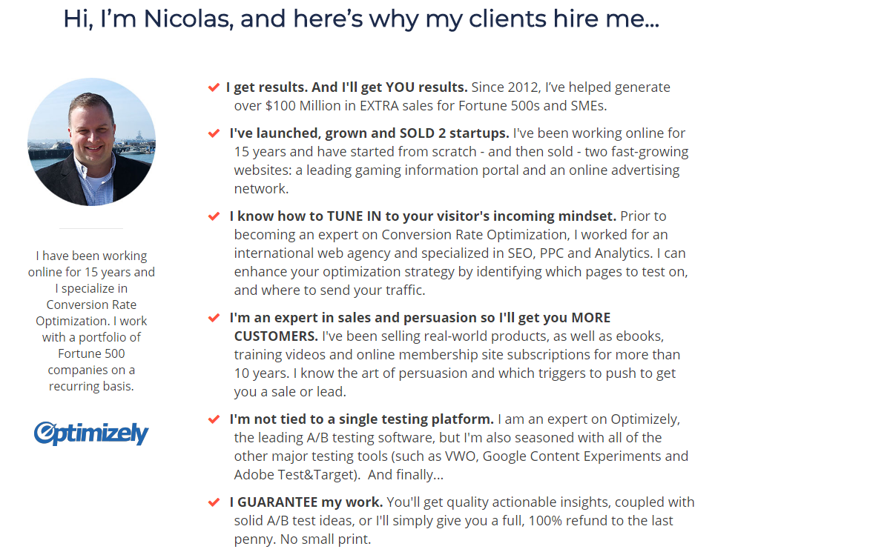
( This is only for me – Don’t worry about this) This will be used in the page that they go to to contact me after they click the apply

