Home Page Corrections
- Extend the squares so the meet the farthest right side and left side of the text above the boxes.

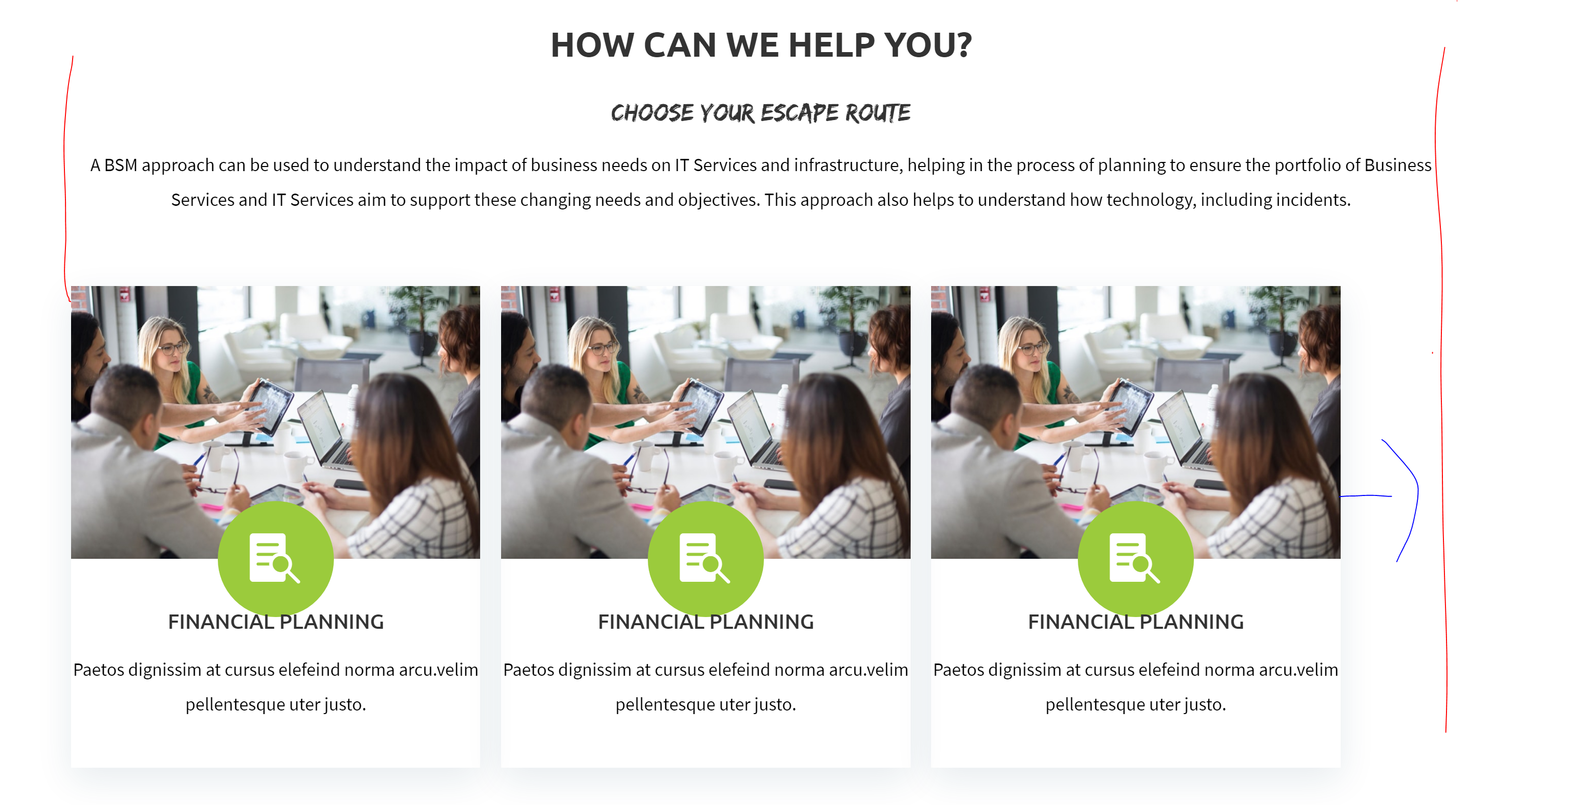

2. The Last Box toward the right has more space from the edge that the one on the farthest left box.
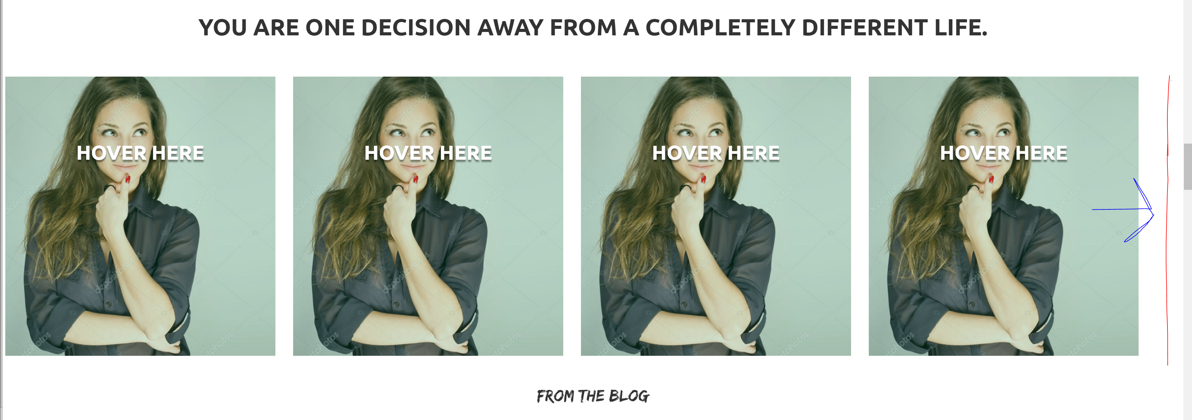

3. The space on the left side of the boxes below is bigger than the space in the right side, make it the same space size on both sides.
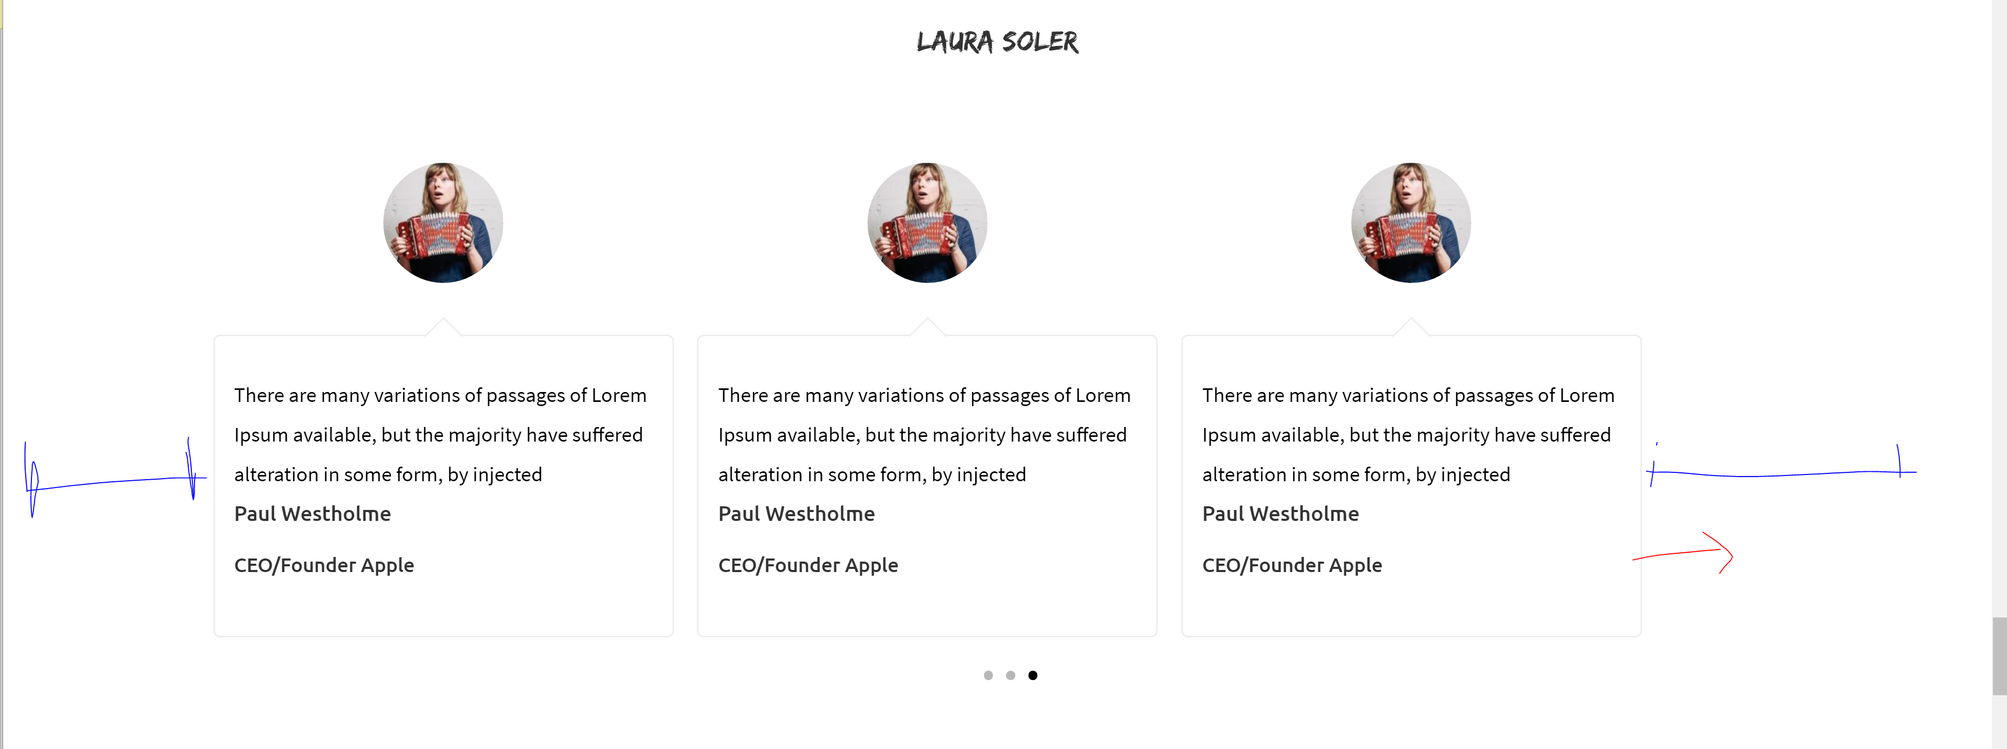

Who’s Laura Page Corrections

- Can you make the background of the bottom Tab Bar White?

- Can you make the bottom blurbs with a White Fills and The icon line and color is green? You can leave the text below it in black? Or send blurb options.
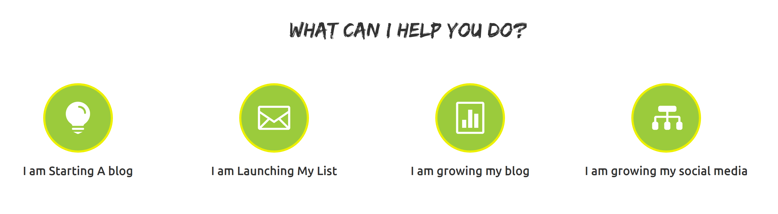

Work with me Page Corrections

- Make the 3 tab option as big as the others so they all match.
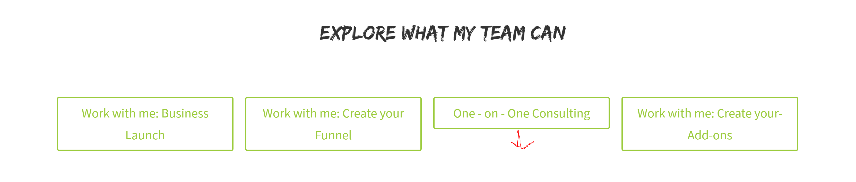
- Can the green that you use in the buttons and the square options be more like the green you use for the line above and for the “LAURA” part is LAURA SOLER shown below? The green you are using for the apply to work button and the green squares is too florescent green.
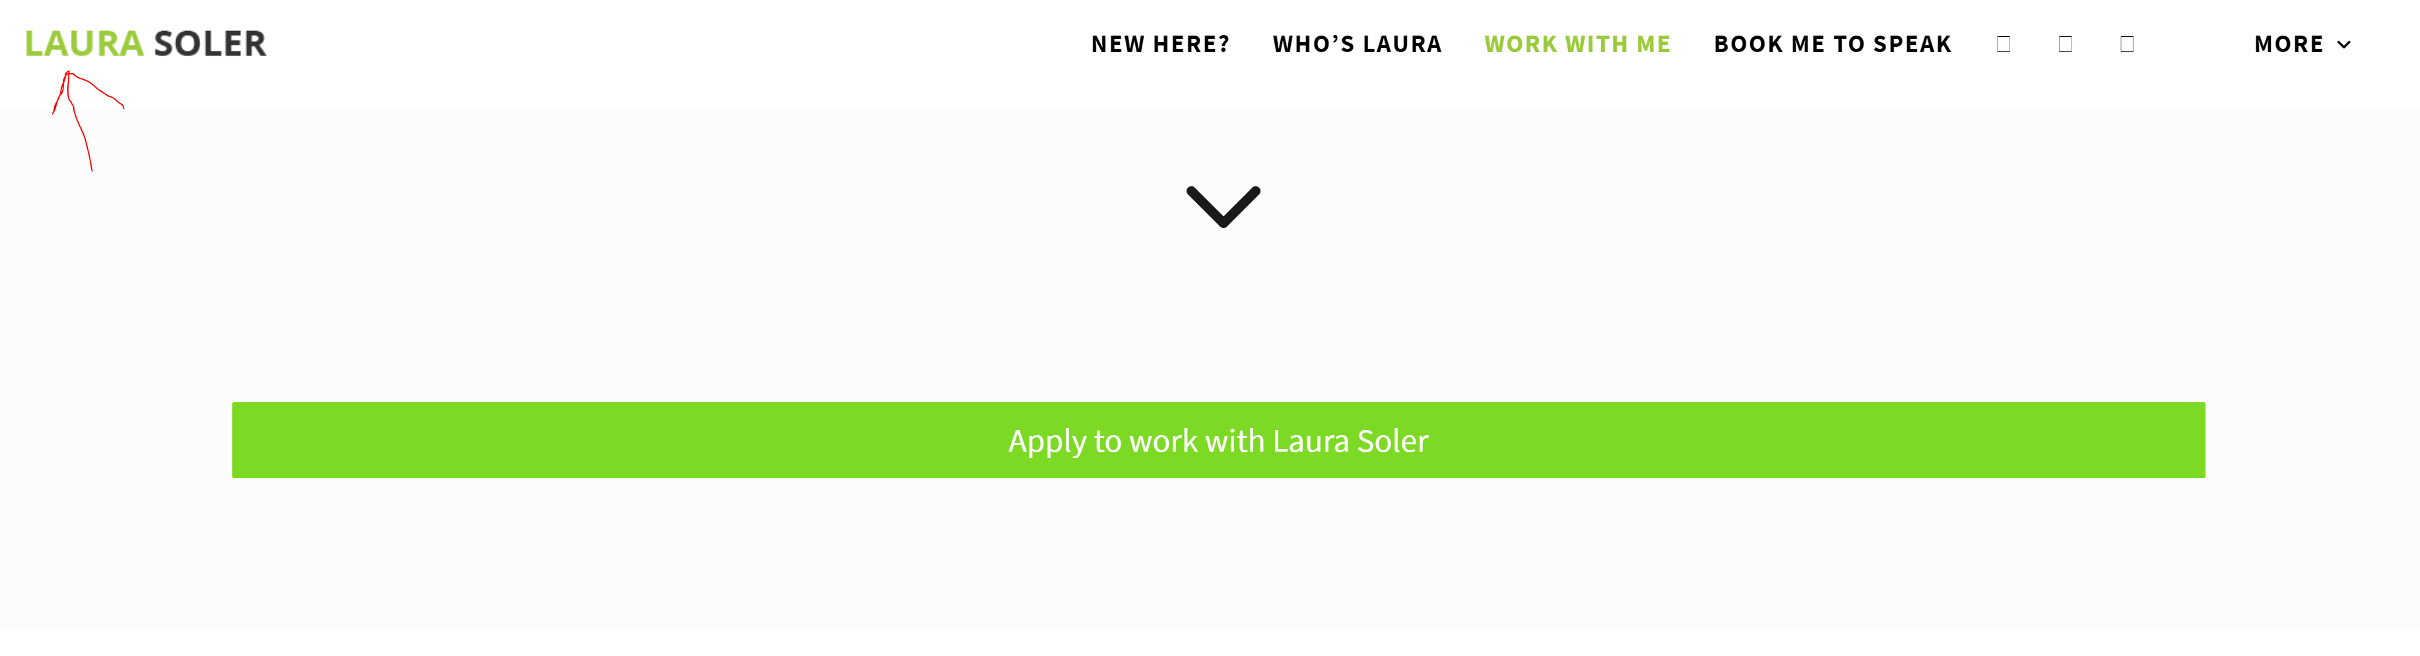

Book me to speak Page Corrections ( we forgot to do this page, but I can do it)

Blog Page Corrections

- Change the blue font color to the Greyish color

- Blog Post Page side bar , Replace the circled side bar by the side bar in the Blog home page.
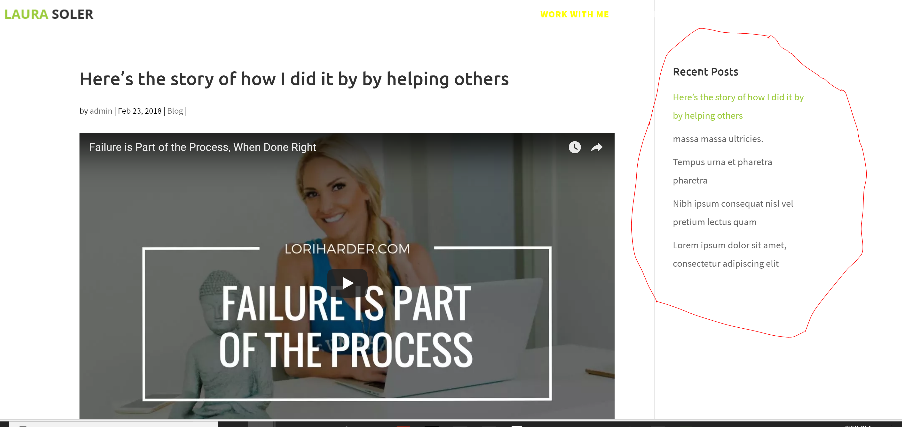

Add the circled side bar ( shown below) in the side bar of the blog post page
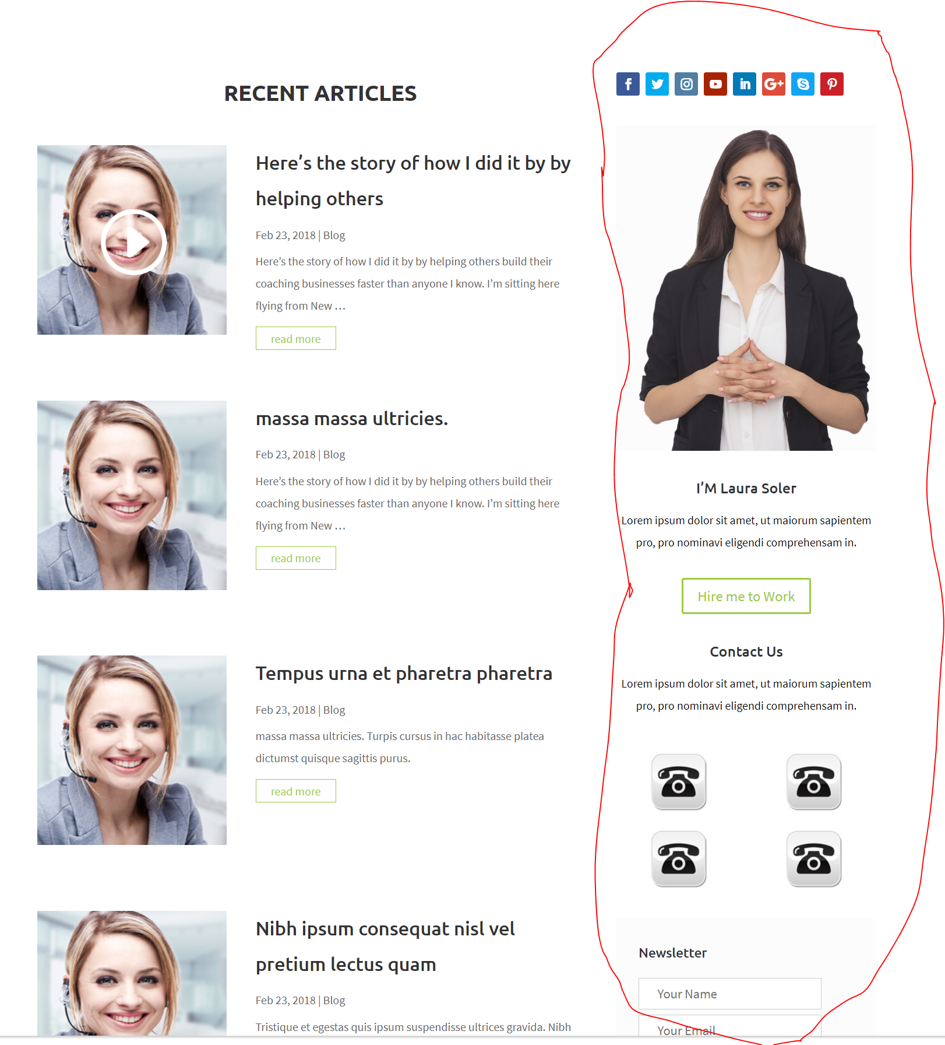

Contacts Page is Good.

