Design Crowd Task description 31/01/18
We are looking for a piece of artwork for our foyer entrance. It will be displayed on the white wall above the two armchairs.
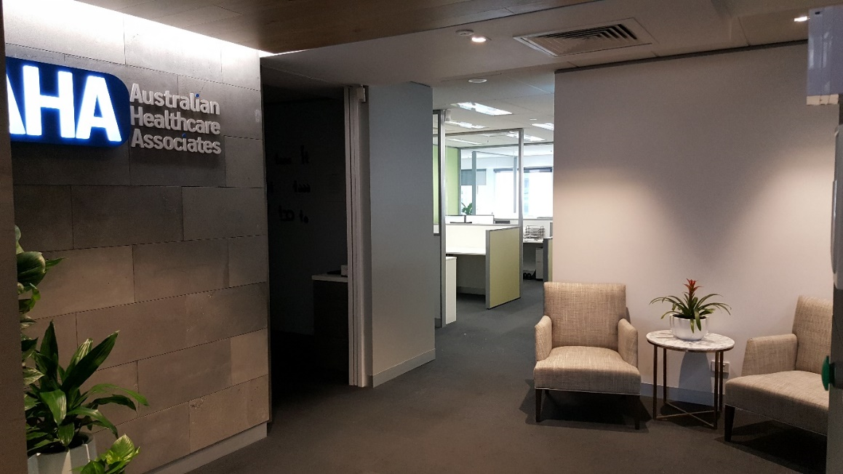
The piece could be meaningful to our organisation, but also could be of an abstract nature. We want the artwork to be striking/interesting as it is displayed in the foyer. The artwork would be printed on a canvas print with dimensions 76 cm x 152 cm.

About us:
Australian Healthcare Associates (AHA) is a consulting firm that helps state and federal governments achieve their health and human service goals. These goals shape our three main work streams: Evaluation and Advisory, Program Administration, and Quality Assurance.
Across these work streams, we have a range of projects that cover areas such as Aged Care, Dementia, Indigenous health, Mental health, Pharmaceuticals, Primary Care, Public Health, Rural Health, Education, Childhood Development, Community Care, and Disability services.
In the Evaluation and Advisory work stream, we consult with a range of stakeholders in the community including peak bodies, advocacy groups, academics, health and other professionals. We consult through surveys, focus groups, phone and email. Our aim is to collect and synthesise information so that we can provide insight about a programs appropriateness, effectiveness and efficiency.
In the Program administration work stream, we administer a range of services depending on the specific needs of the government program. Examples include: receiving and processing applications, evaluating applications by specialist staff, making funding determinations or recommendations and data analysis.
In the Quality Assurance work stream, we help develop quality standards and associated assessment frameworks for health and human services.

What should be included:
- The main colour of our logo should be included and most probably should be the most featured colour – details are in the table to the right “AHA blue” – the other colours in the table are in the AHA colour palette (for documents etc.) and could also be incorporated into the artwork/design – we are open to other colours being included too however, so long as the main ‘AHA blue’ features
- Canvas print dimensions 76 cm x 152 cm
What should not be included:
- Obvious symbolic references to medical/health industry (e.g. do not include caduceus, hospital crosses, medical equipment/devices)
Other things you may like you to consider:
- Our values
  - Quality and Excellence
  - Client Focus
  - Positive and Supportive
  - Integrity and Accountability
  - Development and Growth
- Other words that describes us. the work that we do and how we work: Nimble, Responsive, Innovation, Evaluation, Consulting, Administration, Collaboration
- The colour scheme of our foyer
- We had thought of a ‘word cloud’ (or similar) as one option, so designs of this type using the values and other words above would be welcomed
- The shape of our logo (i.e. the rounded rectangle that the ‘AHA’ sits in could potentially be incorporated in some way – either once or as a repeated pattern.
- 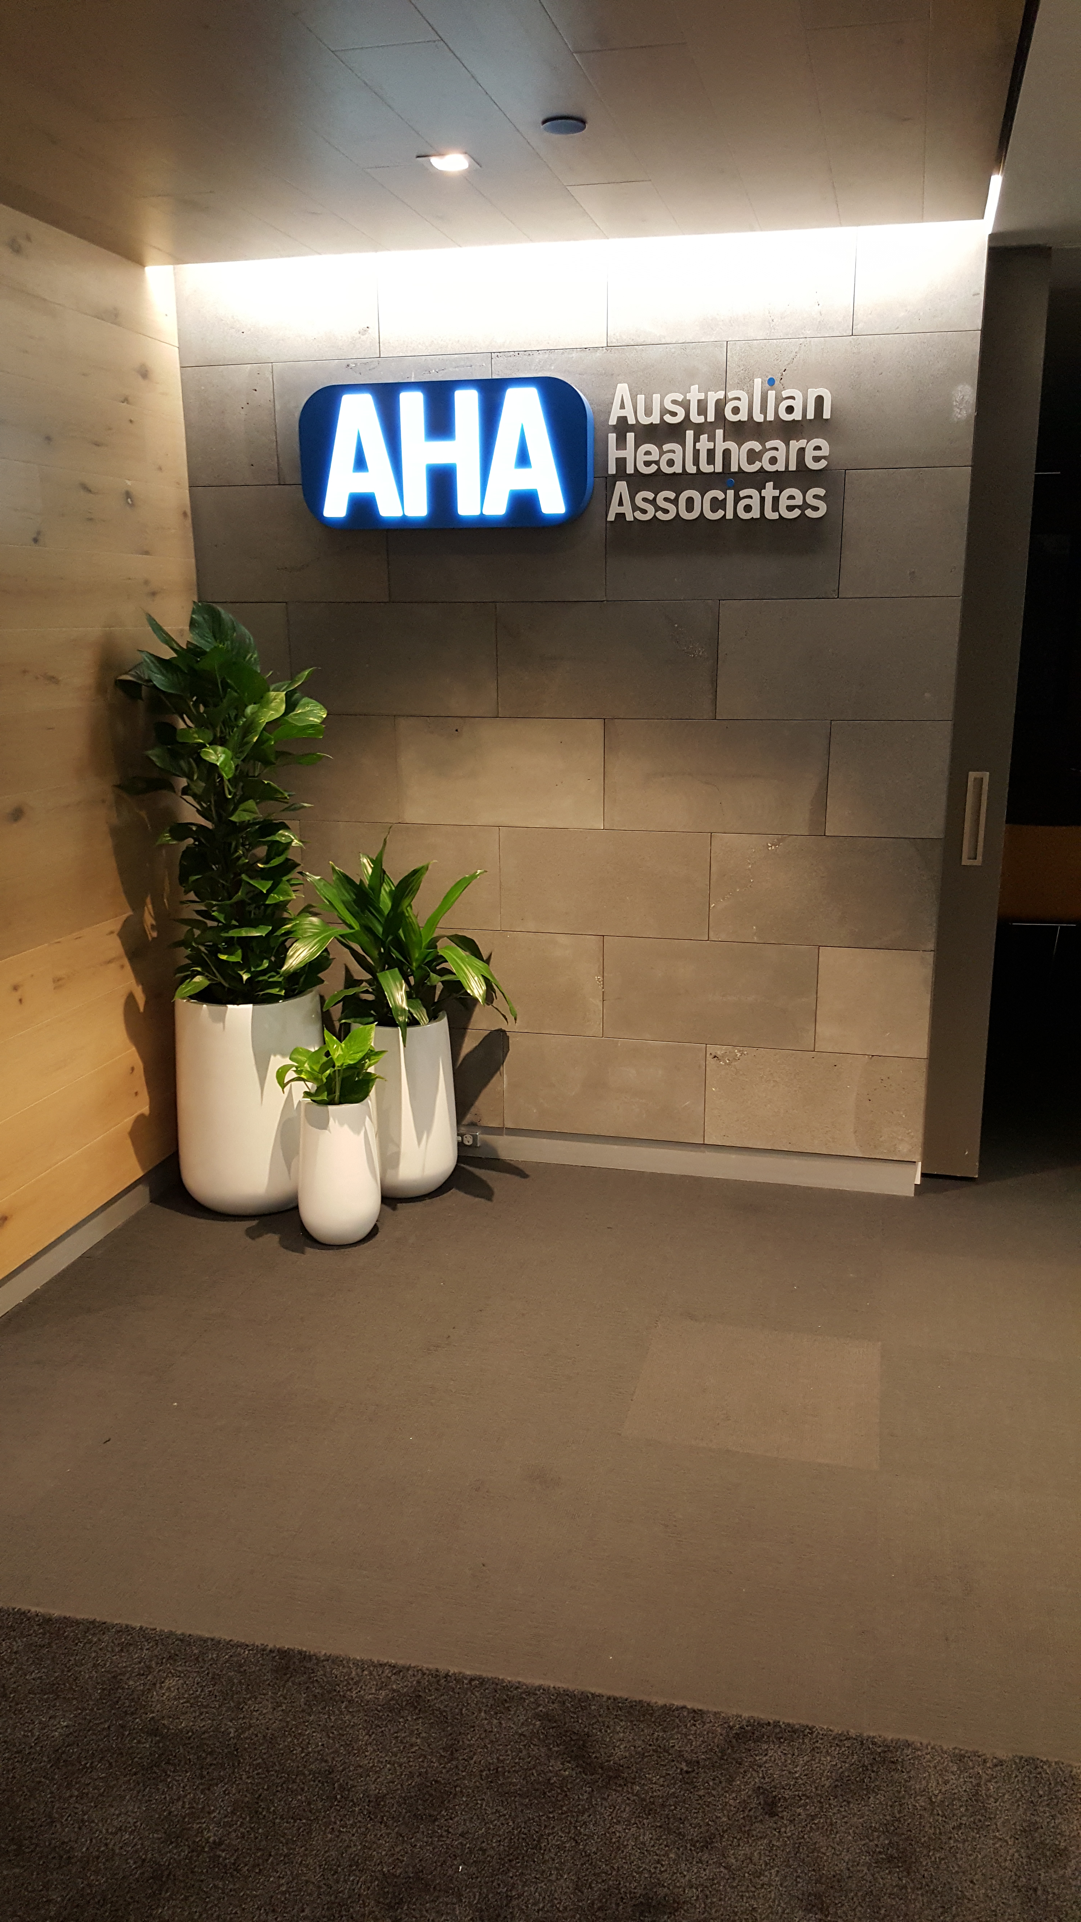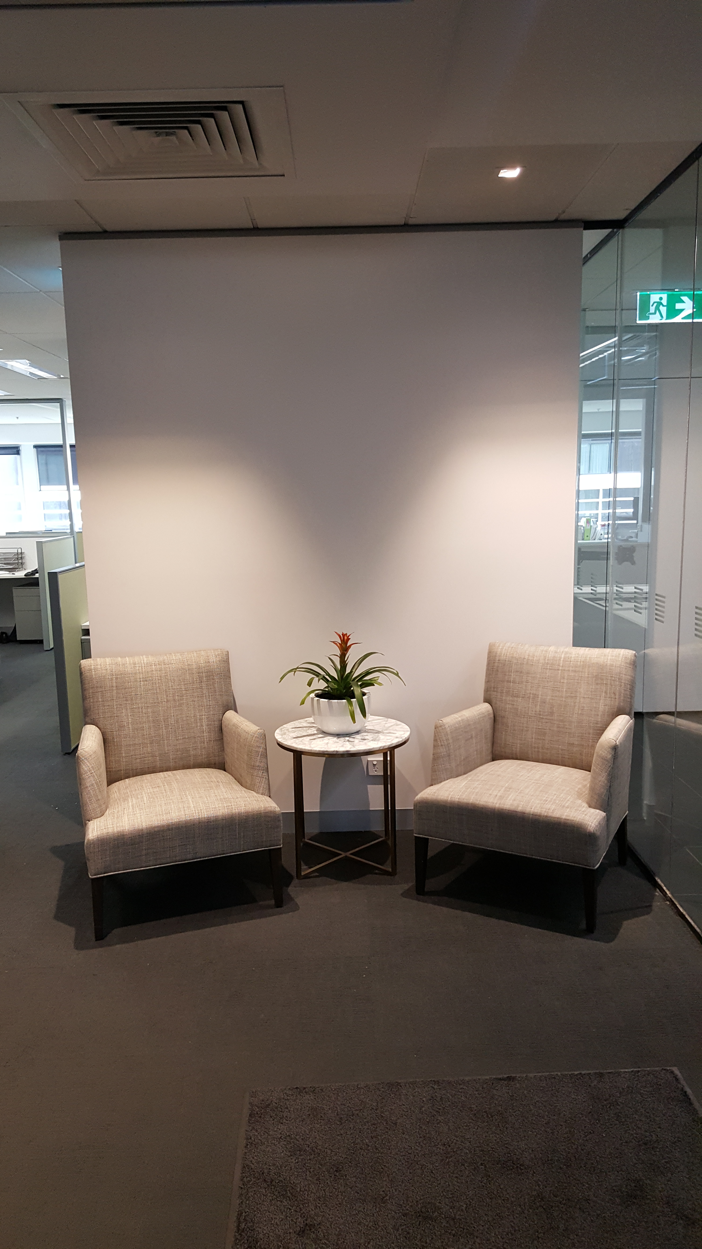We are also very keen on other out of the box alternatives – including designs which are completely abstract

