(page 1)
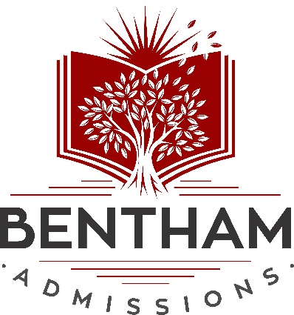

One-on-One College Admissions Counseling from Recent Graduates of America’s Best Universities, including:
- Harvard University
- Stanford University
- Yale University
- Princeton University
- MIT
- Columbia University
- University of Pennsylvania

(bottom)
www.benthamadmissions.com (929) 383-0375

(page 2)

Our Results:
At Bentham, we take a results-driven approach to college admissions. Our students get into top colleges at triple to quadruple the average acceptance rates at those colleges. The metrics we employ below are meaningful to our clients and show how the Bentham methodology can propel your child to his or her dream school.

28% Average acceptance rate of our clients at Ivy League schools (versus the national average Ivy League acceptance rate of 8%)

69% Percent of our clients who gained admission to a Top 25 university (according to US News & World Report)

93% Percent of our clients who gained admission to a Top 50 university (according to US News & World Report)

57% Percent of our clients who received a merit scholarship from a university

72% Percent of our clients who gained admission to a Top 10 Computer Science or Engineering Program (according to US News & World Report)

65% Percent of our clients who gained admission to a Top 10 Business Program (according to US News & World Report)

88% Percent of our clients who gained admission to their flagship state school

(page 3)

Our Team:
Our admission consultants are all graduates from the top universities and private schools in the country, and have extensive writing and editing experience. As recent alumni of America's top schools, they have unique insight as to what distinguishes merely adequate applications from excellent stand-out applications.

[photo]
Michael J. Egnal, Founder
The University of Pennsylvania
Georgetown Law
Prior to founding Bentham Admissions Mike worked as an attorney for a prestigious law firm advising large corporations on business transactions. After leaving his law firm, Mike dedicated several years to working on behalf of the indigent in a variety of legal capacities.
Mike's love for helping students to succeed began when he volunteered as a tutor during high school. While an undergraduate at the University of Pennsylvania, he taught local students at a public high school. Later, while earning a law student at Georgetown University, Mike excelled as a coach preparing law students for the bar examination.
Mike has more than 15 years of experience helping students at all levels conquer admissions.

Our Admissions Consultants:

[photo]
Cherline Bazile
Harvard University

[photo]
Brian Mastroianni
Brown University
Columbia University

[photo]
Chris Mascaro
Cornell University
Columbia University

[photo]
Emil Gewirzman
University of Pennsylvania

[photo]
Jamie Lynn Harris
Brown University

[photo]
Kirk Warner
UNC Chapel Hill
Yale University

[photo]
Natalia Wojcik
Harvard University

[photo]
Neil Lawrence
University of California, Berkeley

[photo]
Olivia Currin Duell
Cornell University

(page 4)
Our Services:
9th Graders, 10th Graders and 11th Graders
Here's how we maximize a student's profile through coaching during one's freshman, sophomore and junior years:
Extra-curricular Activity Strategy - Consultant advises on extracurricular activities for the student's summers and school years that will be most appealing to exclusive colleges and fit the student’s interests.
Summer Program Applications - In today’s competitive application environment summer internships are a MUST. Your consultant will help you draft summer research or other program applications to give you an edge.
Community Service Strategy - Consultant helps the student determine which community service work would be the best fit for their academic goals.

12th Graders
After we've coached you up to senior year, we next focus on the college application process which is also included in the comprehensive coaching packages:
Application Branding - Analysis of applicant’s Client Questionnaire, academic profile and extra-curricular activities to formulate a branding strategy for the application narrative and topic advice for the main college admissions essay.
School List Selection - Analysis of applicant's academic profile to select a list of reach, target and safety schools.
Common Application Personal Statement - Consultant provides the applicant with essay topic and essay content advice for the common application main essay. Consultant analyzes the common application main essay and makes substantive and stylistic revisions to the essay. Unlimited edits are provided by the consultant on the common application main essay.
Supplemental Essays - Consultant develops a strategy on topic and structure for the supplemental essays for the colleges that applicant signed up for help on. Unlimited edits are provided by consultant on the supplemental essays for the colleges that applicant signed up for help on.
Addendum - Consultant advises on Addendum explaining low grades on transcript (if applicable).
Recommendation Letter Advice - Consultant works with the applicant to plan a strategy around recommendation letters, including identifying possible recommenders and how to approach the recommenders.
Final Application Review - Final analysis of the Common Application to ensure the completeness and accuracy of all application materials.
Interview Preparation - Consultant will coach the student for their college interviews and conduct a mock interview with the student.
Financial Aid Assistance - Consultant will guide student to the appropriate resources for financial aid.

