The website will be include 3 pages, a homepage, search to find a provider, and a blog

Top Menu
Home
Find a healthcare provider
Join our network
Newsletter
Blog

I. Homepage
1). Please incorporate our logo and network image into our splash page.

Network image – please create your own vision of this image
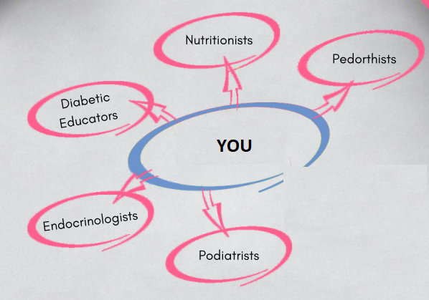
2). Please add Mission statement in the splash image or right beneath the image.
Mission statement
“At the Diabetes Advisory Network, our focus is to connect newly diagnosed and existing patients with diabetes to a network of available professionals who possess the knowledge to manage your diabetes.”

3). New Section

Diabetes Facts and Statistics

Diabetes occurs when your blood glucose, also called blood sugar, is too high. High blood glucose can cause health problems over time. The main types of diabetes are type 1, type 2, and gestational..
- Total: An estimated 30.3 million people have diabetes (9.4 percent of the U.S. population)
- Diagnosed: An estimated 23.1 million people have been diagnosed with diabetes (7.2 percent of the U.S. population)
- Undiagnosed: An estimated 7.2 million adults, ages 18 years or older are undiagnosed (23.8 percent of people with diabetes)

4). New Section

Our network of healthcare providers will help you manage your diabetes.

Pedorthist - a professional who has specialized training in foot evaluation and modification of footwear and supportive devices such as inserts, to address conditions which affect the feet and lower limbs caused by disease, defect or injury.

Diabetic Educator - a health professional who possesses knowledge of and experience in diabetes prevention, pre-diabetes, and diabetes management. Their main goal is to achieve individualized behavioral and treatment goals that reduce risks and optimize healthy lifestyles.

Endocrinologist - a physician who specializes in treating disorders of the endocrine system, such as diabetes.

Nutritionists - an expert in dietetics; which includes human nutrition and the regulation of diet. A dietitian alters their patient's nutrition based upon their medical condition and individual needs.

Podiatrist - a doctor qualified and trained to diagnose and treat conditions affecting the foot, ankle, and related structures of the leg.

5). New Section

Did you know that the government has setup programs to help educate, manage, and prevent your diabetes?

1).Pedorthist Services - Diabetic Shoes - the furnishing and fitting of either one pair of custom-molded shoes and inserts or one pair of extra-depth shoes each calendar year. Medicare also covers 2 additional pairs of inserts each calendar year for custom-molded shoes and 3 pairs of inserts each calendar year for extra-depth shoes. Medicare will cover shoe modifications instead of inserts.
2). Diabetic Educators - Diabetes self-management training (DSMT) – The purpose of Medicare’s DSMT benefit is to give beneficiaries the knowledge and skills needed to adopt diabetes self-care behaviors and to make lifestyle changes needed to improve health outcomes. Beneficiaries are covered for a total of 10 hours of initial training within a continuous 12-month period and 2 hours of follow-up training each year after that, as needed. Courses are offered

3). Nutritionists - Medical Nutrition Therapy - often abbreviated as MNT, is an evidence-based medical approach to treating certain chronic conditions through the use of an individually-tailored nutrition plan. This nutrition plan is ordered and approved by a primary care physician and implemented by a Registered Nutritionist

4). Podiatrist – Foot exams - podiatrist services such as foot exams every 6 months, foot injuries or diseases (like hammer toes, bunion deformities, and heel spurs).

6). New Section – form
Sign up for our newsletter

First Name:
Last Name:
Email:

7). New section - form

Healthcare professional - Sign up to be part of our network
First Name
Last Name
Phone
Email
Profession: Endocrinologist, Diabetic Educator, Endocrinologist, Nutritionists, Podiatrist, Pedorthist

II. Find a healthcare provider

This page should include a form for the user to search for a healthcard profession

Profession: Endocrinologist, Diabetic Educator, Endocrinologist, Nutritionists, Podiatrist, Pedorthist

City:
State:
Zip Code:

The results should be similar to healthgrades.com
https://www.healthgrades.com/usearch?what=Family%20Medicine&where=West%20Palm%20Beach%2C%20FL%2033401&city=West%20Palm%20Beach&state=FL&pt=26.705811%2C%20-80.064783&zip=33401&pageNum=1

III. Blog

Please make a blog page. I do not have any requirements. Please add the best blog site you can make.

