The Duarte Team – Home Loan Group[logo] – Powered by Caliber Home Loans[logo]

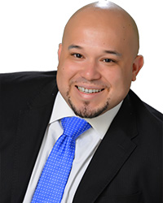
Ivan Duarte
Producing Branch Manager
Caliber Home Loans, Inc – NMLS 32559
Ivan.Duarte@caliberhomeloans.com
(407) 374-5050 Office (855) 844-8232 Fax

I have over 15 years of experience in Mortgage Planning. I rank in the top 1% of loan originators in the country. I pride myself on making the home buying process as smooth as possible. I will guide you through the mortgage process and look forward to helping you with your transaction. My team has been awarded with the Circle of Excellence award and CEO Club for being in the top 5 teams in the country having helped over 700+ families achieve the dream of home ownership between the years 2016 and 2017 and counting.

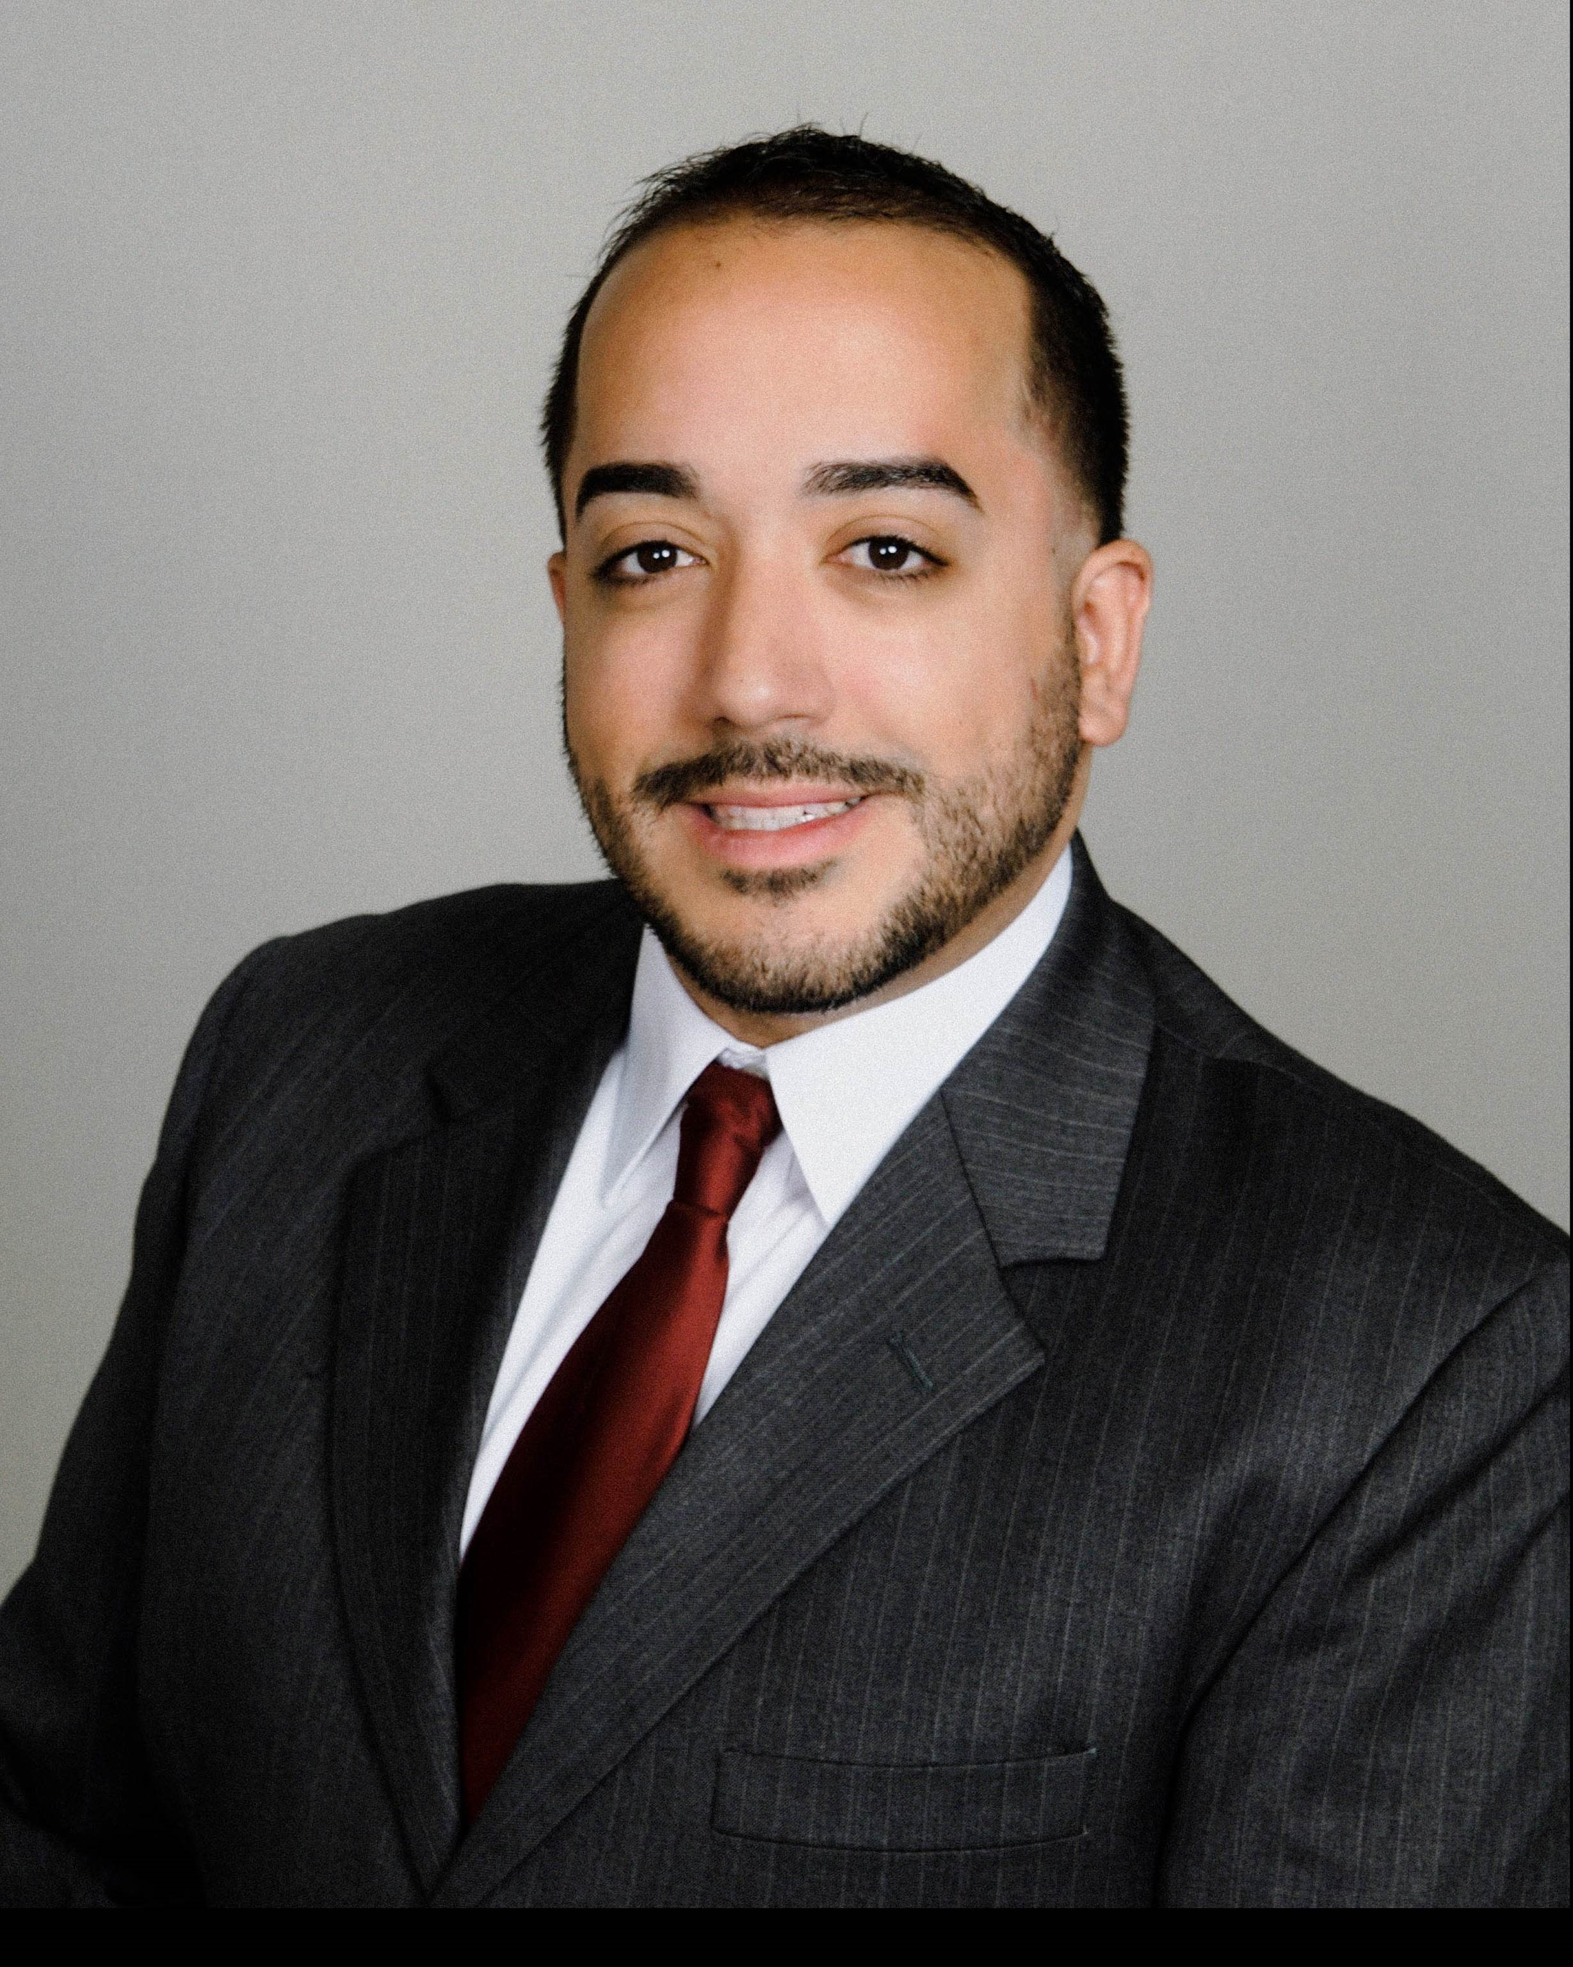
Cesar Robles
Loan Partner I - NMLS ID 1648462
Cesar.Robles@caliberhomeloans.com
(407) 476-7202‬ Direct/Text
I am able to help customers with pre-qualifications and pre-approvals and keep the applicants i and real estate agents informed during the application process.

Juan Farias
Loan Processor – NMLS ID: 1370005
Juan.Farias@caliberhomeloans.com
(407) 906-9294‬ Direct/Text
I verify loan documents including income, credit, appraisal and title insurance, preparing the loan application for submittal to underwriting. I review file documentation and make sure all items needed to ensure a smooth mortgage transaction are requested.

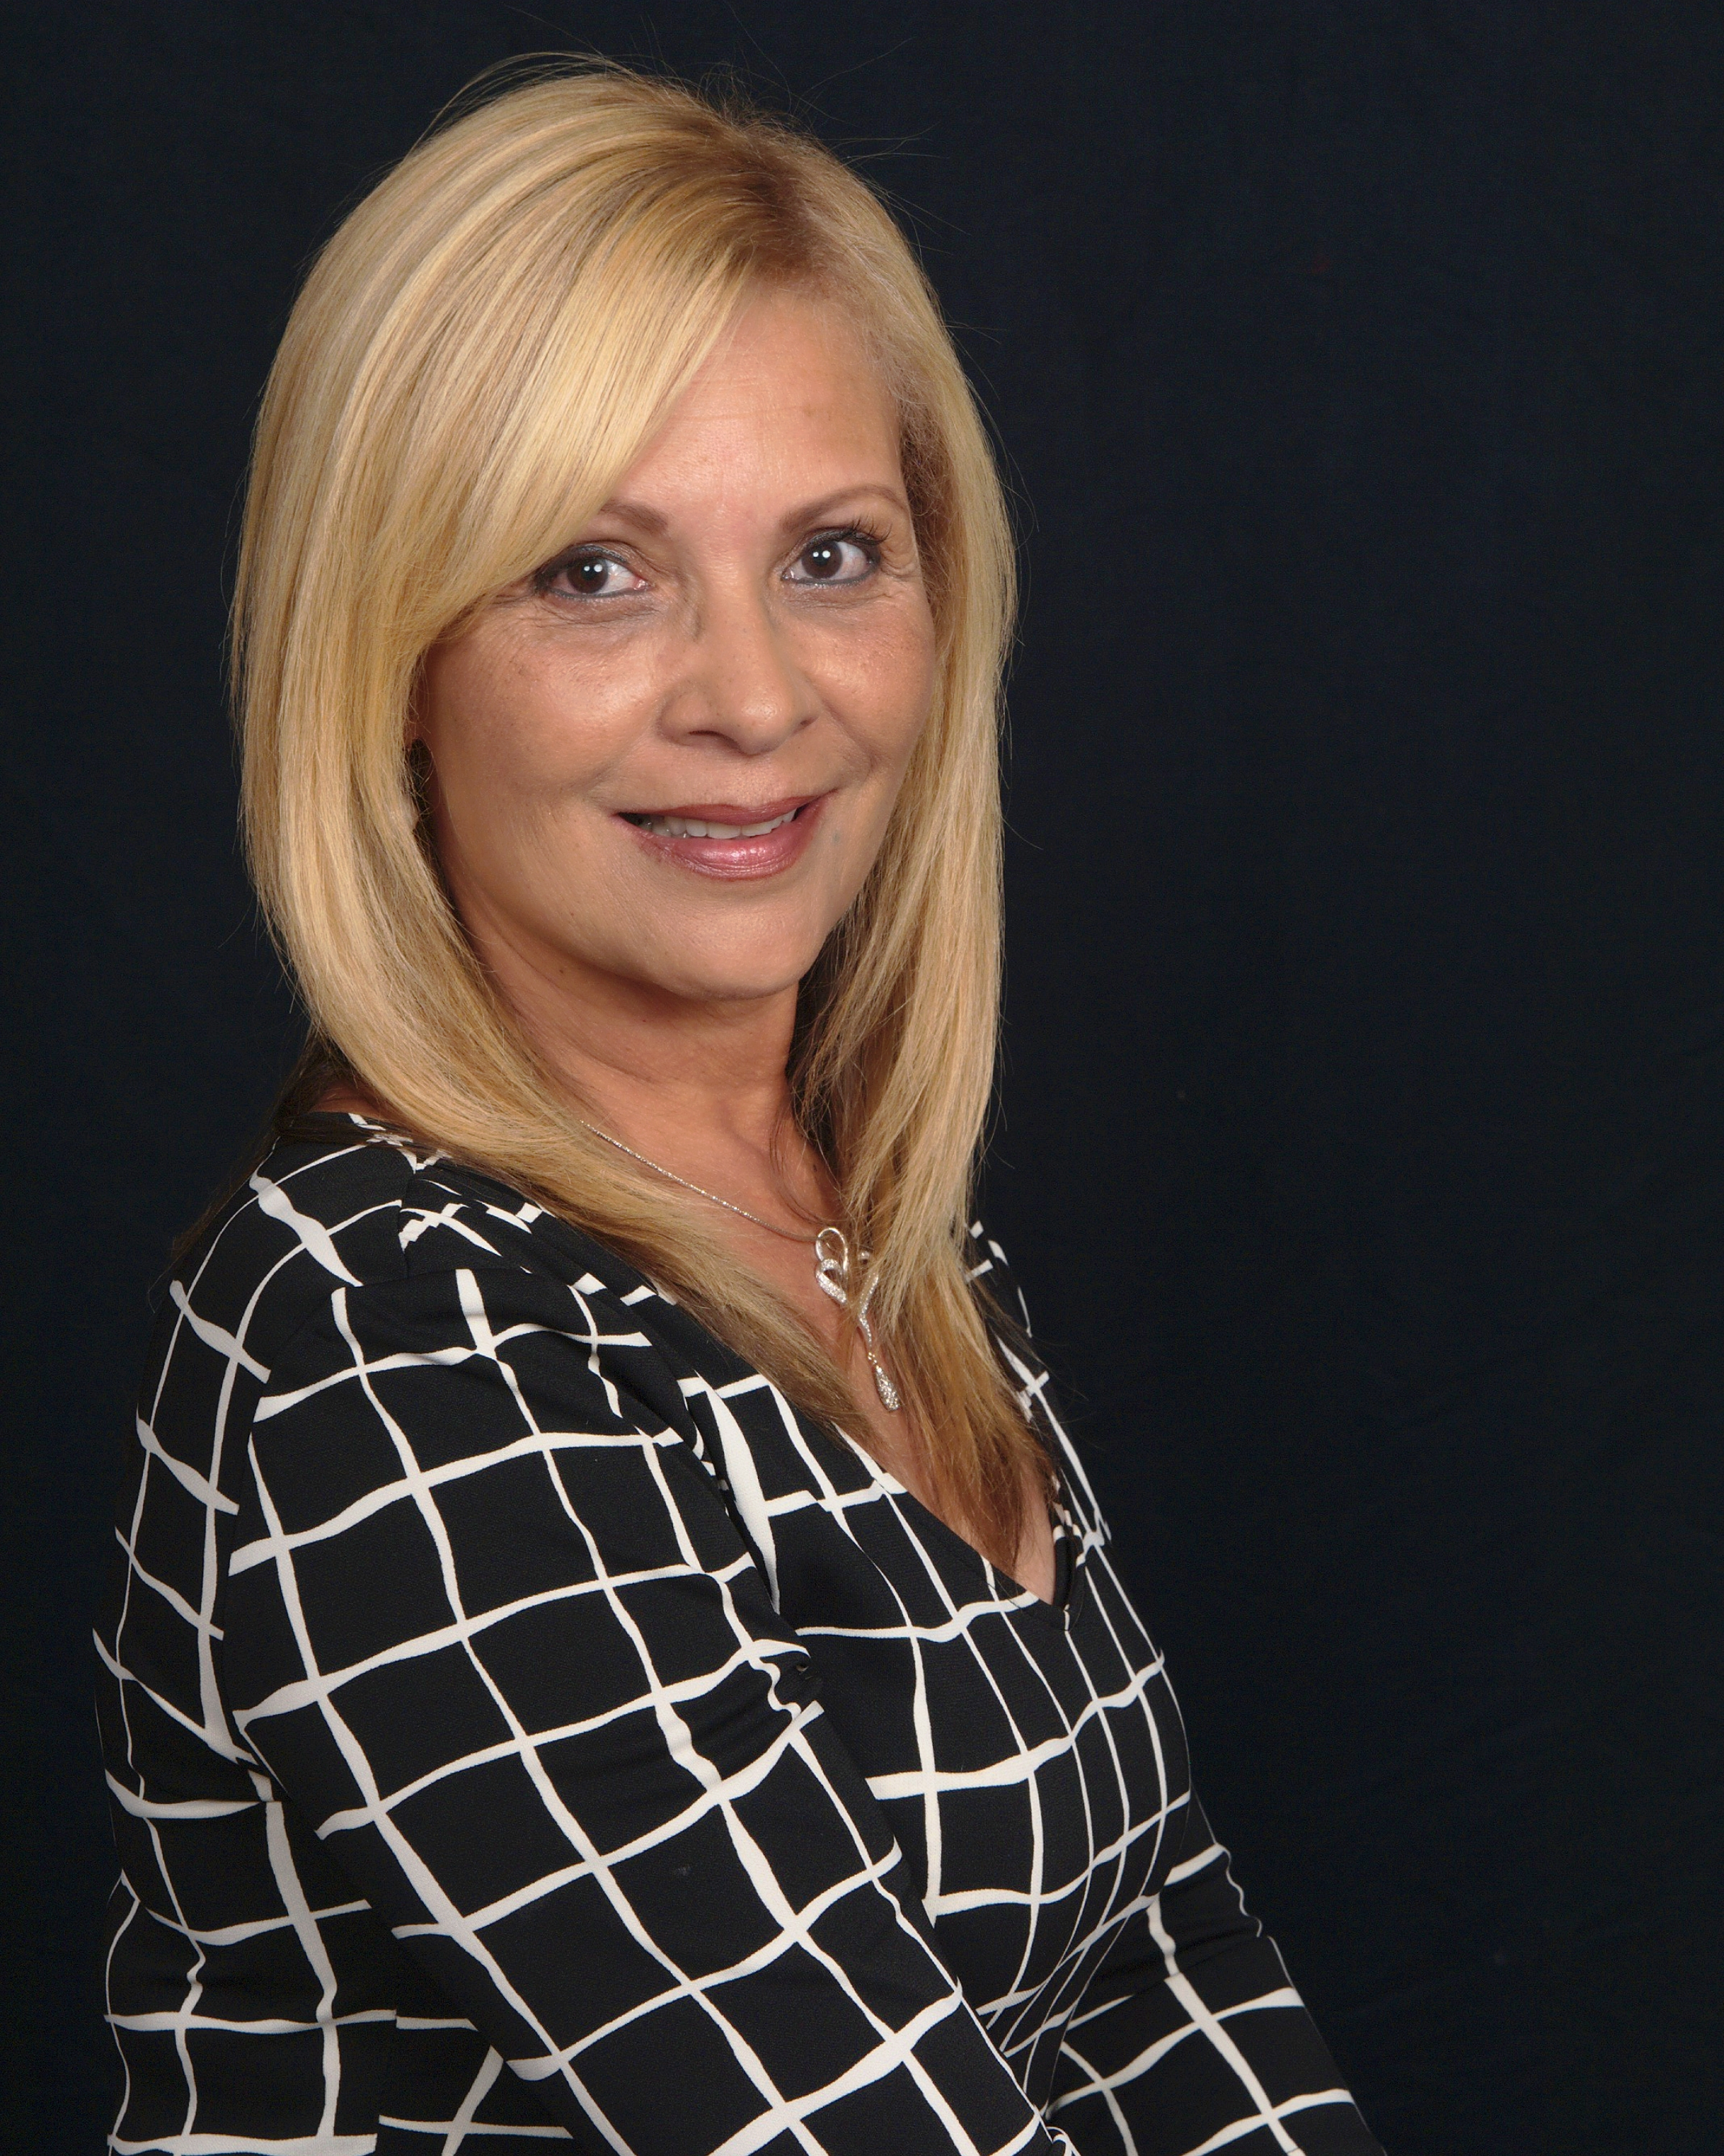
Carmen Vliet
Closing Coordinator/Team Leader – NMLS 1321022
Carmen.Vliet@caliberhomeloans.com
(631) 255-1151‬ Direct/Text

I guide our clients with any conditions or stipulations set by underwriting post loan conditional approval. I make sure all the transaction deadlines are met and help with preparing the loan for closing. I have over 20 years of experience with mortgage operations. I am committed to making sure all transactions close on time.

Footer: Caliber Home Loans, Inc. and any above mentioned companies are not affiliated.
Caliber Home Loans, Inc., 1525 S. Beltline Rd Coppell, TX 75019 NMLS ID #15622 (http://www.nmlsconsumeraccess.org/EntityDetails.aspx/COMPANY/15622). 1-800-401-6587. Copyright © 2018. All
Rights Reserved. This is not an offer to enter into an agreement. Not all customers will qualify. Information, rates, and programs are subject to change without prior notice. All products are
subject to credit and property approval. Not all products are available in all states or for all dollar amounts. If you are refinancing your existing loan, your total finance charges may be higher
over the life of the loan. Other restrictions and limitations apply.

