Front page – Full screen

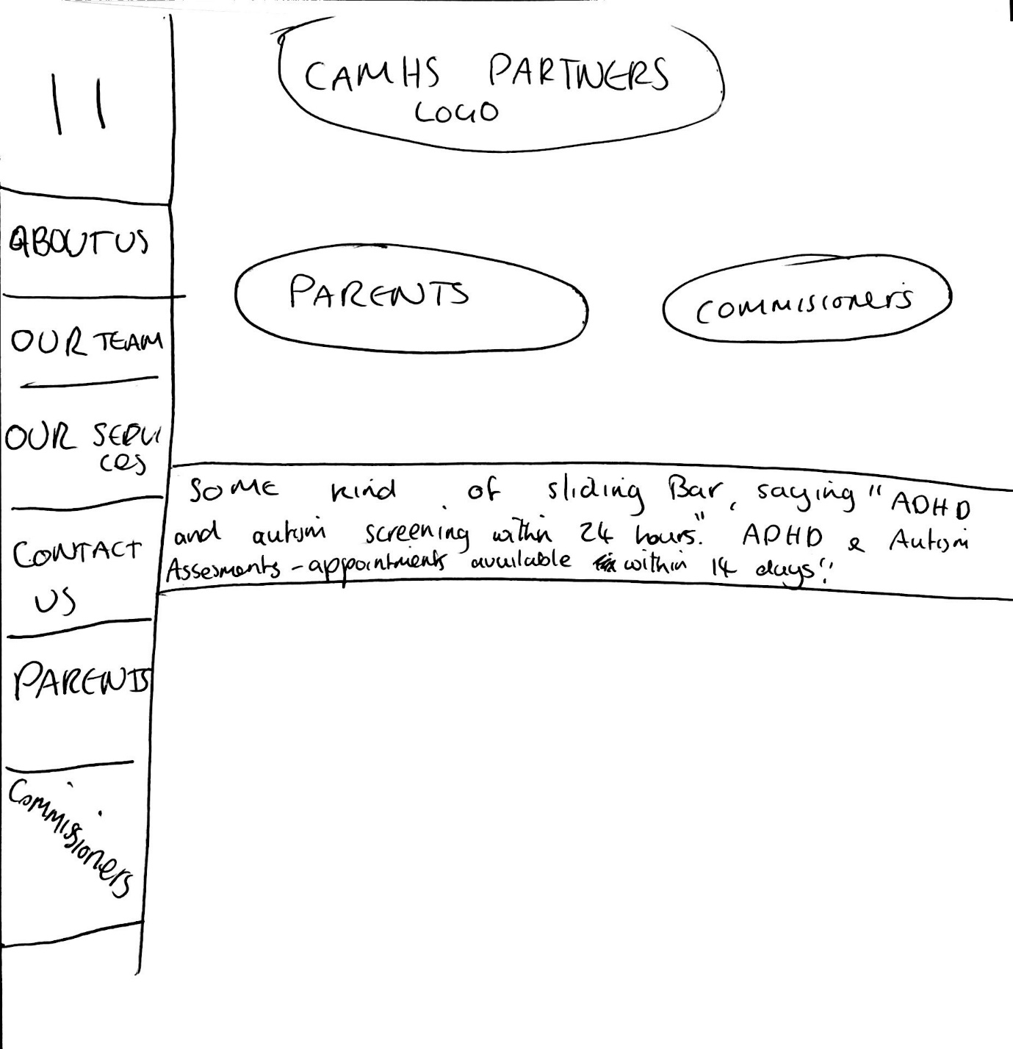

Can we add Blog, Forum to the categories on the left please?

Notes – Contact us should go on the bottom –

Content each category:

About Us
CAMHS Partners was formed with a vision to provide the very best CAMHS assessments, therapy and aftercare. We have unique modern pathways that allow children and adolescents to be seen quickly by handpicked clinicians that are highly skilled and some of the best in their chosen field. We have a turnaround time of 24 hours for all ADHD and ASD screening, and aim to have see any child for a full ASD, or ADHD assessment within 14 days. If your child has been diagnosed with ADHD or ASD we offer the very best post diagnosis support to both the child and family.

The Team

Here I will be adding photo’s and a short description of each staff member, so maybe just mock up some professional photos and a few sentences for 4 Staff so we can get an idea for the layout.

Parents

Are you looking for a thorough, efficient, highly accurate screening or assessment for your child? We use both electronic and paper based screening tools so that we can be flexible to what works better around you. We will deliver you the results within 24 hours after our screening tools have been completed, and will make recommendations based around these results.

Should you opt to have a full ADHD / ASD assessment we aim to have appointments available with 14 days. All of our clinicians have been specifically chosen as they are some of the best in their specialist field.

We offer the following assessments:
- ADOS
- ADI-R
- (few more to add at a later date)

Commissioners
Are you looking to reduce waiting times or commission part of your ADHD or ASD pathway? We have a proven track record in providing robust, high quality, patient focused assessment and post-assessment treatment. We can come take referrals at a variety of stages and are able to offer the highest levels of service and exceptional value.
Call us today to discuss how we can be supporting part of your service.

Our Services

When over our services on the home scren there will be sub categories:

ADHD
ASD
CBT
EMDR
Family Therapy

ADHD
We have a multidisciplinary team that has been selected due to their vast experience and reputation of being some of the best in their field. The team consists of a Clinical Psychologist, Consultant Psychiatrist and Nurse who will work collaboratively to provide a robust, thorough and highly accurate assessment. Should your child need post treatment, we will recommend and offer support that is best suited to the child and family.

Services offered are:
- Service 1
- Service 2
- Service 3
- Service 4
- Service 5
- Service 6
Autism (ASD) -
We have a multidisciplinary team that has been selected due to their vast experience and reputation of being some of the best in their field. The team consists of an Assistant Psychologist, Clinical Psychologist, Consultant Psychiatrist and a Nurse who will work collaboratively to provide a robust, thorough and highly accurate assessment. Should your child need post treatment, we will recommend and offer support that is best suited to the child and family.

Services offered are:
- Service 1
- Service 2
- Service 3
- Service 4
- Service 5
- Service 6

CBT
We can offer high quality that will be carried out by either a qualified psychological wellbeing practitioner or a BABCP accredited CBT therapist. Our therapists are trained to work with the following:
- Anxiety and Depression
- Eating Disorders
- Trauma
- Body Dysmorphia
- Addiction

EMDR
We can offer high quality that will be carried out by fully qualified EMDR therapist. Our therapists are trained to work with the following:
- Anxiety and Depression
- Eating Disorders
- Trauma
- Body Dysmorphia
- Addiction

Family Therapists
We can offer high quality that will be carried out by fully qualified Family Therapists therapist. Our therapists are trained to work with the following:
- Anxiety and Depression
- Eating Disorders
- Trauma
- Body Dysmorphia
- Addiction

Contact Us

Phone Number
0203 150 0440
Address
Elmhurst Suite 1A, 98-106 High Road, London, E18 2QH
Opening Times
9am – 5pm Mon-Fri
Email – enquiry@camhspartners.co.uk

