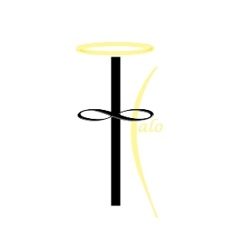
Halo Clothing Company Design Contest

Venture: Halo Apparel

Executive summary:
- Halo Apparel is a clothing brand that is meant to bring together a basic middle to higher end T-shirt look with a powerful message. This shirt will use the basic strategy of clean look with a brand that has a much more meaningful message. The basic halo logo will represents a company that gives back to society. Customers will also have the opportunity to put a custom bible verses over their heart to give the shirt a personal feel as well. This shirt will combine an awesome design with an even greater message that can be enjoyed by every generation. The selling point is that a percentage of profits will be given back to charities and churches.

Design concepts:
- The design should include a bible verse over the heart. The scripture needs to really be eye catching and appropriate for all ages to wear, this means nothing cheesy. Ask yourself if you would wear something like the design in public. Incorporate anything you feel may really connect with a religious consumer. (Sunsets, mountains, crosses, ect…). Try to think of brands you wear now and incorporate their eye catch flare into your concept. Also feel free to incorporate your signature somewhere below the design, so if your design is picked credit for the design is given properly.

Please use one of the following verses in your design:

- I can do all things through Christ who strengthens me. PHILIPPIANS 4:13

- Do to others as you would have them do to you. LUKE 6:31

- And now these three remain: faith, hope and love. But the greatest of these is love. 1 CORINTHIANS 13:13

- Judge not, that ye be not judged. MATTHEW 7:1

- For God so loved the world, that he gave his only begotten Son, that whosoever believeth in him should not perish, but have everlasting life. JOHN 3:16

- Love your neighbor as yourself. MARK 12:31

- Though I walk through the valley of the shadow of death, I will fear no evil: for thou art with me; thy rod and thy staff they comfort me. PSALM 23:4

- Surely goodness and mercy shall follow me all the days of my life, and I shall dwell in the house of the Lord forever. PSALM 23:6

- For to me, to live is Christ and to die is gain. Philippians 1:21

Important things to keep in mind:
- The shirt has to not look cheesy, a lot of the competition have designs that only kids would wear. This shirt should appeal to all ages, so when designing think of making a design that you would feel comfortable wearing in public.

A couple of images to get you brainstorming, does not have to be exactly this or even close but just to give you a starting point for ideas!



Also in case you were wondering what our Logo looked like, it is attached below:
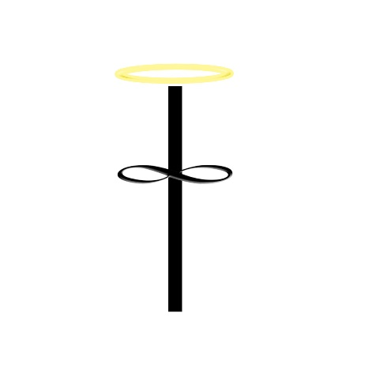
Best of luck and thank you!

Contact info:
Email: Kyle@haloclothingcompany.com
Phone: (609) 204-7747

