Track 61

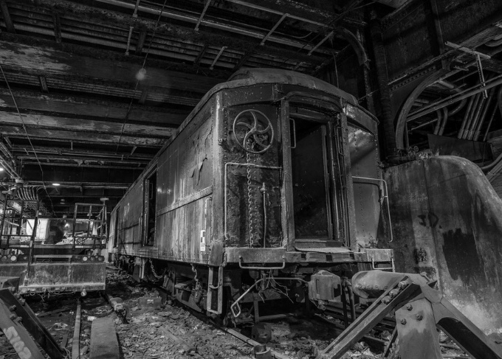
Track 61 is a secret train track under the Waldorf Astoria in NYC that was built for private train cars to enter directly into the hotel where they could take a private freight elevator directly into the building.

General John Pershing was the first to use this secret track during world war 1. President FDR used the track to conceal his paralysis from the public when he traveled to New York in 1944. Rumor has it that Andy Warhol threw an underground party there in 1965. The track was also prepped for a visit by George W Bush when he attended a meeting at the hotel. Fun fact: it takes 7 minutes to get from track 61 to JFK airport.

Appetizers
Arancini (Italian rice balls) Cheesy risotto balls deep fried and served with marinara sauce 10

Antipasto imported cheeses, cured meats, peppadew peppers, and balsamic roasted eggplant 16

Fried Bocconcini made with fresh mozzarella cheese and homemade marinara sauce 11

Mint and Basil Pesto Shrimp served with a side of avocado cumin sauce 12

Grilled Scallops served over a sautéed creamy corn relish 8.50

Eggplant Rollatini thinly sliced grilled eggplant drizzled with pesto and stuffed with creamy ricotta cheese and spinach 5

Creamy Spinach Dip served hot with grilled Italian bread 9.75

Bruschetta grilled Italian bread topped with tomatoes, basil, garlic, parmesan and olive oil 7.75

Salads  (small/large)  Add grilled shrimp 3.50 / 5  Add grilled Chicken 2.50 / 4  Add Flank Steak 4.25 / 6  Track 61 Salad Kale with sliced almonds, Pecorino Romano, candied fig, pancetta and lemon sesame dressing 6.95 / 10.25  Mediterranean Salad with green leaf lettuce, fresh mozzarella, garbanzo beans, tomatoes, cucumbers, bell peppers, onions and balsamic vinaigrette 6.95 / 10.25  Chicken Caesar Salad with romaine lettuce, pecorino romano, garlic knot croutons and Caesar dressing 10.50  Grilled Flat Iron Steak salad with avocado, blue cheese, sliced almonds, garbanzo beans and candied bacon served with a creamy Garlic roasted dressing 14.50  Apple and Brie Salad with candied walnuts, arugula, pancetta, and balsamic vinaigrette 11  Soups  Pasta Fagioli ditalini pasta, veggies and  beans in a chicken broth sprinkled with  freshly grated pecorino romano cheese  4 cup / 8 bowl  Chicken Noodle Soup home style chicken soup with ditalini pasta  4.25 cup /8.50 bowl | Sandwiches  All Sandwiches are served hot and can add candied  bacon or cheese 1.50  Italian Hero Salami, Capicola, Pancetta, Ham, peppadew peppers, pickled onions, melted provolone, Oregano, lettuce and tomatoes with Dijon vinaigrette on a fresh baguette 10.50  Grilled Flat Iron Steak served on a baguette with garlic aioli, grilled onions and arugula 11.50  Adult Grilled Cheese with cheddar, provolone, gruyere, tomato and avocado 7.95  Candied Bacon Burger with melted provolone cheese, avocado, arugula and pickled onion 9.75  Home style Fried or Grilled Chicken Breast with garlic aioli, arugula, melted gruyere, Dijon vinaigrette and pickled onions. 9.50  Grilled Veggies bell peppers, spinach, mushrooms, eggplant with fresh mozzarella and pesto served on a fresh baguette 7.95  Turkey and Melted Brie roasted apple, arugula  with Dijon vinaigrette on a fresh baguette 9.50  Sides  Caprese Salad drizzled with  balsamic reduction 4  Couscous Salad with fresh veggies,  garbanzos and feta cheese 3  Parmesan fries 3  Homemade chips 3  Garlic knots 3

*All Entrees are served only during dinner hours*
Entrees
Add shrimp 6
Add meatballs 5
Add Chicken 4.50

Seared Redfish
served over a sautéed creamy corn relish and wilted spinach 24

Grilled Flat Iron Steak
served with sautéed mushrooms, parmesan fries and wilted spinach 26

6 oz Filet
with parmesan fries and balsamic roasted eggplant 28

Chicken Marsala
lightly fried chicken breast marinated in Marsala wine and mushrooms served over linguine 16

Fettuccine Alfredo
buttery and creamy fettucine with chicken or shrimp 16/18

Eggplant Parmesan
fried eggplant stacked with layers of feta, mozzarella, and basil and served over marinara sauce 12

Penne alla Vodka
light, tangy and creamy tomato sauce served over penne pasta 13

Homemade Marinara
basil, olive oil, with pecorino Romano served with your choice of pasta 9

Traditional Spaghetti and Meatballs
classic spaghetti with traditional beef meatballs 14

Desserts
Tiramisu 8
New York Style Cheesecake 8
Chocolate Chip Cannoli 4 each
Giant Chewy Chocolate Chip and Walnut Cookies 3.50 each
Chewy Lemon Ricotta Cookies with lemon glaze 3.50 each

Consuming raw or undercooked meats, poultry, seafood, shellfish, or eggs may increase your risk of foodborne illness.

Specialty Cocktails  Sangria $  Red Sparkling Wine served with a variety of fresh fruits | Fountain Beverages  Coke ,Diet Coke,  Dr. Pepper, Sprite  Mint Lemonade 2.99  Iced Tea 1.99  Coffee 2.75  Domestic Beer  Budweiser  Bud Light  Coors Light  Miller Light  Michelob Ultra  Yuengling Lager  Imported Beer  Stella Artois  Peroni  Shiner Bock  Sierra Nevada Pale Ale  Corona Light  Blue Moon  Abita Amber  Abita Andygator  Suzy B  Lagunitas IPA  Fat Tire Amber Ale  Guinness

Sparkling
Cantina Ronca $half glass $ glass $bottle
Bevilo Brut, Italy

White Wines
The Royal half glass glass bottle
Chenin Blanc, South Africa
Villa W $ half glass $ glass $bottle
Pinto Gris, Germany

Red Wines
Domain de Chateaumar $ half glass $ glass $bottle
85% Grenache, 10% Syrah, 5% Mourvedre , France
Hedges Family C.M.S. $ half glass $ glass $bottle
50% Cabernet Sauvignon, 44% Merlot, 6% Syrah
Washington State
Sexual Chocolate $ half glass $ glass $bottle
Syrah/Malbec Blend, California
Hedges Red Mountain $ half glass $ glass $bottle
Cabernet Sauvignon, Washington State
DLD Syrah Red Mountain $ half glass $ glass $bottle
Syrah, Washington State
Anthony & Dominic $ half glass $ glass $bottle
Pinot Noir. California

