Pitchdeck – Content Outline
1 – Cover – ADAM Macro Global Fund
2 – Table of Contents
3 – Executive Summary
4 – The Opportunity
Brazil: Most recent recession saw asset prices fall
Now well below global comparisons
Major opportunities in Fixed Income and FX
Other EMs: Evidence that Brazil provides a template for returns elsewhere
Valuations in EM trail those in DM
Mix of strategies is best way to generate performance; and protect portfolio from adverse short-term volatility
5 – ADAM Capital: Introduction
Founded in 2016, ADAM Capital is an independent asset management firm focused on the generation of superior returns.
Investments decisions use fundamental macroeconomic analysis balancing long term performance with portfolio positioning to navigate short term volatility
Expertise in management of FX, interest rates and equity strategies, both in Brazil and globally
ADAM Capital had the biggest inflows of any hedge fund - $3.5bln in 2017; and the same in 2016*
*Preqin (need link)
6 – A Leading Independent Asset Manager
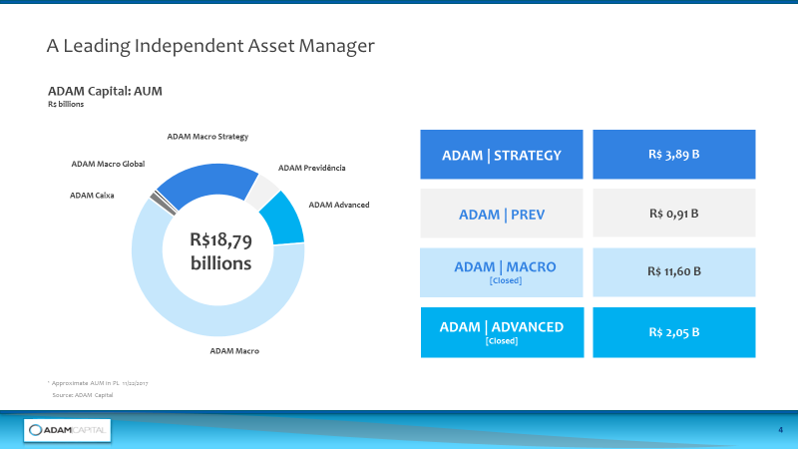
7 – ADAM Capital: Marcio Appel – CIO and Founding Partner
An asset management specialist with a strong track record of performance
2016 - Founded ADAM Capital – holds majority stake and makes all investment decisions
2008 – 2015 - Head of Safra Asset Management – top decile or quartile performer (some qualitative or quantitative evidence needed)
2001 – 2008 – Head of Santander Asset Management - top decile or quartile performer (some qualitative or quantitative evidence needed)
8 – ADAM Capital: A unique and proven approach
Proven alpha generator through careful position structuring
Balanced approach allows portfolio to ride out any scenario
At any juncture the portfolio has positions that behave with negative correlation, while offering long term positive return potential
Combines positions with negative correlation but which are consistent with the secular trends that we have identified
A global fund with expertise in both Developed and Emerging Markets, especially Brazil, that invests both long and short
‘Alpha’ is derived 50% from Brazil and 50% from other international markets
9 - Philosophy and investments process
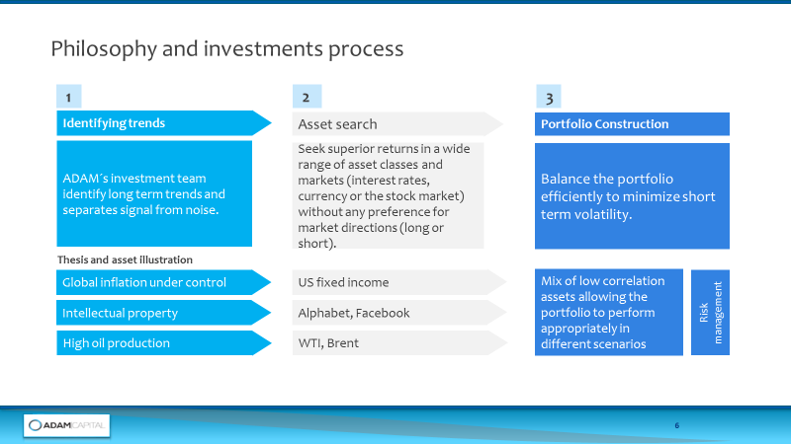
10 – ADAM Macro Global Fund – The Opportunity
This new offshore vehicle is ADAM Capital’s only fund that is open to investors
Capacity is capped at $500 million
Volatility of new fund is targeted at 12
Brazilian asset manager with proven understanding of Emerging Markets
20 months of fund data shows ADAM Capital can generate alpha in the macro area
In contrast, HFRI Macro Index up 1.6% in 2018; many top managers in drawdown
11 – ADAM Capital – A unique investment model
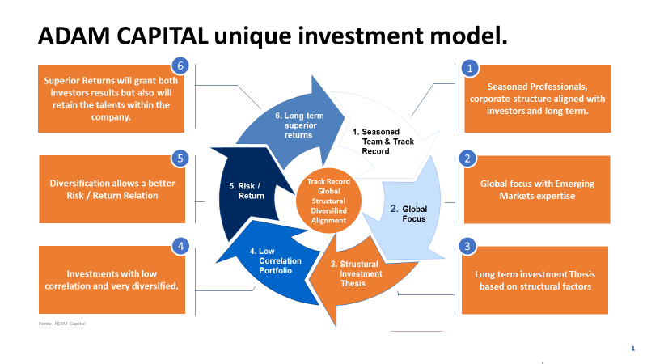

12 – ADAM Macro Global Fund – Trade Ideas … 1
Tech Disruption – An investment theme that cuts both ways
Long US tech sector
Bullish on stocks where intellectual property is worth the earnings multiples: Amazon, Google
But short where the intellectual property value is exceeded by excessive valuations and threat of competitive disruptions: Netflix, Tesla
Automakers – Constructing a global macro trade
Auto sales forecast to fall over next 5-10 years so sensible to be short automakers
With China the biggest market for auto sales, the sector is a significant hedge for a China slowdown
On the long side, Brazil is a significant exporter of commodities, mainly to China
Rising commodity prices, pushes up the value of the BRL
Trade is to be long BRL and Brazilian equities which generally rally with commodities
The short position on automakers will cover that exposure – a slowing auto market and tech disruption in the sector will hurt those companies
Favoured trade structure: one position has a negative correlation to the other but both positions have a positive expected return
13 – ADAM Macro Global Fund – Trade Ideas … 2
FX Pair Trade – Short Turkish lira, long Brazil real
Turkey has left-wing, interventionist government pursuing a loose monetary policy
Short Turkish lira is negatively correlated with long BRL
Portfolio is always built this way:
Combine multiple different theses long and short
Each can make a positive return
But have ‘0’ or negative correlation with each other
14 – Portfolio Construction: Low correlation positions

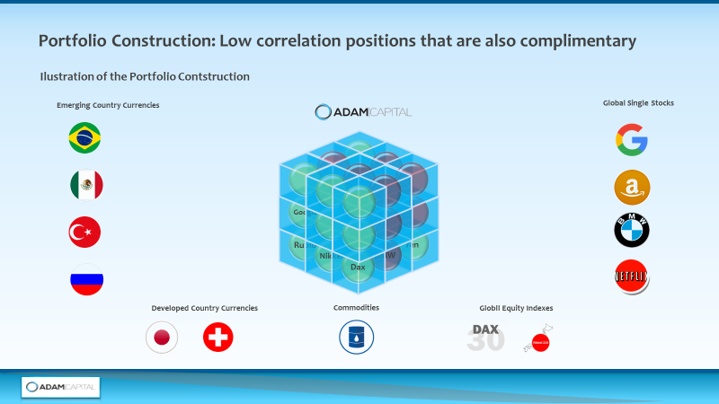

15 – Performance Chart – (ADAM Macro ??)

16 – Consistent Returns 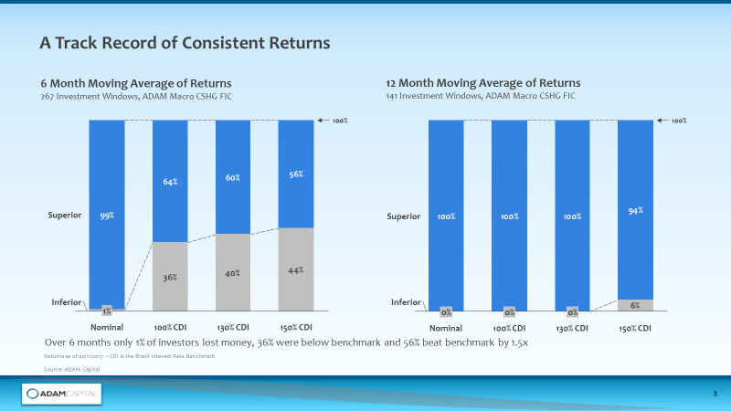

17 – Key Facts – ADAM Macro Global Fund
(adapted from slide 13 – ADAM background deck – Caracteristicas do ADAM Macro Strategy)

18 - Flagship Funds

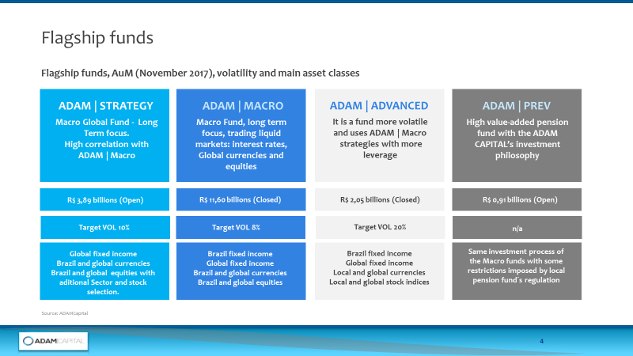
19 – Flagship Funds Performance
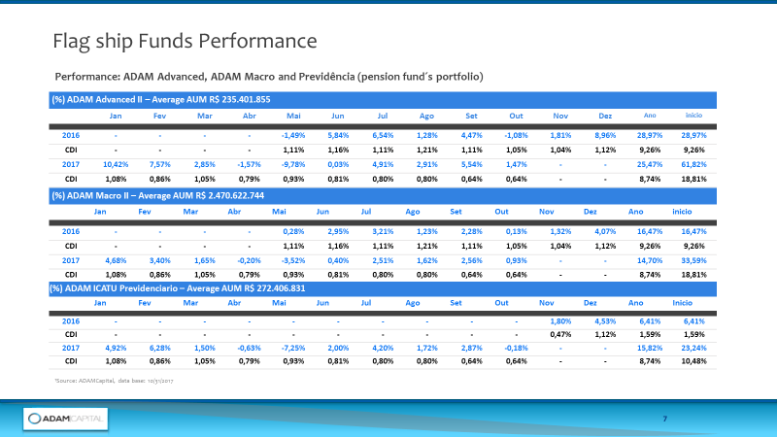
20 – The Team
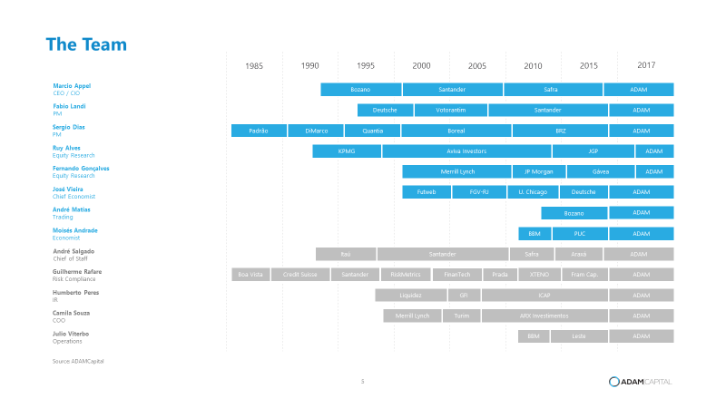
21 – Disclosures
22 – Contact information

