EPC Background
Established in 2007, EPC International Limited (EPC) is a Hong Kong company specializing in single and double sized printed circuit boards. Its manufacturing facility is located in a self-owned facility in Tangxia, Dongguan of China which is 50 minutes from Hong Kong.
Our mission is to become a premium low costs PCB supplier that fully embraces human, social and environmental responsibilities.
Through our insatiable drive to maximize efficiency, EPC is becoming a highly efficient PCB factory with a capacity of 140,000 sq meter a month.
PCB is our business and it is through continued automation and innovation that will drive our growth in the next 10 years.

SINGLE LAYERED PRINTED CIRCUIT BOARDS
We are offering single layered circuit boards through our own production facility in China for customers in the following industries:
应用范围  Application | 比例%
家電製品  Household appliances | 60%
電源製品  Power supply | 20%
照明製品  Lighting controlsystem | 10%
その他  others | 10%

DOUBLE LAYERED AND MULTI-LAYERED PRINTED CIRCUIT BOARDS
We are offering two layered and multi-layered circuit boards for our customers through our strategically approved printed circuit boards manufacturers.
With our own UL for double sided and multi-layered circuit boards, we work with a number of strategically approved manufacturers in delivering 100% quality guaranteed printed circuit boards for our customers.
All the PCBs are inspected by our own Automatic Visual Inspection (AVI) Machine before we deliver to customers.
We perform comprehensive quality and environmental audit of our manufacturers on quarterly and annual basis.

Our investment and upgrade
Maintaining a highly automated factory is the only way to ensure consistent product and long term competitive efficiency.
From 2015 to 2017, EPC invested over US$3.5 million in automating our production and quality control process and enhancing our environmental processing facility. We will spend a further US$1.5 million in 2018 to continue our improvement process to ensure we are one of the most efficient and highest quality single sided PCB manufacturers in Asia. By the end of 2018, 100% of our PCBs will be inspected by AVI before they are delivered to our customers.

Show pictures of the facility.

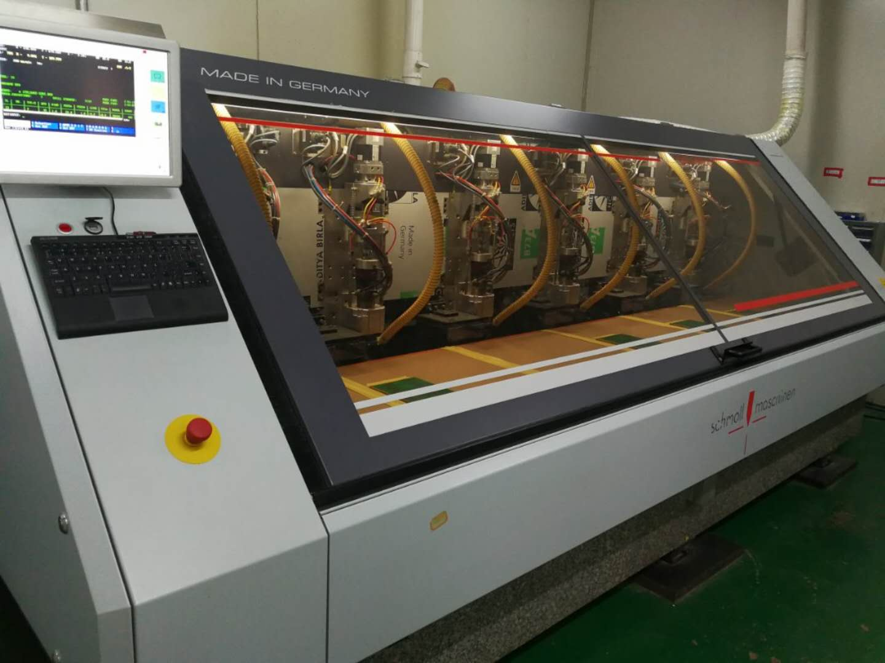

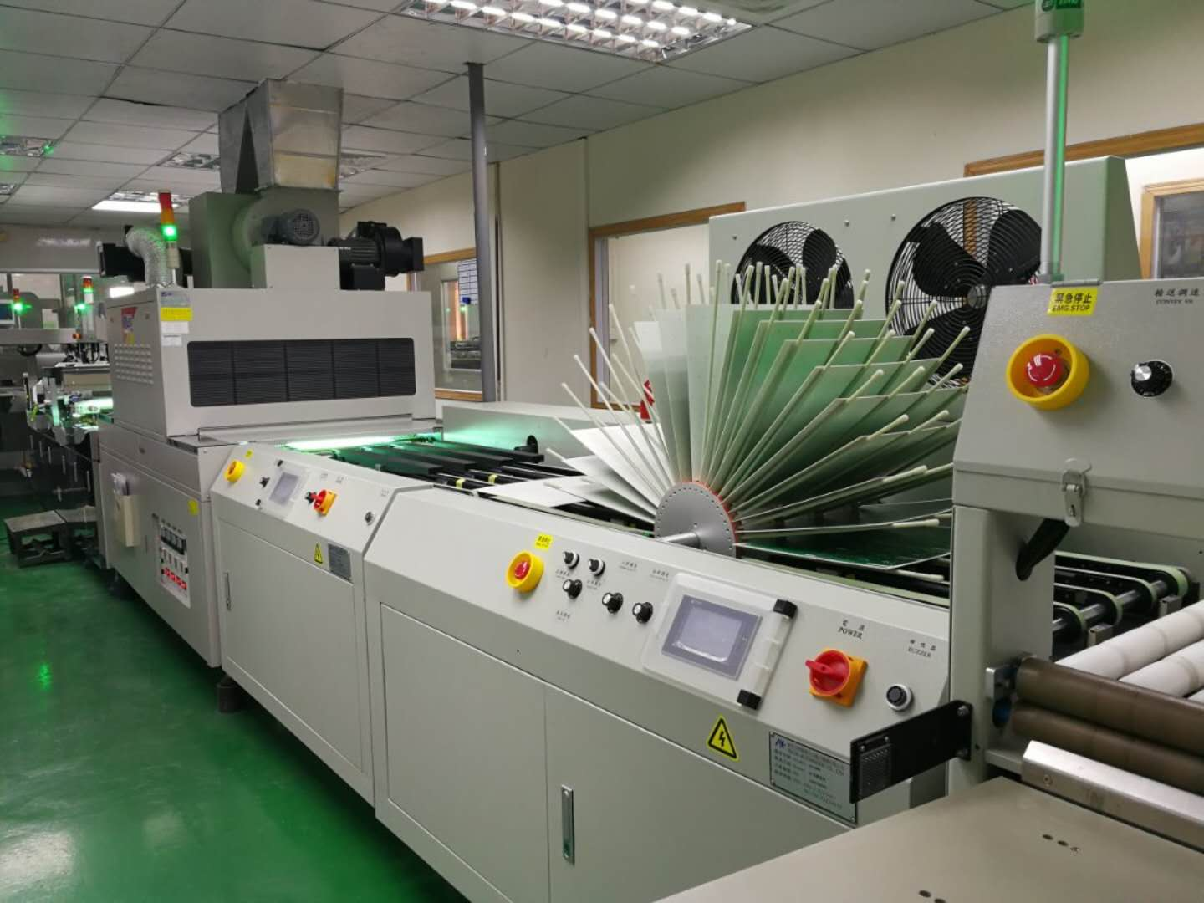

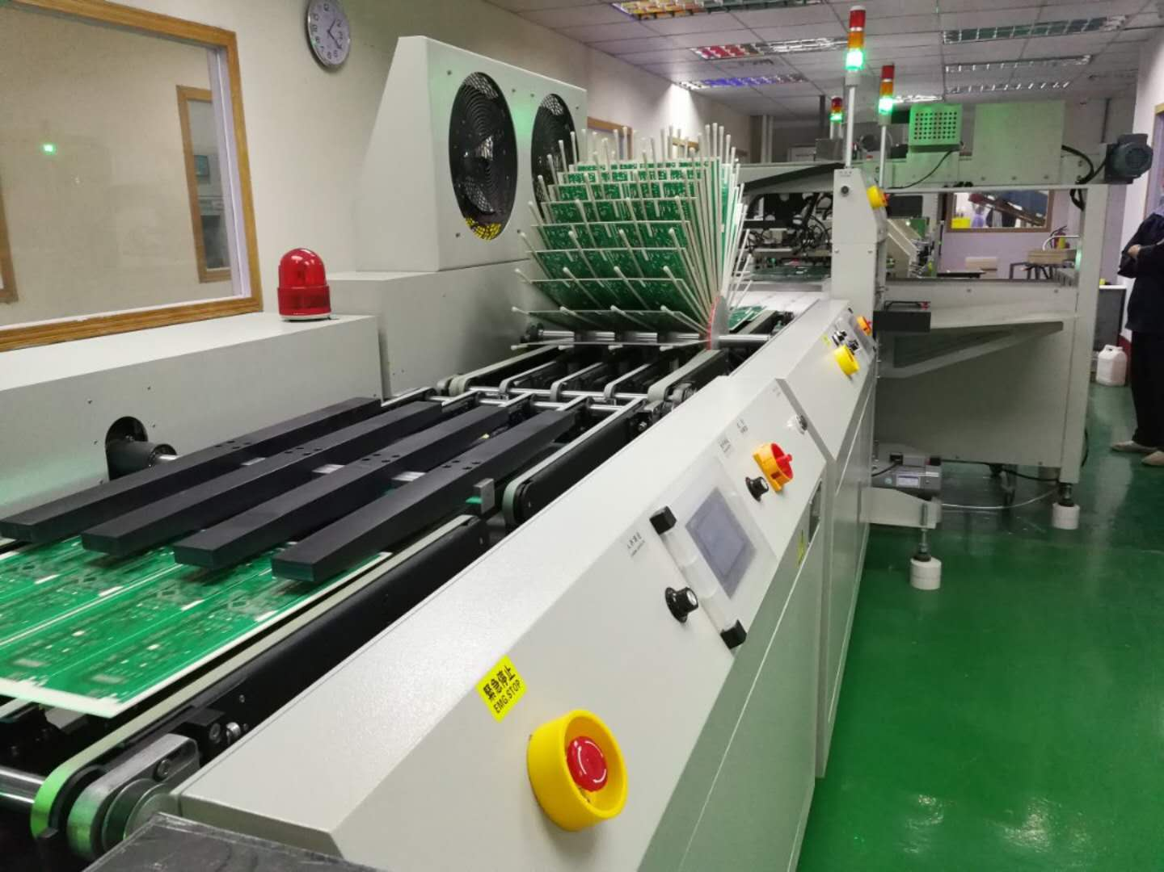
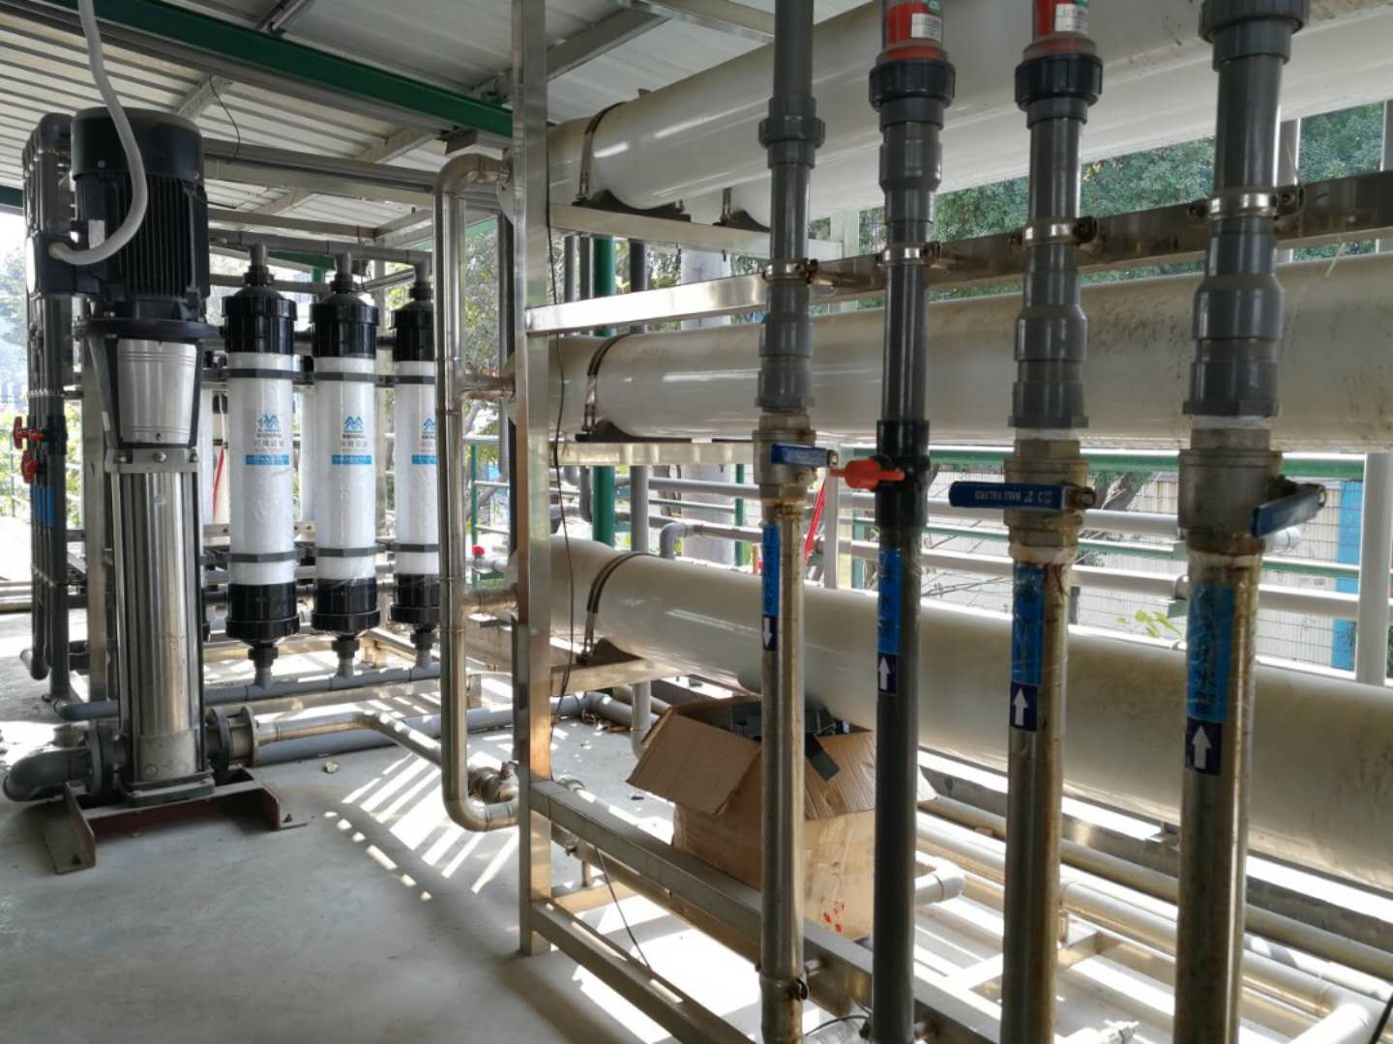

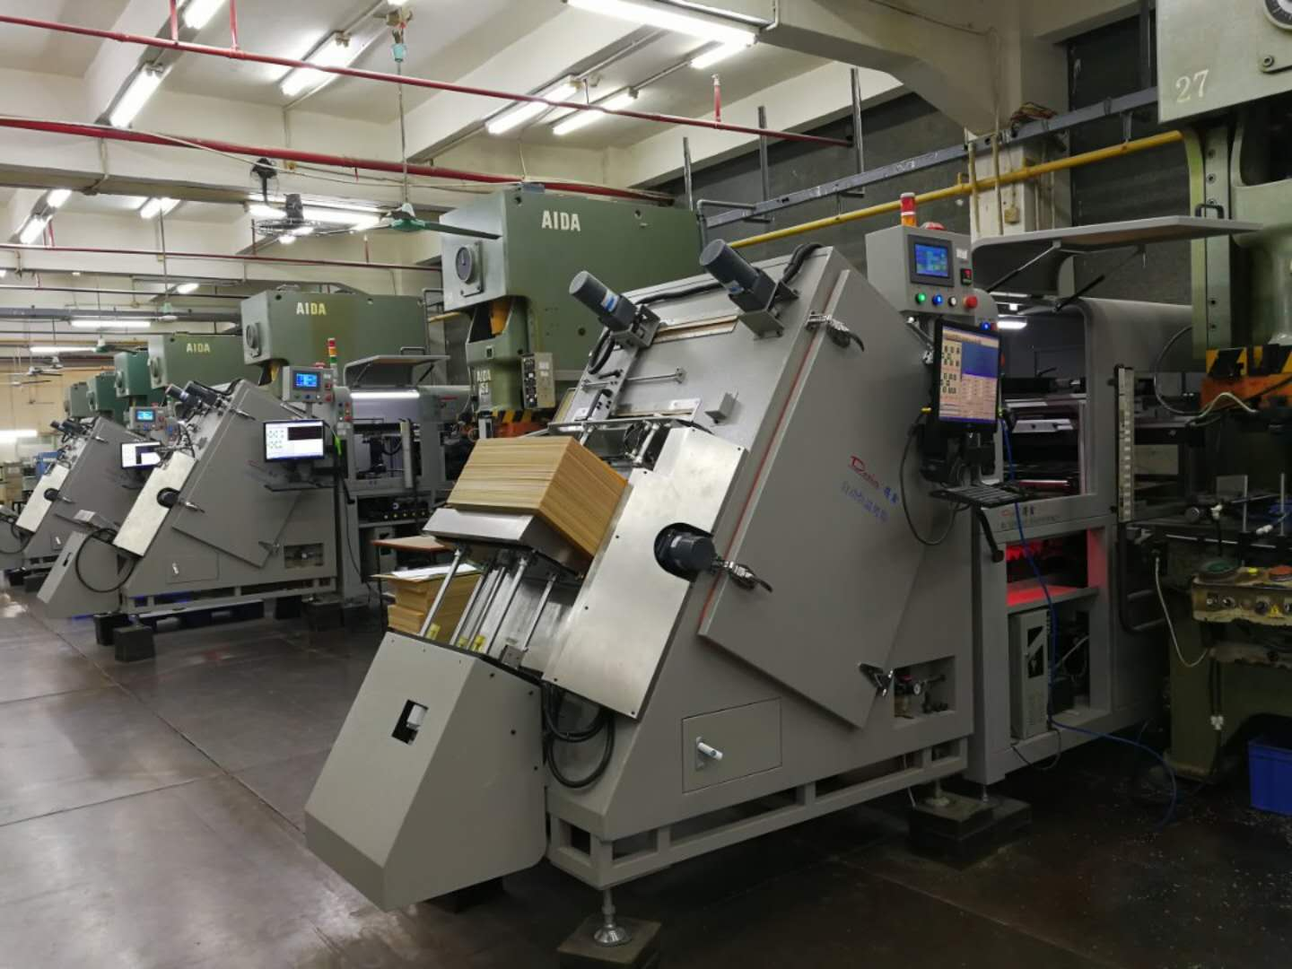

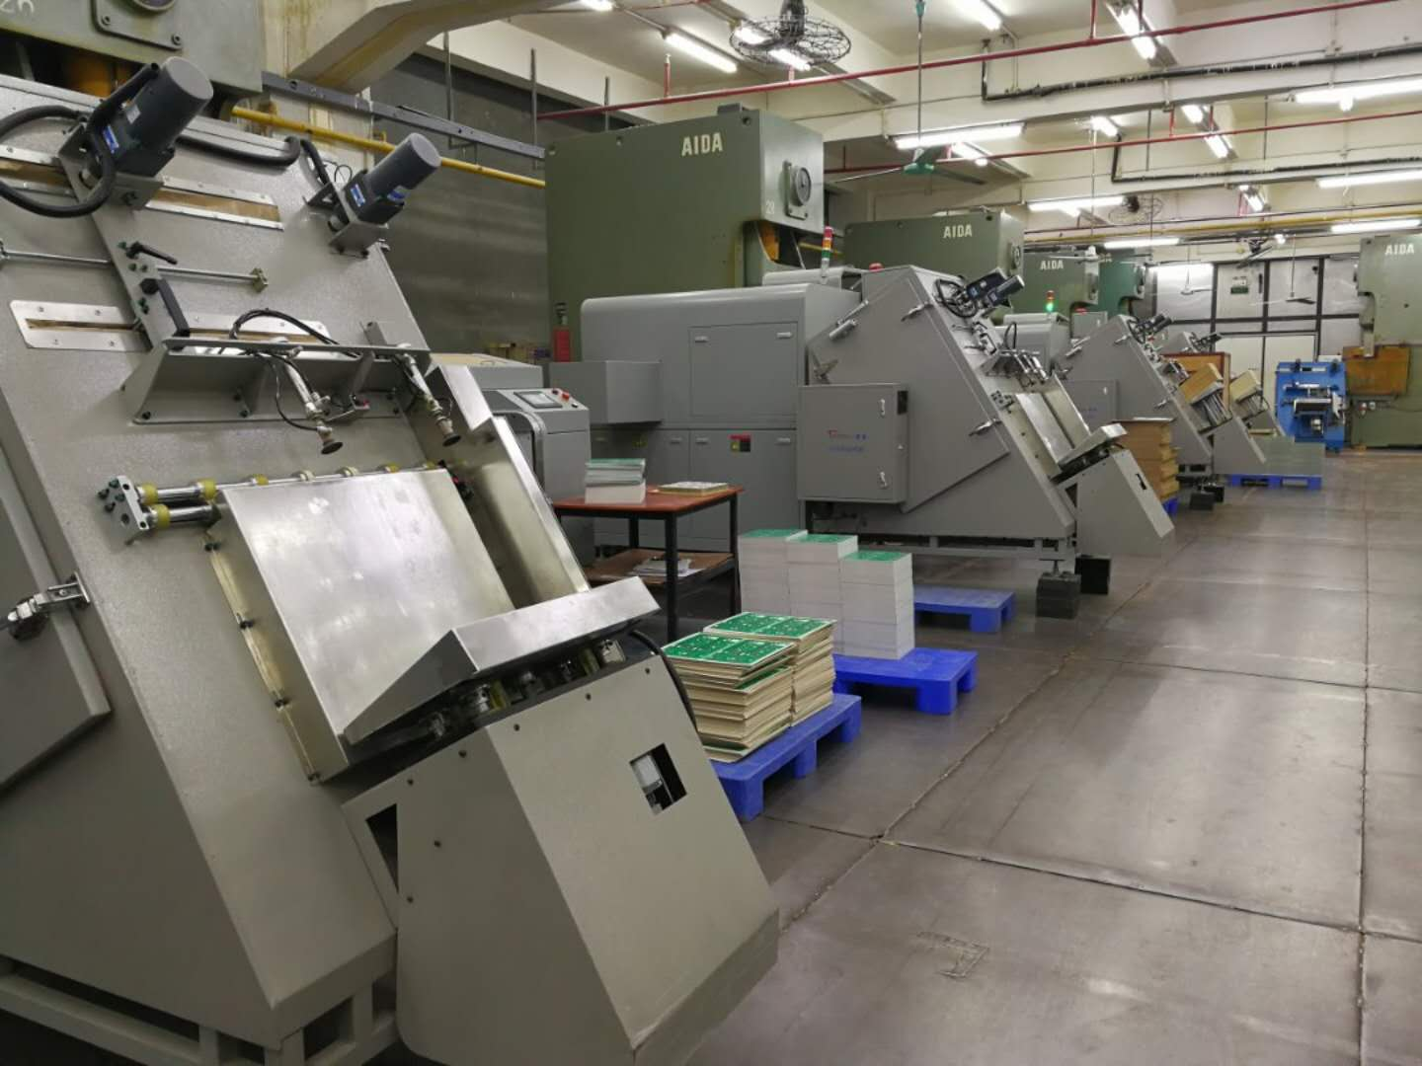
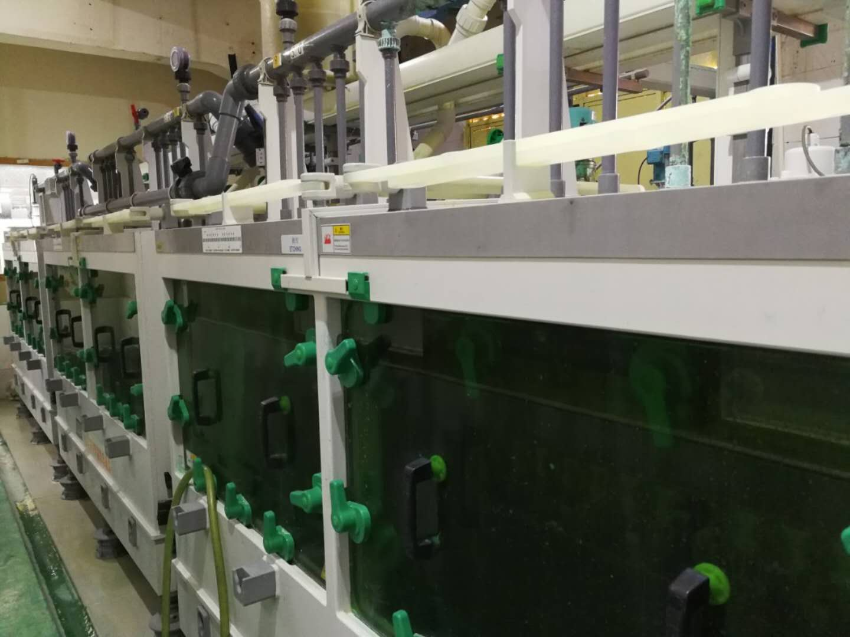
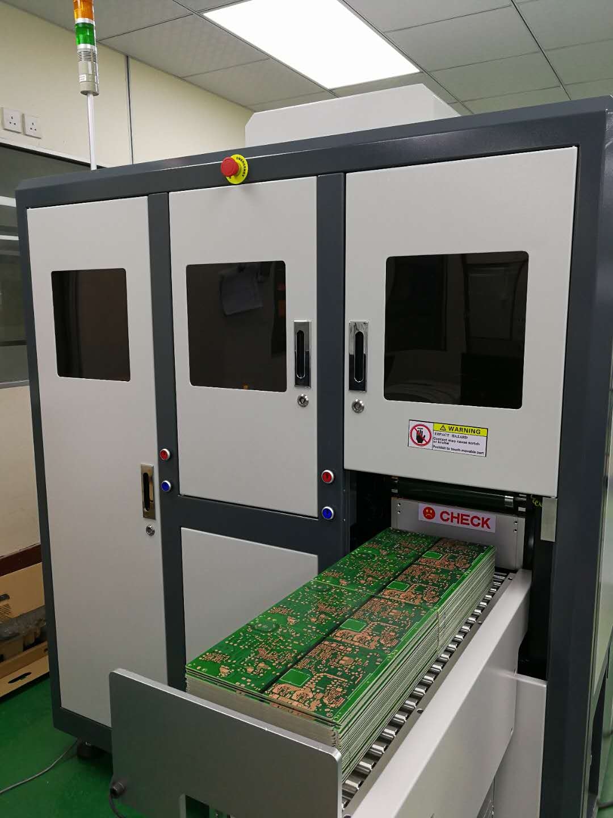

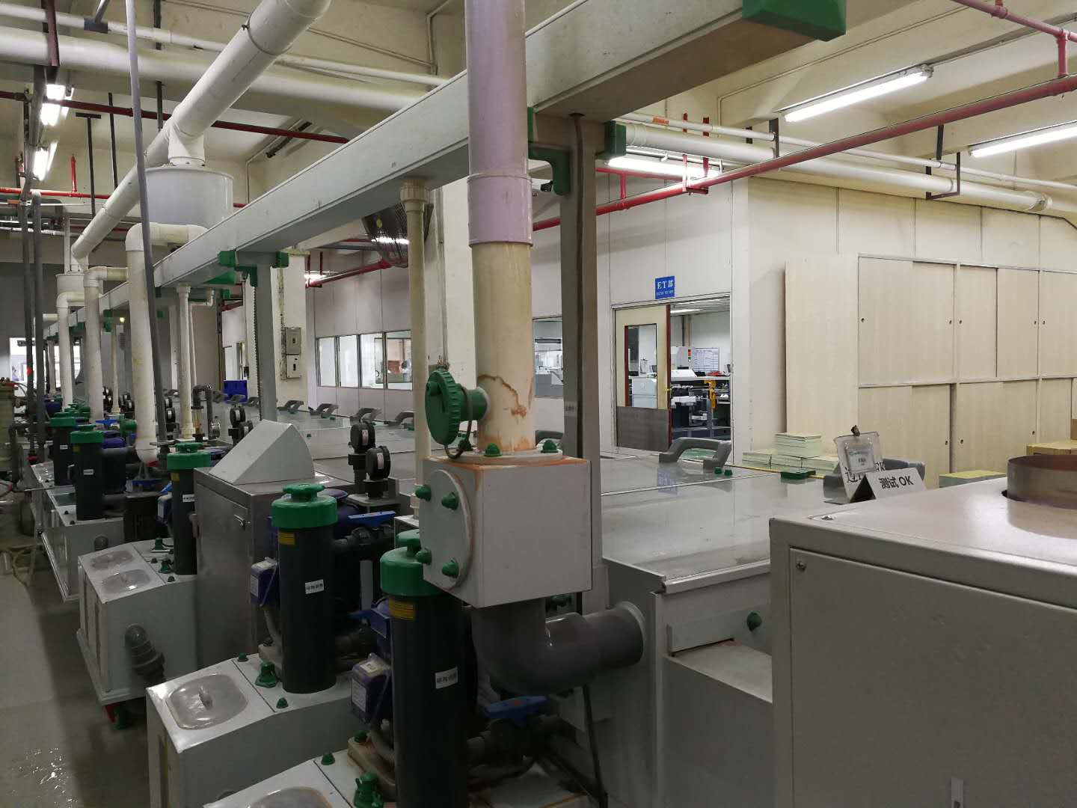

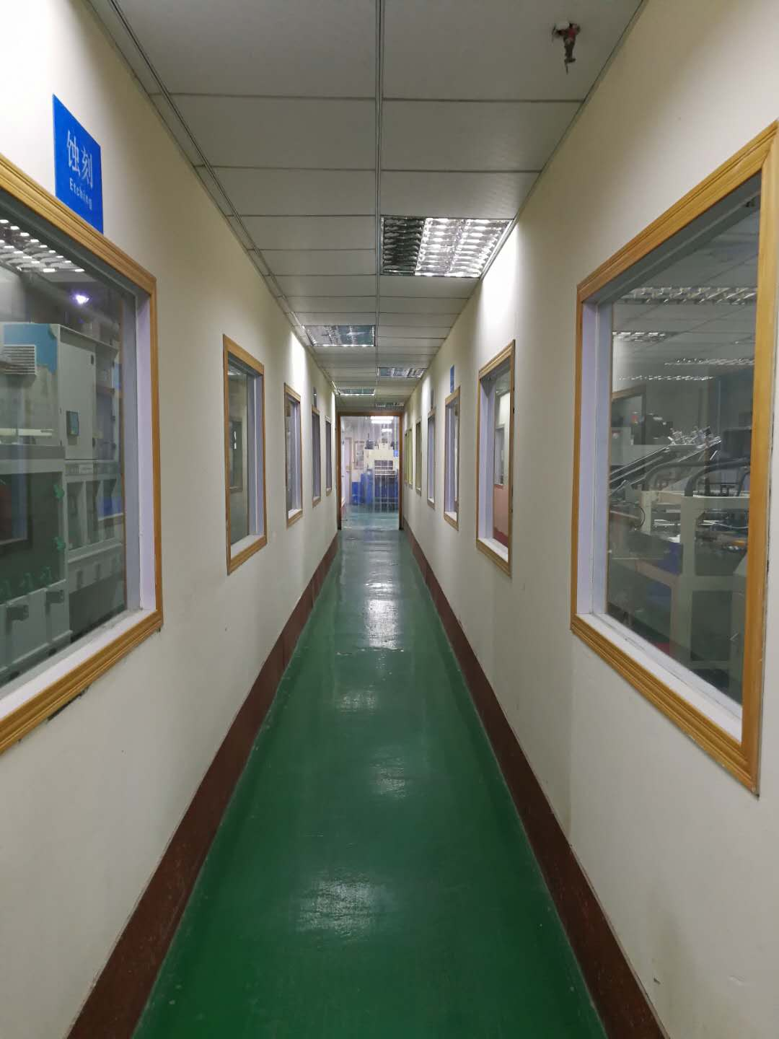

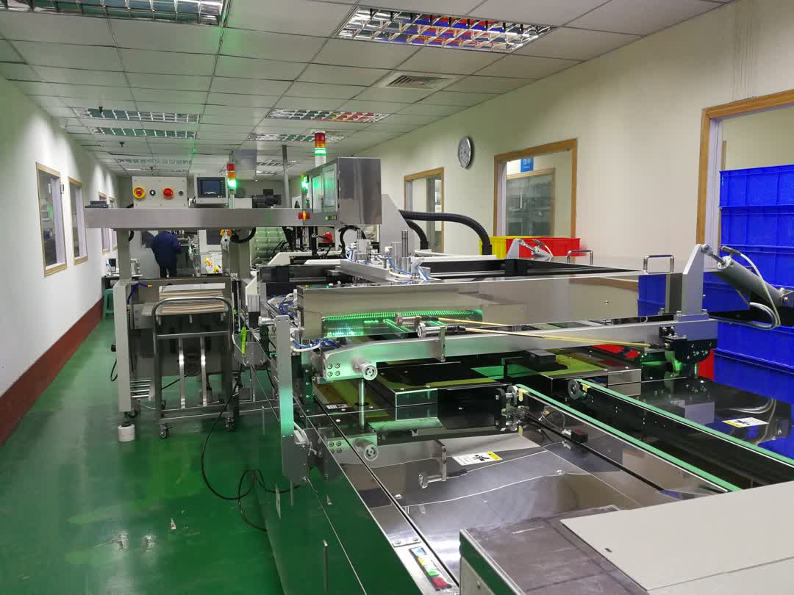
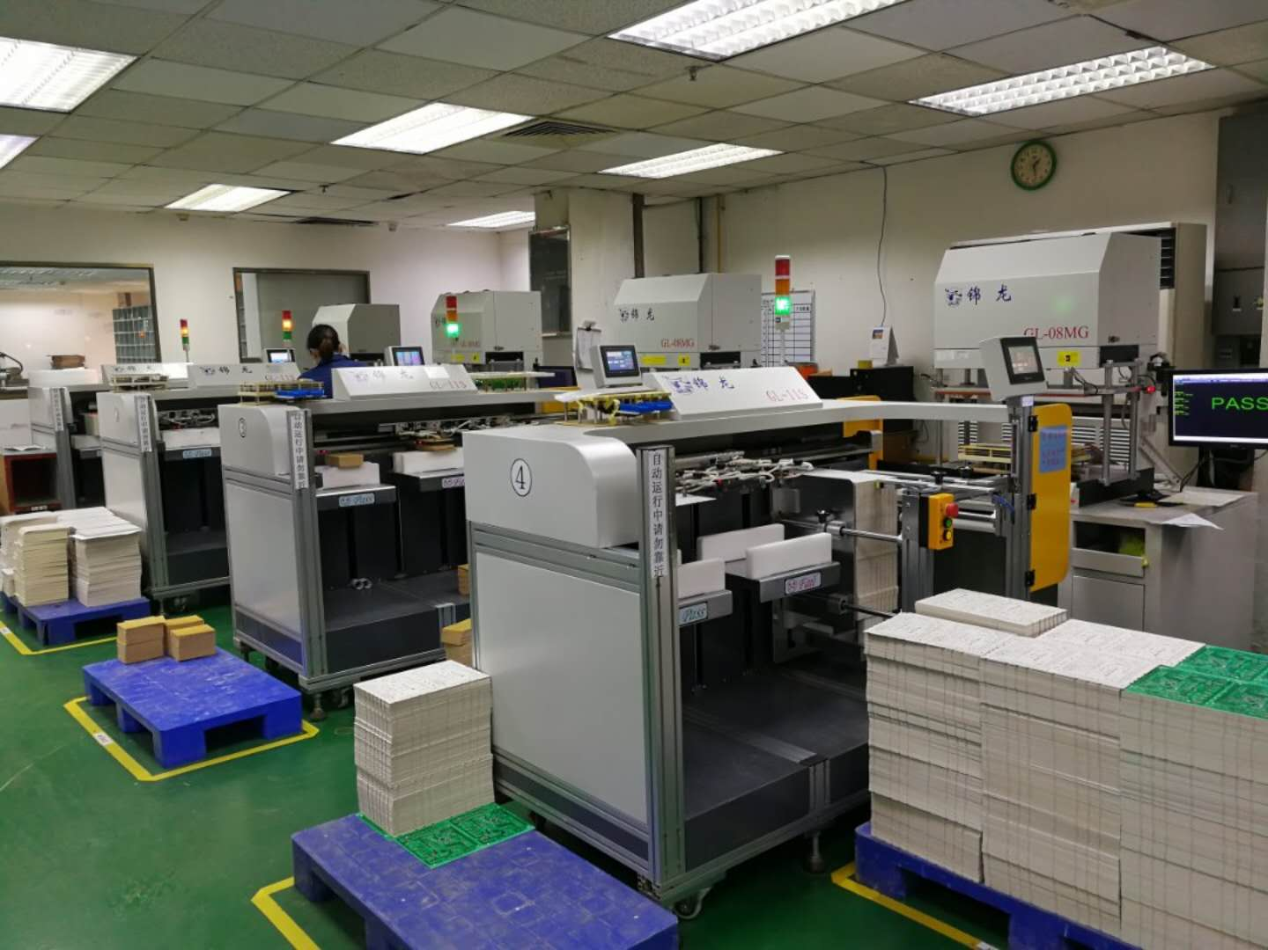
Customers
EPC is embracing a philosophy of being a partner with our customers. As a result, we are strategic PCB suppliers to the following world renowned companies:

Technical capabilities
Below is an overview of the capability of EPC.

