Columbiad LLC

www.columbiad.net

- Columbiad provides solutions to the Quick Serve (QSR)/Fast Food industry worldwide. Columbiad provides design, engineering and local supply solutions to lower the CAPEX cost and increase speed of opening restaurants around the globe.
- Target customer are global Quick Service Restaurant (QSR) Chains and their franchisees around the world; cross many different cultures and languages
- Business to business selling and marketing to corporate executives, financial entrepreneurs and franchisees.

The name Columbiad came to be while on a tour of Ft. Sumter in Charleston, SC. Columbiad’s were strong, powerful artillery cannons. They were symbolic of the nation’s defense in the 19th century. See pics below.

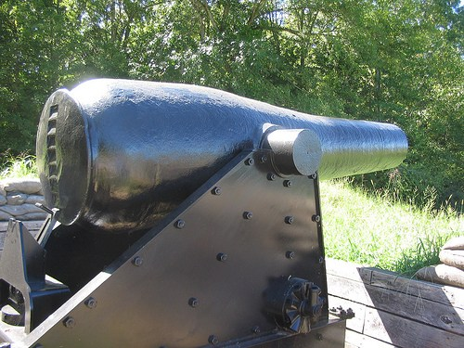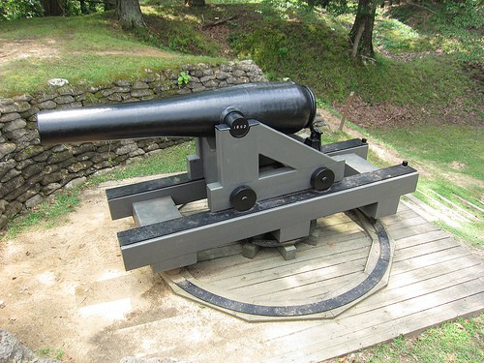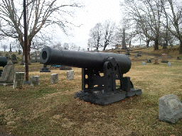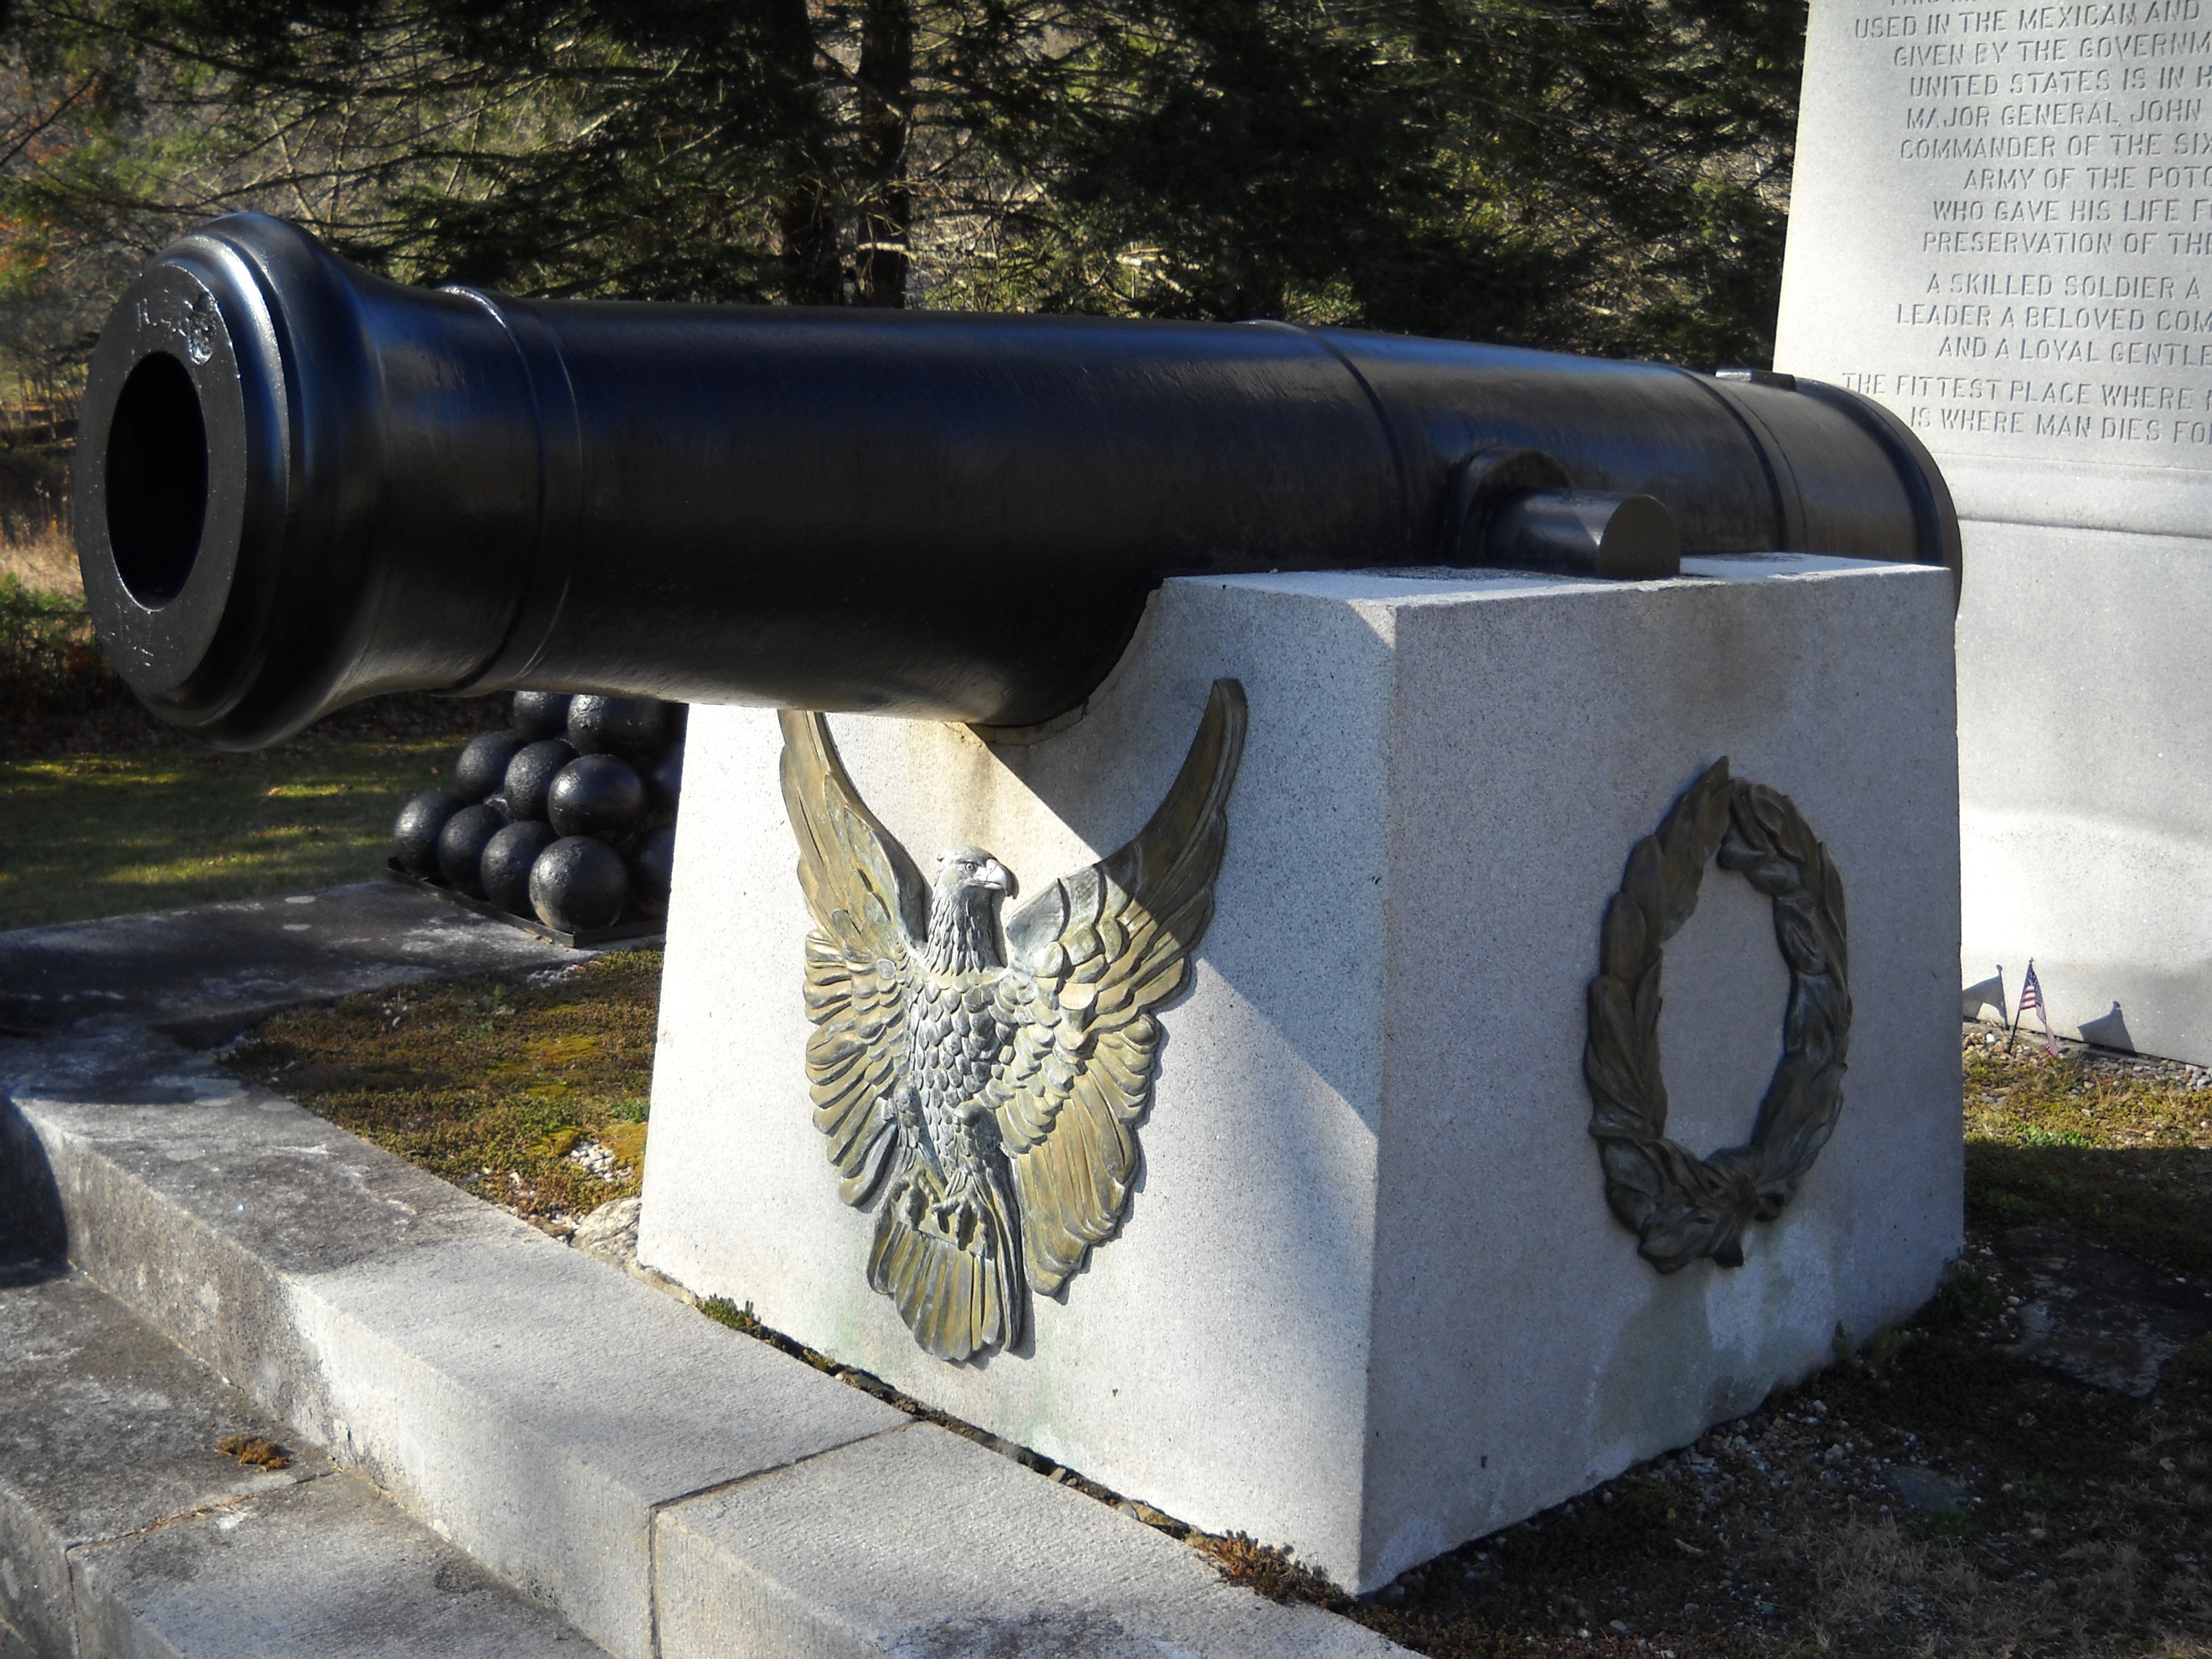

Logo requirements:

- Use the pics to drive logo concept only and provide background. The logo does not have to be identifiable as a Columbiad canon
- Simple, clean, modernized geometric shapes/image that can be used as a bold, distinctive mark/logo, fully colored or black and white. With or without the word “Columbiad”
- Identifiable on its own as a stand-alone mark over time
- Recommend/specify fonts, standard colors
- Look modern, solid, reliable, dependable,
- Combine logo with name in different applications/orientations.
- Logo and name will be used on-line, for business communications (cards, email, literature, etc.), and as a logo on stainless steel & molded foodservice equipment and supplies.

Very simple Columbiad logo concept done by me

COLUMBIAD

