ECN TRADE is a leading forex broker in Australia, which provides professional services to retail and institutional customers in online investing and trading.
The product ranges include CFD's over forex, precious metals, crude oil, global indices and related financial derivative instruments.
Our Slogan:
COLLABORATIVE
LEADING
PROFESSIONAL
Contact Us:
ECN TRADE PTY LTD
Address: Level 13, CitiGroup 2 Park Street, Sydney
NSW 2000 Australia
Free toll: 1300 733 452 Text: +61 427 469 888
Email: support@ecntrade.com.au

Client service QR CODE: Must included 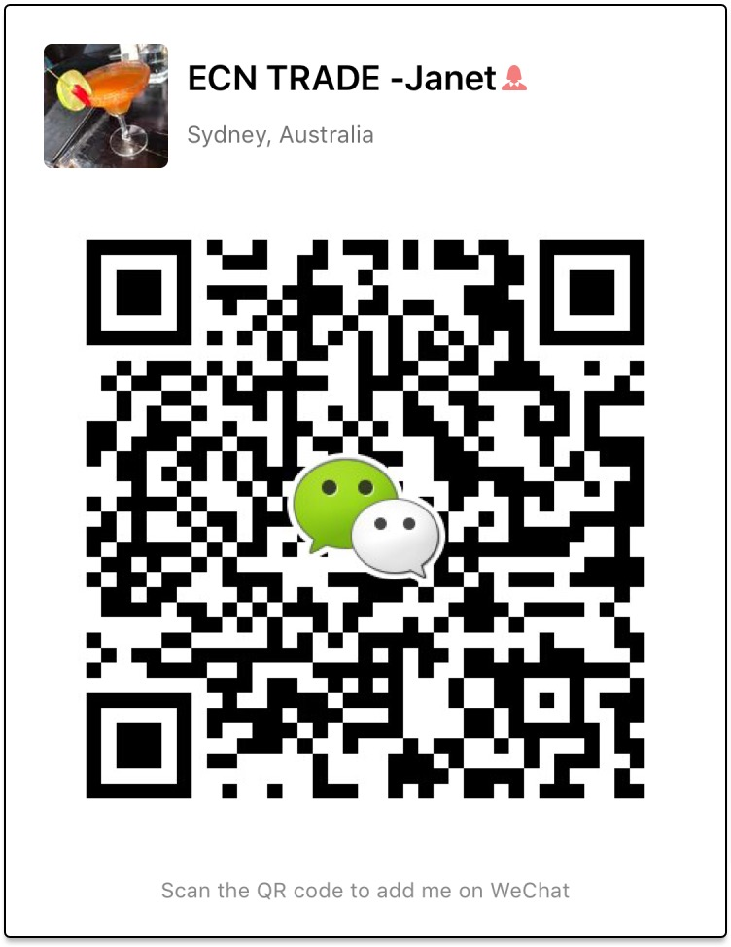

Company FREE information QR CODE: Must included
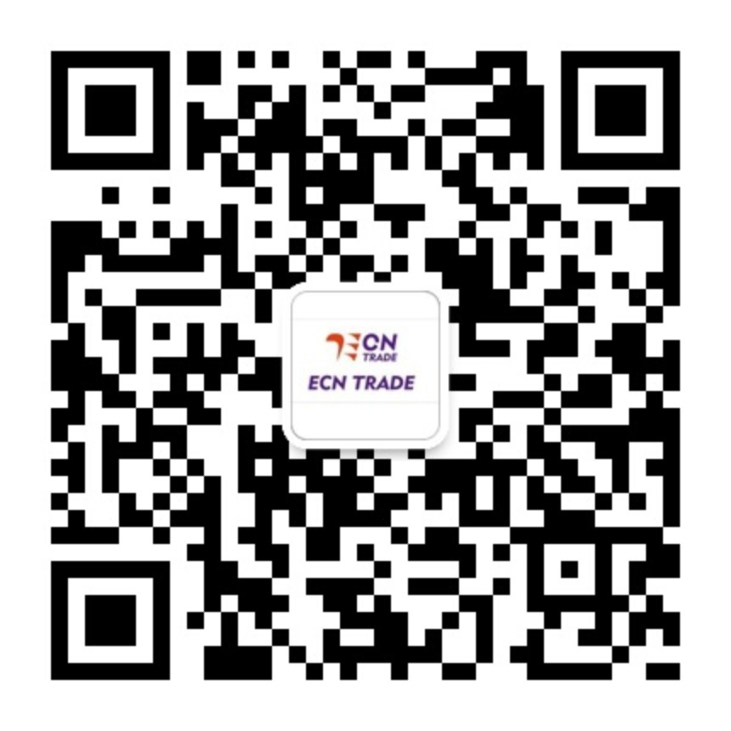

Risk Disclosure (Must included, you can put on the bottom use smaller words)

Due to volatility and uncertainly in financial markets, risk is an inevitable factor accompanying potential returns. Under certain circumstances or due to extraordinary events, investors might not have their principals returned and you could lose substantially more than your initial deposit. You do not own, or have any interest in, the underlying assets. We advise you to fully understand the risks involved in financial vehicles before making an investment. If necessary, independent financial or legal advisory is recommended. We do not, however, in anyway guarantee profits or accuracy of our market analysis.
AFSL:388737
----------------
The information below don't need put on banner, help you understand us:
ECN TRADE is a registered entity with the Australian Securities and Investments Commission (ASIC) in 2007 and holds Australian Financial Services License (AFSLNo.388737).
We provide fair, transparent and quick market leading pricing for investors and traders as like by the easy-to-use ECN Trade MetaTrader 4 platform allowing you to improve your trading potential with competitive, efficient and fair trade executions.

Besides tablet and PC applications we also have mobile trading that allows our clients to manage trading accounts from portable devices like Android and Apple IOS. Wherever you are, you can keep abreast with the market's latest developments, analyse news events and perform trading operations at any time you are online.
We also provide ongoing face-to-face training to new traders and existing clients at regular ECN TRADE seminars, provide markets experienced external analysts for advanced trading discussions and meet and greet sessions, all of which are courtesy of ECN Trade. We pride ourselves on maintaining a professional, dedicated service and the highest level of support to our global clients.

