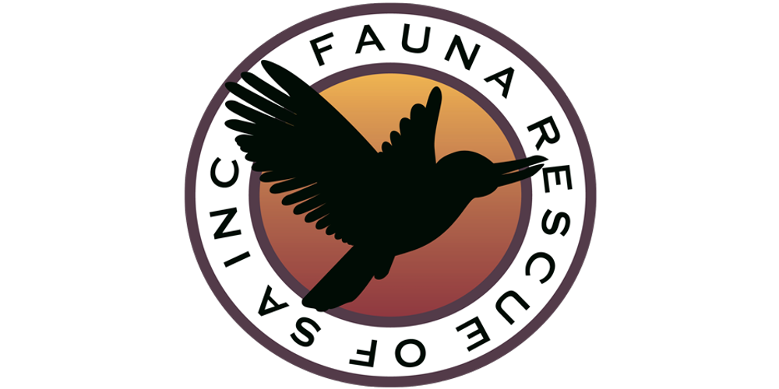
Design Brief – Fauna Rescue of SA

Project: Logo Redesign

Purpose

Fauna Rescue SA wants a logo that reflects the large range of native animals we care for – mammals, birds and reptiles. The name of the organisation on the current logo is difficult to read from a distance when used on car magnets and uniforms.

About Us
Fauna Rescue SA is South Australia's largest wildlife organisation caring for our sick, injured and orphaned wildlife. Our policy is to raise/rehabilitate and release when it is in the best interest of the animal. Founded 30 years ago, the organisation is run entirely by volunteers.
Wildlife in South Australia we care for includes the following species:
Koalas, Kangaroos, Wombats, Possums, Bats, Echidna, Lizards, Turtles, and many native bird species.
Service
We provide a 24/7 telephone hotline for members of the public, emergency services and vets to call for assistance and/or advice.
Our members rescue, transport and care for sick, injured and orphaned wildlife with the goal to release back into the wild when it’s in the best interest of the animal.
We provide training and mentors to support our members.
We offer public education sessions to enable members of the public, including children, to provide first care to injured, sick and orphaned wildlife and have a better understanding of the wildlife living around us.
Industry
We are the largest coordinated group of wildlife carers in South Australia and have relationships with RSPCA (domestic animals), DEWNR (government department of environment) and other wildlife organisations.
Similar organisations interstate are:
https://www.wires.org.au
https://www.wildlifevictoria.org.au
Target Audience
Our target audience consists of members of the South Australian public, aged between 5 and 85, that care about the conservation of our native wildlife and are willing to donate their time or money to the cause.
Brand Values
Professional
Environmentally Conscious
Nature loving
Volunteers
Organisation Name
Fauna Rescue of SA Inc – trading as Fauna Rescue SA
Tag Line
Caring for SA’s Wildlife
Logo Style
Our current logo is an emblem style with the font embedded into the design. We would like a new emblem or combination style logo that includes the name “Fauna Rescue of SA”, tag line and an image/s that portray the service we offer or animals we care for.
Format
The logo will be required in jpg, png and eps formats to be used for print, a new website (being built), social media, marketing collateral and uniforms.
Brand Colours
The logo will be printed or embroidered on black or khaki coloured clothing and white letterhead and car magnets so will need to look great on all three colour backgrounds. We are open to the introduction of new colours from our existing logo design but would expect a nature-based colour scheme.
Font
Font must be easy to read but open to new styles
Project Contact:
Marian MacLucas, Marketing Coordinator, Fauna Rescue SA
M – 0408 613 749
marian@marketinghat.com.au

