Top logos we like in order


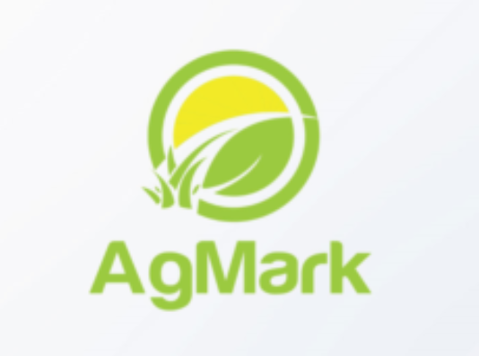
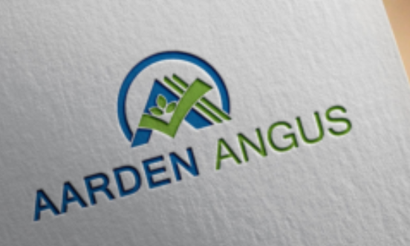

Other options around
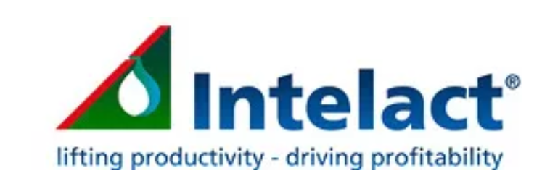



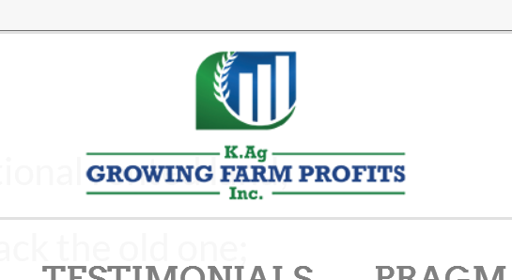









We need a logo design for a new company based in Sydney called “Farm profits”. We provide innovative business and technical management services to farm clients throughout Australia and internationally, predominately dairy farmers but also beef. Farm profits has an extensive network of industry farm clients across Australian agriculture, from farm managers and contractors to service providers such as agronomists, bankers, accountants, investors and solicitors.
The company was formed with a clear vision to provide financial and physical production data to farmers in a format that allows them to understand their business and assist them to make better more profitable business decisions
The business has a strong profit focus so incorporating $ sign in logon would be highly beneficial, consequently we would like to see designs using gold type colours for financial success and darker green as well representing grass which is key driver of profitability for these types of farmers. Grass or clover type symbols may also be useful to incorporate into design.

Whilst for simplicity we would like most of the logos designed around farm profits name, the Full business name is “Farm prophets farm profits”. We would also like to see some logos based on the full business name, I was thinking of having mirror image of the two words ie two meanings visionary (farm prophets) (Above) and profitable (farm profits) (Below)

The final design should communicate financial success and profit maximization.

