Three Sisters Beauty Co. Label and Packaging

Logo:

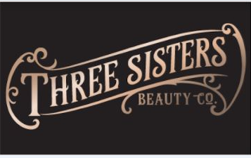

Tagline:

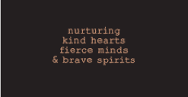

Packaging:

60ml Amber Glass Jar
Internal Dimensions: 5.5cm including lid x 50mm round diam
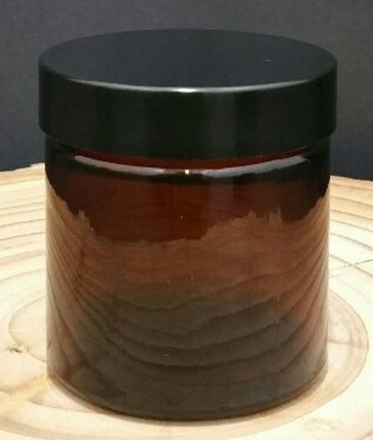
30ml Amber Glass Jar
Internal Dimensions: 5cm including lid x 40mm round diam
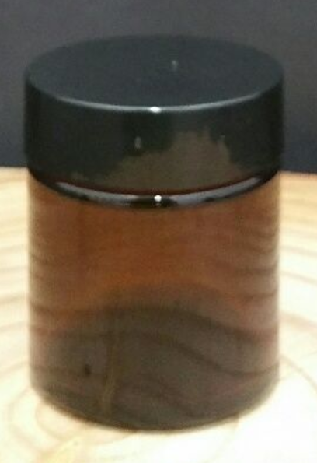
Label inspiration
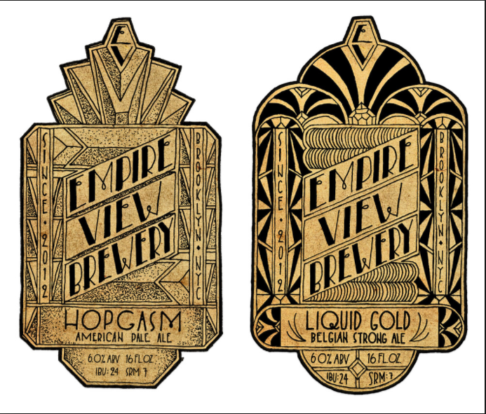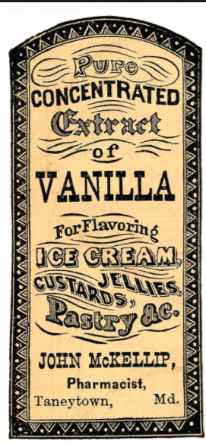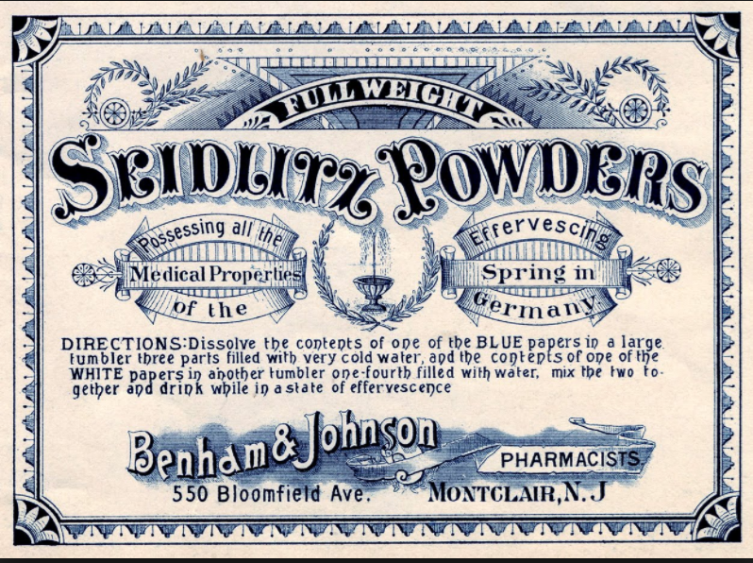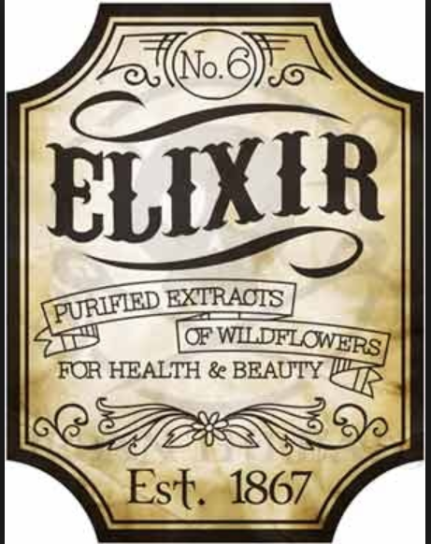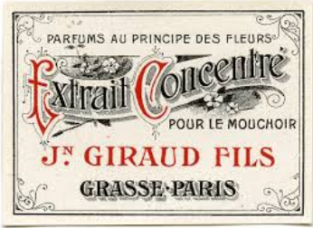

Copy & detail required on label
Logo
Ingredients- Blank field
Space for Product name- Blank field
Space for Product description – Blank field
Space for Instructions- Blank field.
Batch number (and a blank field for filling out later)
60 or 30 ml
Tagline – nurturing kind hearts, fierce minds, & brave spirits
Hand crafted with love in Melbourne
Website- www.threesistersbeautycompany.com

