Three Sisters Beauty Co.
Segmentation Analysis

Segment | Socially Conscious Shoppers
Hero Statement | I am a professional working woman, wife and mother. I use products that are work for me and contain pure ingredients. I try to live a healthy lifestyle and I like products that support this.
My Profile | Financially secure women. Professionals. Might have own business. Majority are full time workers. $80k plus. Urban dwellers. Clean living supporters. Use organics. Have healthy diets. Mothers whose children are 10 years +.
My Technology | I have an iPhone and I use an apple iPad.
My Media | I learn about the world through podcasts and social media. I watch ABC and SBS from time to time.
My Influences | I am influenced by what I read on the internet, what I see on social media and through my own education. I also learn through my discussions with my peer groups.
My Key Shopping Times | I shop online at night time once the kids are in bed and I can relax. This is normally post 8pm. I also shop occasionally on the weekends.
Competitors for My Disposable Dollar | Online clothes shops, entertainment, activities for the kids, eating out.
Conversations to engage with me | Ethically sourced products, redefining beauty, self love, understanding the passages of life for women, lessons about looking after myself, positive commentary on what is happening in our society.
What will stop me from using this company? | Competitors, the brand message not resonating with me, the products not giving my skin what it needs, accessibility.
Other good things to know about me | Don’t patronise me. I’m a savvy shopper and might be likely to try other brands that resonate with me (I could be fickle). Based on this, brand loyalty is harder to build.
How much am I worth as a customer | We determine this to be 60-70% of sales until further data is available.

Three Sisters Beauty Co. Value Proposition
Three Sisters is a small batch, locally made, hand crafted beauty company which makes natural, ethically sourced beauty products for socially conscious consumers.

element | definition
target / segmentation | Individuals who are socially conscious about the products they use.
core needs | - To find products that work that are ethically made
offering name | Three Sisters Beauty Co.
frame of reference | Small batch, hand crafted, ethically sourced beauty company
benefits | - Good for you and for the environment
point of difference | Hand crafted by the company. We will never outsource.
support | - All ingredients are natural and paraben free, including the use of natural preservatives - X% of profits are donated to a range of charities, who support women - Products are made hand crafted and made locally in Melbourne, Australia in small batches from ethically sourced materials.

Three Sisters Beauty Co.
Brand Identity

Tagline
“nurturing kind hearts, fierce minds, & brave spirits”

Logo
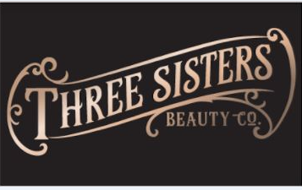
Everyday Font- typo

Colour Pallette-
Pantone 8043 c metallic Pantone 274c
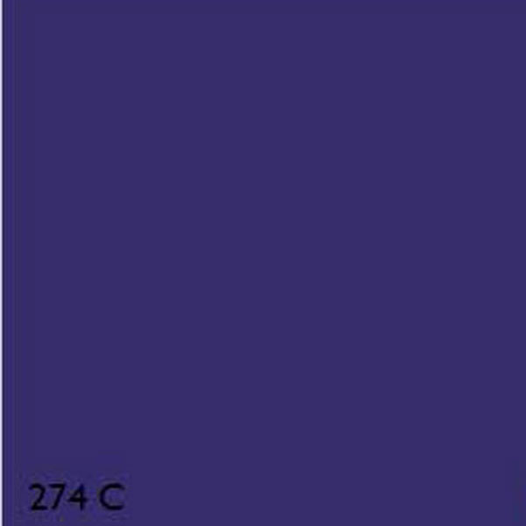
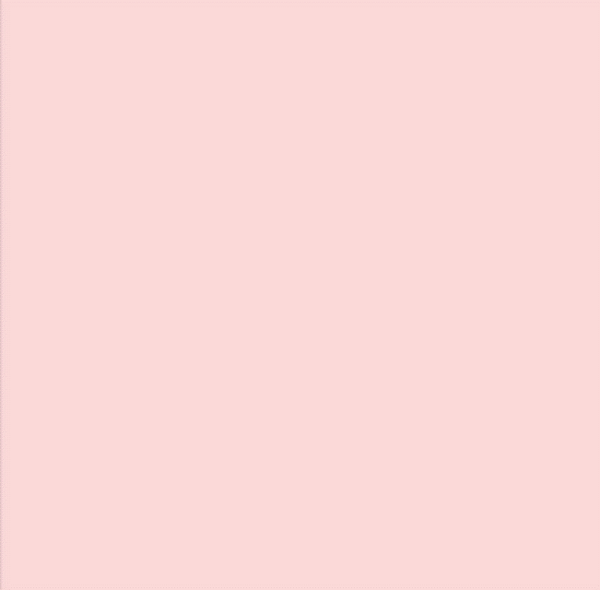
Pantone 689 Pantone 698

Logo/ Labelling and packaging