ROMANZA JEWELLERY

SHOPIFY STORE

FUNCTIONAL AND

USER INTERFACE REQUIREMENTS

v.1.0
Document version history

VERSION | COMMENTS
1.0 | Draft

Contents
1 Project Overview 4
1.1 Document Purpose and Contents 4
1.2 Scope 4
1.3 Design Guidelines and Mission 4
1.4 Products and Target Audience 5
1.5 Other Details 5
2 Site map 6
3 Requirements 7
3.1 Header 7
Logo 7
Search 7
Currency Selector 7
Promotional message 7
Sign-in 7
Wishlist 8
Shopping bag/Cart 8
3.2 Body 8
Home Page 8
Promotional Banners 9
Product Catalogue 10
Product Page 11
Account Management 11
Detailed Shopping Bag/Cart page 13
Checkout Page 13
Our Story Page 13
Wholesale Inquiries Page 14
Size Guide Page 15
Returns Policy Page 16
FAQs Page 16
Care and Warranty Page 17
Contact Us Page 17
3.3 Footer 18
Menu 18

Project Overview

Document Purpose and Contents

This document is to be used as a guide for creating an online Shopify website that will sell Women’s Jewellery. This document is not a project plan. It is a guide for how we expect the store to function not for phasing, timelines or deliverables. We will work with the Shopify developer to create a project plan. The document provides some basic guidelines to consider when designing the store, a site map and list of requirements on how we expect the store to function. We don’t intend on the requirements in this document to be strictly prescriptive and remain very open to the designer providing their inputs on how best to create the store. The requirements are provided in order to address a lot of the questions the designer may have.

Finally, this specification will change, continuously, as the project proceeds. We will add details and edit existing information in the course of the project.

Scope

The authors of this document do not have background in website development or associated technology. As such the scope of this document will be limited to providing basic functional and customer interface requirements for the front-end store.

This document will not provide details of database structures, programming languages, hardware/hosting requirements or any other technical aspects of website development. The authors are not familiar with technical terms associated with website development. There will be mention of content management but the author is not familiar with various tools available for this. We will rely heavily on the developer to guide us in this respect.

Requirements concerning content management and security are also out of scope for this document and need to be discussed with the Shopify developer.

Design Guidelines and Mission

The expectation is that the Shopify developer will provide their expertise concerning how best to design the store and organize/display content, with the objective of achieving the following aims, listed in order of priority below:

- Conversion: The primary objective of the design/content is to prompt the customer to make a purchase. While this may sound obvious, it is mentioned so as not to distract the design process by focusing on other objectives (which are also important). The site also needs to be optimized so as to rank high in search engine searches for relevant keywords (SEO)
- Navigation: An intuitive interface which takes away a lot of the thinking from the customer by making it obvious what they need to do when they visit the store
- Engagement: Encourages the customer to spend time on the website and share content with their social network

Where applicable, the design of the store should reflect as closely as possible the mission statements and words outlined below:
- Jewellery you’ll fall in love with
- We want every client to leave the store with a smile
- We want to be able to provide the best service we can in every situation no matter what
- We aim to increase our business by word of mouth; therefore we tell people things about our store that makes it interesting for them to share
- We only want Fairtrade jewellery and we have strong values on humanitarian issues
- We love every customer, no matter how difficult things get
- We, as a team, are so well informed about our products and brands that we always have the best information for our customers
- We celebrate women here!
- We celebrate life in here!
- We celebrate beauty here!
- We celebrate families here, as jewellery often stays within families.
- We will always try to make an extra step
- We will always try to exceed the expectation of our customers
- We will go as far as we possibly can to attract a customer back to our store and connect with us
- Every client that leaves our store knows more about jewellery because we passionately told him about it
- Romantic, classic, love, warm, cool, stylish

Products and Target Audience

The following products will be sold on the store:
- Rings
- Bracelets
- Necklaces
- Charms
- Earrings

Products will be made up of the following materials:
- Gold (Rose, White and Yellow)
- Silver
- Diamond
- Ruby
- Sapphire
- Emerald
- Moissanite
- X
- X
- X

Products sold will be in the price range (US$20 – US$1,000). The target audience is female aged 18-55 years old across

Other Details

- Store name: Romanza Jewellery
- Slogan: “Jewellery you’ll fall in love with…”
- Logo: Logo shown below in gold and black typeface



- Font: The font to be used is Myriad Pro, which matches the logo. If an alternative complementary font is suggested, we are open to this
- Domain: romanzajewellery.com
- Primary Colours: Outlined below. We expect use of a secondary palette that complements/accents the primary colours
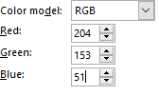
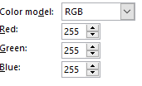
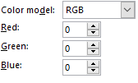

Site map
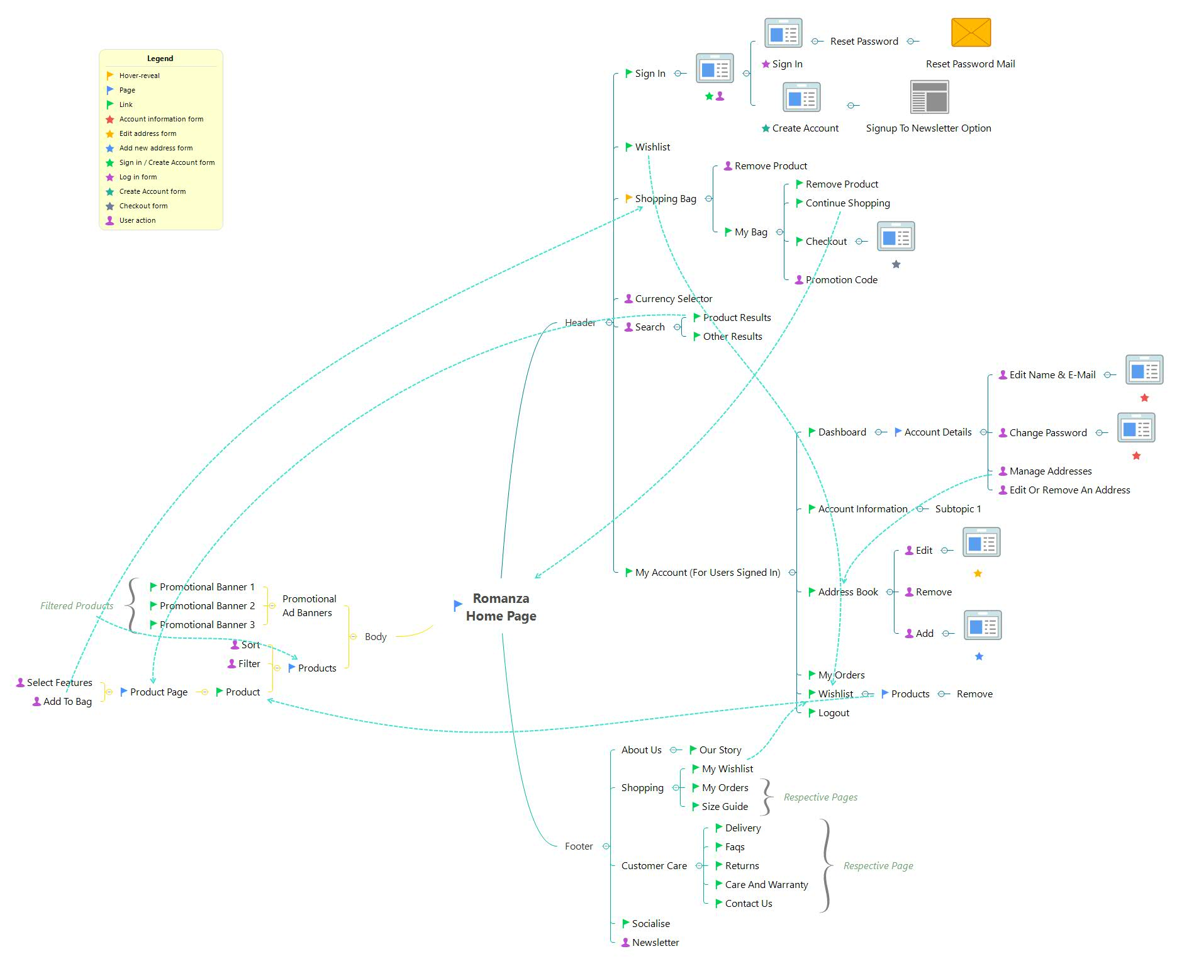

Requirements

Header

REQ# | HEADLINE | REQUIREMENT DESCRIPTION | DEVELOPER COMMENTS
 | Logo | - The Logo will be place on the header with the slogan “Jewellery you’ll fall in love with”  - Clicking on the LOGO will take the customer to the Home Page
 | Search | - A Search icon will be made available on the Header  - Clicking on the search icon prompts the customer to enter search criteria  - As the customer types the search criteria, a pop up showing products appear matching criteria entered is shown  - On clicking a product, the customer is taken to the Product Page  - Other than returning a product list, other search results from other part of the site (e.g. from FAQ, Customer Care etc…) should also appear next the section showing products
 | Currency Selector | - An option to choose currency will be made available on the header  - The following currencies can be chosen  - HKD (default currency)  - GBP  - USD  - EUR  - RMB  - JPY  - AUD  - CAD
 | Promotional message | - A short configurable promotional message to be placed on the header e.g. “Extra 10% off for orders over $500 till March 31st, 2018”, “Extra 10% off Diamond rings till March 31st, 2018”  - Where a monetary promotion is stated, it needs to be in currency chosen by customer e.g. HK$500 would be £50 if GBP chosen or $50 if USD chosen  - Where a promotion on a product is stated, a link is provided on the product name, which filters items on home page for that product e.g. “Extra 10% off Diamond Rings till March 31st, 2018”. Clicking on Diamond Rings will filter for all Diamond rings on the home page and auto-scroll down to the product section of the home page. By default, the products filtered will be sorted by Our Favourites  - The promotional message banner needs to be accented in a colour different to the theme in order to stand out
 | Sign-in | - Clicking on SIGN IN will take customer to a page where there will be a field to enter an e-mail address and a CONTINUE button  - After the customer enters an e-mail address and presses the CONTINUE button, the relevant page will show depending on whether the customer is already registered or not
 | Sign-in | - If the e-mail entered above is already registered, the customer is prompted for a password and a SIGN IN and RESET MY PASSWORD button is made visible  - After entering an Email Address, a valid password and clicking the SIGN IN button, the customer is taken to the Account Management Page  - After signing in and returning to the home page (e.g. by clicking on the Romanza Logo), the Sign In wording on the header will be replaced with My Account. Clicking on My Account will take the customer to the Account Management Page  - On clicking RESET MY PASSWORD an e-mail is sent to the customer to re-set their password
 | Sign-in | - If the customer e-mail address is not registered another form will appear which the customer will need to complete followed by pressing the CREATE ACCOUNT button to complete registration  - A Signup to newsletter option should also be available. If this is checked, the registered e-mail is added to the newsletter mailing list  - On successful registration, the customer will be taken to the Account Management Page
 | Wishlist | - On clicking WISHLIST, the customer is taken to the Account Management Page
 | Shopping bag/Cart | - The number of items added to the Shopping Bag will show in parenthesis next to the SHOPPING BAG/CART icon  - Clicking on the SHOPPING BAG/CART from any page will not navigate away from the page but will “reveal” the shopping bag in the form of a pop-up. This is a concise view of the SHOPPING BAG/CART and will show:  - Product images and brief description. Clicking on the product image or description will take the customer to the Product Page  - An icon next to the product that will remove it  - Quantity  - Price  - Total Amount (in relevant currency)  - A button that will take the customer to a more Detailed Shopping Bag/Cart page from where the customer can checkout

Body

REQ# | HEADLINE | REQUIREMENT DESCRIPTION | DESIGNER COMMENTS
 | Home Page | - On launching the Home Page, a sign-up to newsletter pop-up will appear prompting the customer to enter their e-mail address and clicking a SUBMIT button. The customer will be added to mailing list used to send regular newsletters. The customer can also cancel the sign-up process  - The body of the home/landing page will consist of two sections  - Promotional banners  - Product catalogue
 | Promotional Banners | - Up to 3 promotional banners should appear on the home page, taking up about ½ the visible area of the body on the Home Page without scrolling down  - Clicking on the promotional banner will auto-scroll to the product catalogue which appears in the bottom ½ of the body on the home page  - A filter is applied on the product catalogue and products matching what is presented on the promotional banner appear for the customer to browse e.g. if a banner is promoting Moissanite jewellery, when the customer clicks on it, the customer is taken to the product catalogue by auto-scrolling down to the catalogue where all Moissanite jewellery items are featured  - The promotional banners are configurable and can be changed on an ad-hoc basis (see Content Management
 | Product Catalogue | - The product catalogue will feature on the body of the Home Page below the promotional banners  - The user will need to scroll through the promotional banners to view the product catalogue  - By default all products will be shown  - There will be a filter next to the catalogue that will allow the customer to filter the catalogue by the following categories:  - Type (Rings, Necklaces, Bracelets, Earring, Charms)  - Collection (to be defined)  - Metal (10K Rose Gold, 14K Gold Rose, 18K Gold Rose, 10K Yellow Gold, 14K Yellow Rose, 18K Yellow Rose, Silver, Gold plated, Silver plated)  - Gemstone (Amethyst, Aquamarine, Sapphire, Topaz, Diamond, Citrine, Cubic Zirconia, Emerald, Garnet, Moissanite, Quartz, Ruby, Tanzanite)  - Price range (to be determined)  - The customer will have the ability to select multiple options within a category and across categories  - There will be a sort option on top of the catalogue that will allow filtering by:  - Our Favourites (this will sort the collection in order of how we rate a particular product)  - What’s new  - Price: high to low  - Price: low to high  - The products will be displayed as an image with a short description and price  - The customer will be able to add a product to the Wishlist  - There will be an option to select a Quick View for a product  - When the customer clicks on Quick View, a pop-up of the product appears that will have:  - Product image  - Additional product images to scroll through  - Short description  - Price  - Customization options (e.g. size, metal) – See Product Page  - The option to go to a more detailed view i.e. the Product Page  - The ability to add the product to the Wishlist  - The ability to add the product to the Shopping bag/cart  - The ability to share the product on a social network  - Customer will browse products using infinite scrolling as opposed to pagination/load more
 | Product Page | - The Product Page will be a detailed view of a single product and can be accessed by:  - Clicking on a product image in the Product Catalogue, Search results, Shopping bag/cart, Quick View and Promotional banner (if a specific product is promoted)  - The following will be available on the product page:  - Promotional banner on top of the product image without any link. We don’t want the customer to navigate away from the Product Page  - Navigation tree on top of the product image e.g. Home>Rings>Diamonds><short product description>  - Clicking on any of the words on the navigation tree (except the short product description) will the customer to the Home Page, auto-scrolling down to the Product catalogue which will be filtered according to which link is selected e.g. in above example, if Home is clicked then customer will return to Home Page, if Diamond is clicked, the customer returns to the Home Page and the Product Catalogue is filtered on Diamond products etc…  - Main product image  - The ability to zoom into the product image  - Additional product images to scroll through as applicable  - Short description  - Detailed description  - Price  - Customization options as follows:  - Size  - Metal  - The ability to select quantity  - The ability to add the product to the Wishlist  - The ability to add the product(s) to the Shopping bag/cart  - The ability to share the product on a social network  - A view of recently viewed product images
 | Account Management | - The Account Management page is accessed by the following means:  - By signing into a registered account  - For registered customers that have signed in by clicking the My Account link on the header  - For registered customers that have signed in by clicking on Wishlist link on the header  - By clicking on the My Orders or My Wishlist links under the Shopping heading under the footer  - The Account Management page will have the following menu options:  - Dashboard
 | Dashboard | - The Dashboard with show the following information for the customer:  - Registered e-mail address  - Default Billing and Shipping address  - The following actions can be taken on the Dashboard  - Edit e-mail address or change password. This action will open a user form described in Account Information  - Edit or remove billing and / or shipping address. This action will open a user form described in Address Book
 | Account Information | - The account information option will display a user form where the customer can view or edit their e-mail address and / or password  - This form can also be accessed from the Dashboard when clicking on the edit e-mail address or change password options  - A Save button will be made available to commit changes made
 | Address Book | - The address book option when selected with allow the customer to view the default billing and shipping address, Edit this address, Remove this address and / or Add a new address  - When clicking on Edit, the customer will be taken to a form displaying the current address where they can edit details of the address  - Checkboxes for setting address as default shipping and / or billing address will be made available  - A Save button will be made available to commit changes made
 | Wishlist Page | - Clicking on the Wishlist option will display all the products the customer has added to the Wishlist  - The products will be displayed in the form of images with a short description and price  - The customer will have the ability to remove products from the Wishlist  - The customer will have the ability to buy the item  - Clicking on the option to buy item will show a Quick View of the item as described in the Product Catalogue section  - Clicking on the product image will take the customer to the Product Page
 | Orders Page | - This option will display order previously placed by the customer
 | Logout | - Clicking on this option will log the user out of their account
 | Detailed Shopping Bag/Cart page | - Products added to the SHOPPING BAG/CART will appear in tabular form, with the following attributes as headers of the table:  - Product (image and brief description). Clicking on the image will take the customer to the Product Page  - Price  - Quantity Customer will have the ability to adjust quantity  - Total  - A Promotional Banner at top of the page to be used for promotions (e.g. giveaways if customers order over a certain amount)  - A REMOVE button that will be available to remove an item  - A CONTINUE SHOPPING button, which when clicked, will navigate the customer back to the Home Page  - A CHECKOUT button will be made available at the top and bottom of the page that will take the customer to the Checkout Page  - A Promo Code link will be made available that when clicked will prompt the customer to enter a code and click on an APPLY button. The SUBTOTAL will be adjusted accordingly. Alternatively, customer can choose to Cancel
 | Checkout Page | - The Checkout Page should guide the customer through the process e.g. step 1 entering customer details, step 2 entering/selecting delivery address, step 3 choosing delivery method, step 4 choosing billing address, step 5 choosing payment etc…  - The store will accept the following modes of payment:  - Credit Card (MasterCard, Visa, American Express)  - PayPal
 | Our Story Page | - A new page will display the following text to appear with respect to Our Story  <TO BE DEFINED>
 | Wholesale Inquiries Page | - A new page with an inquiry form will appear. The form will have the following fields for the customer to complete and a SUBMIT button will be made available  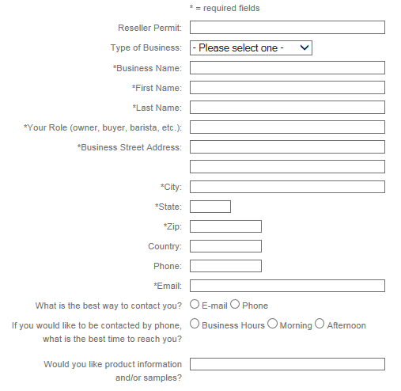
 | Size Guide Page | - A new page will display the following text to appear with respect to Size Guide  RING SIZE GUIDE  HOW TO FIND YOUR RING SIZE  - Select a ring which you own that properly fits the intended finger  - Measure the inside diameter of the ring  - If the ring falls between two sizes then we suggest buying the larger size  NECKLACE SIZE GUIDE  Please use the image as a guide for the necklace drops. Most of our designs come with adjustable chain lengths; please see the product’s details for individual information.  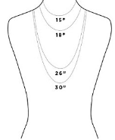  NEED HELP?  Have you got a query about our jewellery? Our Personal Shopping Team will be happy to assist you.  Email us at xxx@xxxx.com  Call us on: +852 XXXX XXXX
   | UK SIZE | US SIZE | EU SIZE | DIAMETER (MM)
  EXTRA SMALL | J | 4 | 49 | 15.4
  SMALL | L | 6 | 51 | 16.4
  MEDIUM | N | 7 | 54 | 17.2
  LARGE | P | 8 | 56 | 18
 | Returns Policy Page | - A new page will display the following text to appear with respect to return policy:  RETURN POLICY  If for any reason you are not satisfied with your purchase, you may return the unused item in its original condition within 30 days  - All items must be returned in their original condition, without scratches or signs of wear, and must not be resized or altered in any way  - Products that have been worn, damaged or altered are not refundable, and will be returned to the customer at their expense  - Free gifts that were included in the purchase must also be returned  - Diamonds and other items that included a Diamond Certificate must be returned with the original Certificate. If the certificate is not included we must deduct $300 per certificate, from the amount being refunded  - Clearance items are not refundable  - Packages must be received at our office within 30 days of the original shipment.  - Although we do offer free shipping, we do incur the cost of shipping for every order. Therefore, we do not refund our shipping cost  RETURN PROCESS  Our simple return policy makes it very easy to return an item. Simply follow the instructions below:  - Return Authorization Number (RMA): email us at <enter e-mail address) or call us at +852 XXXX XXXX to let us know that you would like to return your item.  - We will give you an RMA number. Write the RMA number in the original invoice that we have sent you. Returns will not be accepted without this number  - Safely package the item you are returning, and include all original packaging, the invoice, and collateral material. For security reasons do not write jewellery on the box. Return shipping costs are paid by the customer  - Insure your Package: Insuring your package is extremely important. Please also make sure to get a tracking confirmation for your order  - Upon receiving the package, our quality assurance team will review the item. Upon their approval we will issue a refund within 7 business days in the original payment method
 | FAQs Page | - A new page will display the following text to appear with respect to FAQs  <TO BE DEFINED>
 | Care and Warranty Page | - A new page will display the following text to appear with respect to Care and Warranty:  OUR TOP TIPS  - To minimise any scratching or tangling to your jewellery, ensure necklaces and bracelets are fastened  - Avoid wearing your jewellery in the bath, shower or swimming pool; the water can cause it to discolour  - Store your jewellery away from the sun and be careful not to allow perfumes, make up, body and sun creams touch your pieces as these can tarnish plated items  WARRANTIES (TO DISCUSS)  - Our sterling silver, gold and rose gold plated jewellery have a warranty of 12 months with proof of purchase  - Please note that in order for the warranty to be valid you will have to return to us your faulty item in full in order to receive a replacement  - Important information: Our warranty does not entitle you to receive a replacement or refund for lost or stolen items  CLEANING YOUR JEWELLERY  - If your jewellery has been exposed to intense light, perfumes or any other chemicals, you may notice over time the silver may darken slightly. If this does occur, your jewellery can be cleaned using a very soft specialist jewellery cloth. Alternatively silver pieces can be cleaned gently with a soft toothbrush and warm soapy water  - Avoid using ‘dip’ polish or abrasive jewellery cleaners as these contain harsh chemicals and can destroy your jewellery over time. We also do not recommend the use of any jewellery polishing cloths which have been treated with cleaners or polishing agents
 | Contact Us Page | - A new page with a contact form will appear. A standard form provided by Shopify can be used for this purpose

Footer

REQ# | HEADLINE | REQUIREMENT DESCRIPTION | DESIGNER COMMENTS
 | Menu | - The footer will contain the following menu options and corresponding links under each option  - When the customer clicks on the link they will be taken to the relevant page shown in the body of the web page  - About Us  - Our Story (see Our Story Page)  - Wholesale inquiries (see Wholesale Inquiries Page)  - Shopping  - Orders (see Order Page)  - Wishlist (see Wishlist Page)  - Size Guide (see Size Guide Page)  - Customer Care  - Returns (see Returns Policy Page)  - FAQs (see FAQs Page)  - Care & Warranty (see Care & Warranty Page)  - Contact Us (see Contact Us Page)  - The footer will contain icons to represent the following social media icons which upon clicking will take the customer to Romanza Jewellery’s page on the social platform:  - Facebook  - Instagram  - Pinterest  - The footer will contain a field where the customer can enter their e-mail address to sign-up to the Newsletter

