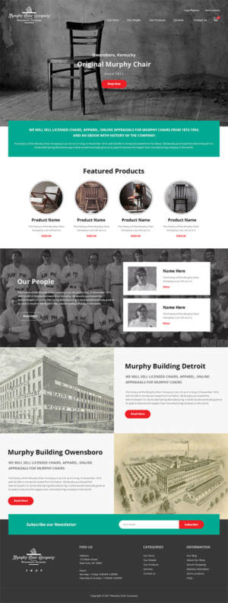
10. Place the title: Our Story. for this section as you did for the others:
11. Retitle this section: Murphy Detroit
12. Retitle this section: Murphy Owensboro
13. Rearrange/move the sections in this order:
1. Our Story
2. Our Products
3. Our People

14. Can you change the color “red” used in the website to crimson and this section to crimson.
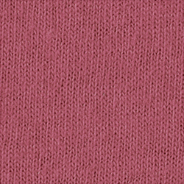http://www.comfortcolors.com/us/colors/pigment
15. Can you find a black and white stock photo that looks more like a murphy chair. Either of these.
