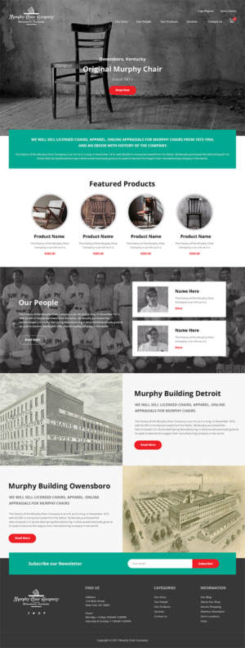
9. Make Murphy logo a little bigger.
The Original
1. The top header should read: Our Story Our Products Our People Resources Contact
2. Can we make this into a two slider. Current image plus an outdoor something like below.
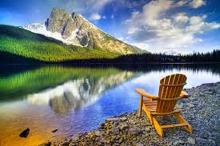
3. Remove store locater on top corner.
4. Replace to read:

Murphy Chair Company
Detroit, Michigan Owensboro, Kentucky
Since 1872
5. Replace words in this section with:
Honoring Our Past Embracing our Future
Each of the one hundred and forty-six years has formed a stepping-stone to broader fields of usefulness; has established an international reputation and created a force for good in the lives of everyone who has shared in the past, present and future of Murphy Chair Company.

6. Rename this section: Our Products. Products to be listed are: Murphy Chairs, Murphy Chair Appraisals, Murphy Chair Apparel, Resources

7. Replace the background picture with the one shown below. Please add a caption underneath this picture that reads: Murphy Chair Company Co-Workers, 1939
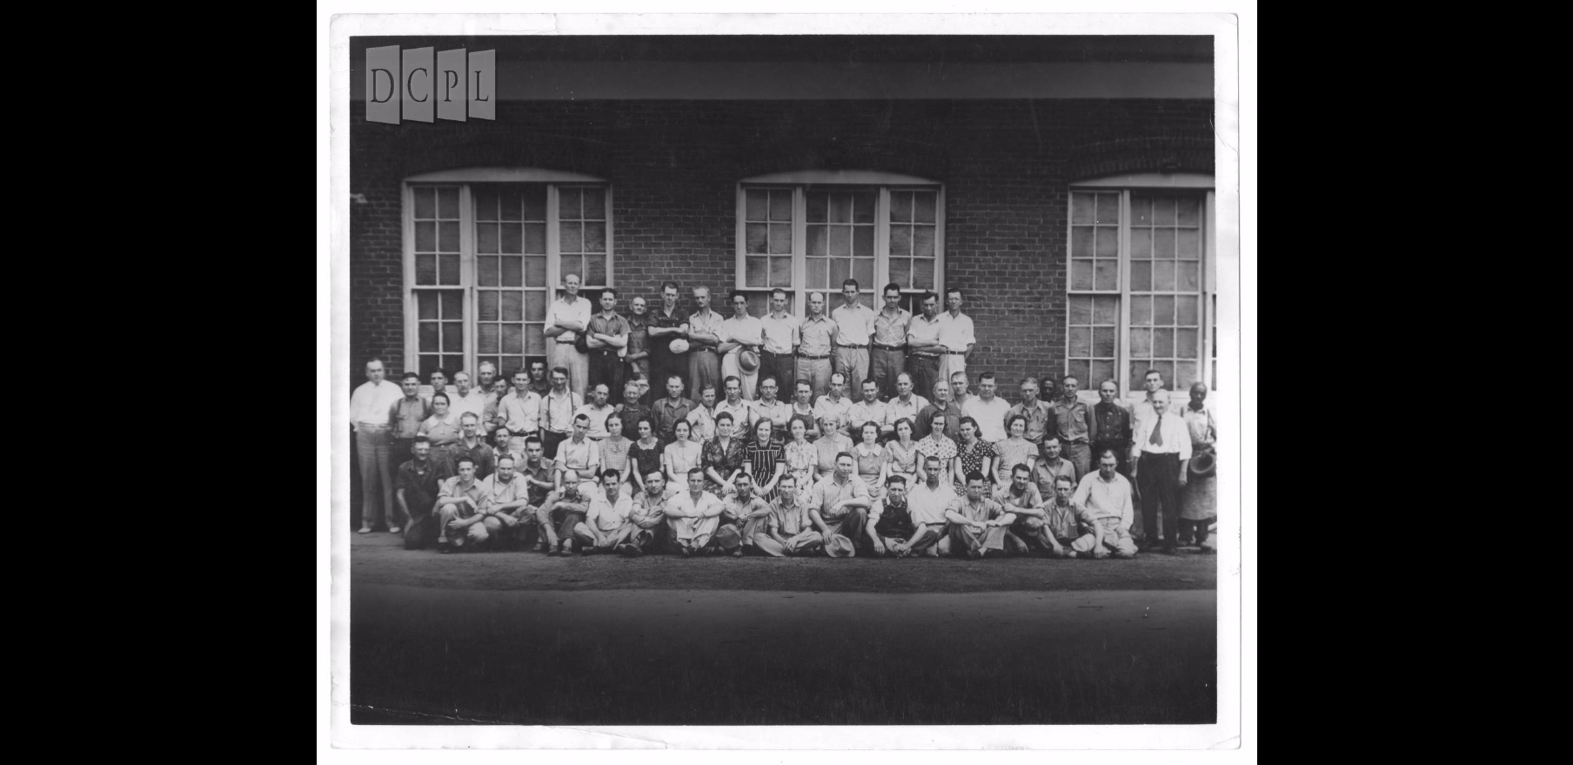
8.Replace these pictures with:
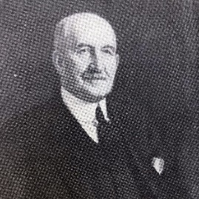
Michael Joseph (M.J.) Murphy
Founder


Stephen Michael Johnson
General Manager, 5th Generation

