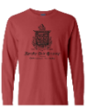
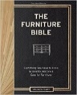
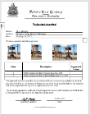
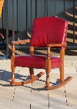
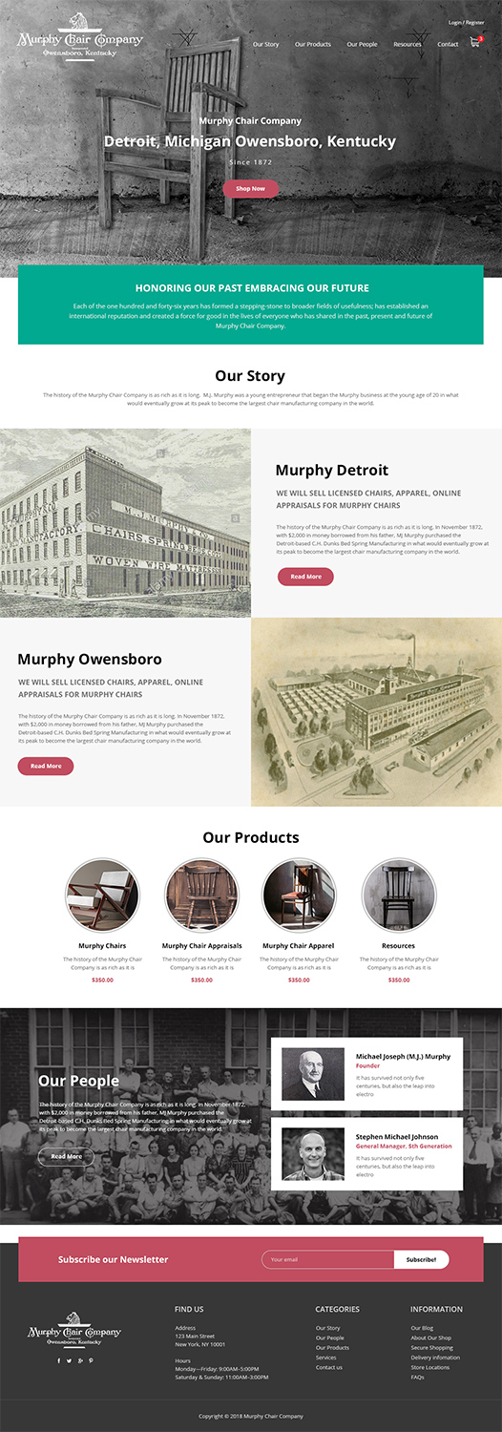
Replace pictures (keep circular border)
Detroit, Michigan Owensboro, Kentucky
REVISE: Separation between Michigan and Owensboro Perhaps a character between the two.

HONORING OUR PAST EMBRACING OUR FUTURE
REVISE: This is a “tagline”. Make it stand out more. Italics maybe? Separation between PAST and EMBRACING. Perhaps a character between the two.

FOLLOW US
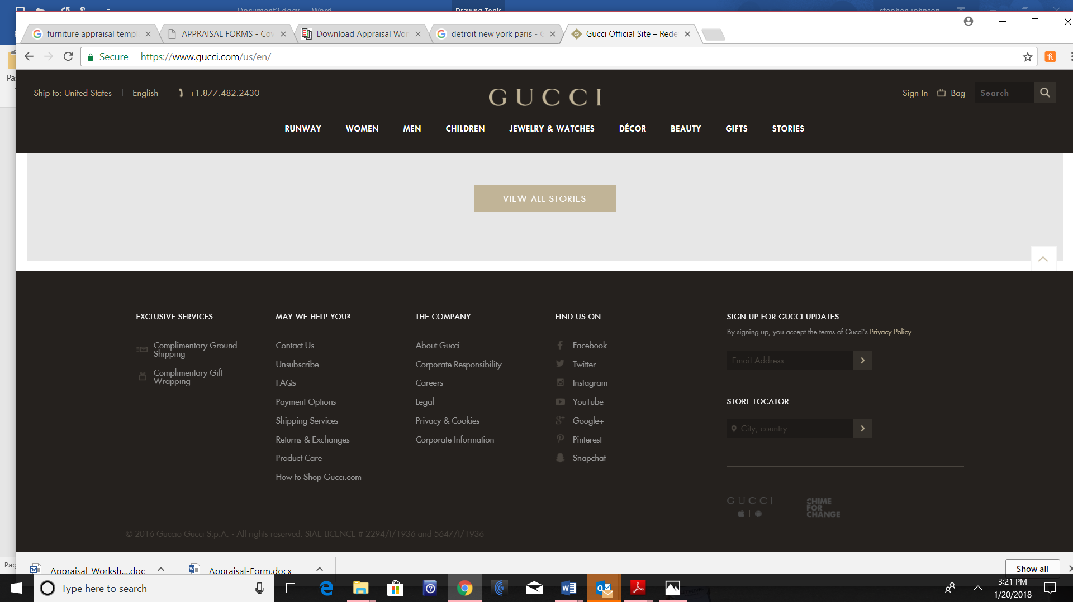
The Original
Remove prices $300
Remove this text
CONTACT US THE COMPANY RESOURCES
118 West 4th Street, #1021 Our Blog Murphy History Ebook
Owensboro, KY 42302 About Us Restorers/Restoration
info@murphychaircompany.com About Our Shop Books
phone:(313) 335-1690 Secure Shopping Auctions/Sales
Delivery Information
FAQs

Subscribe to The Murphy Chair-maker Blog

