1. New Patients – What to expect at your first visit to see Dr. Blais?

Your initial visit will involve a thorough discussion with Dr. Blais encompassing your medical history, as well as your dental history. It is here where you will have the opportunity to discuss your past dental experiences and any fears you may have. This will help paint picture of where you are coming from as a patient and will help Dr. Blais guide you in your dental journey. He will work with you in achieving the oral health you so desire. Dr. Blais understands that oral health is something we work on everyday to maintain and he is there to be a resource to you and help you every way he can.

After telling Dr. Blais your story, he will conduct an Oral exam that comprises a looking at each tooth one by one checking for any pathology or tooth decay. Photographs with an intra-oral camera will be taken, a perio exam to detect gum disease will be conducted, as well as an oral cancer screening to ensure every aspect of oral health is examined and meets the highest quality of care. X-Rays will then be completed to check for any problems that are not able be detected with the naked eye. Gotham Smiles has the latest in digital radiography that ensures the lowest radiation exposures as reasonably possible. Our digital sensors result in some of the finest diagnostic pictures that help us detect hard tissue pathology and interproximal cavities. All of this information is gathered in getting you ready to begin your oral health journey with Dr. Blais.

In your first visit you will get a cleaning done by Dr. Blais himself. He believes that a cleaning is one of the best services he can provide for a patient. With a thorough cleaning you can really instantly feel the benefits of having a fresh mouth again. A cleaning can get back on track even if it has been a while since your last visit. He will also go over how to use a toothbrush properly and answer any of your questions ranging from new oral health products on the market to even trying to understand how a cavity forms. The New Patient Exam is an excellent session that takes you on a journey through your mouth, while getting you excited to about reach your long-term oral health goals.

3. Invisalign
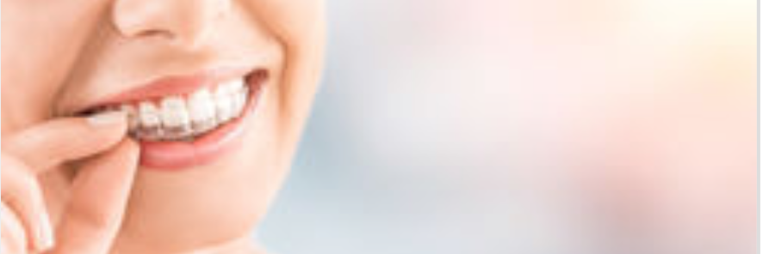

Dr. Blais’ training in Invisalign started at NYU College of Dentistry under the world-renowned teacher of Invisalign and Orthodontics, Dr. Rebecca Polling. Leo will work with you on your treatment plan to ensure the outcome meets or exceeds your own expectations. He works with a team of Orthodontists to ensure the Clincheck we receive from Invisalign is the best treatment or plan for you.

How does it work?

Your Invisalign® clear aligners are custom-made for you. The aligners are virtually invisible and fit snugly over your teeth.
Each aligner shifts your teeth slightly, moving them horizontally and vertically and even rotating them when needed. Your aligners are engineered to use the right amount of force in the right place at the right time moving your teeth gradually following a custom treatment plan mapped out by Dr. Blais.

3. Implants

At Gotham Smiles, we utilize our in-house CBCT that enables Dr. Blais to give you a complete consultation and treatment planning session upon your first visit to our facility. Dr. Blais is a Fellow of the International Congress of Implantologists (ICOI) and he will guide you through what to expect in the procedure. Whether you require a single implant placement for one missing tooth or multiple implants for larger edentulous regions that could potentially replace your existing denture, he takes the time to ensure the proper treatment plan is in place for you.

5. Teeth whitening.

Smoking. Wine. Coffee. Medications. These substances can all discolor your teeth, making them appear dull or lack-luster. Even if you brush your teeth religiously, you still may not have the bright and white smile you desire. Fortunately, there are fantastic teeth whitening options on the market these days.
At Gotham Smiles we offer two excellent ways to enhance your appearance and, quite possibly, transform your life.

- Philips Zoom in-chair whitening
- Take home whitening kits

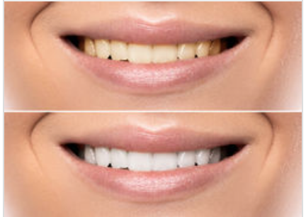

6. Weekend Smile Design.

Whether you are a Bride trying to look your best on your day or a working professional wanting to exude confidence at your next meeting. At Gotham Smiles, Dr. Blais will work with you in creating your dream smile over a weekend in NYC. Before you arrive, the process first begins simply with you and your camera or cell phone. Simply take a photo following the guidelines we have set up and just email it to Dr. Blais.

Dr. Blais will then email you a mock up of your smile transformation. You can then setup a time with him for an initial consult to discuss what your goals are before even coming into the clinic. The initial consult is completely free and you don’t need to live in NYC either. Dr. Blais is happy to discuss with you what to expect in a Weekend Smile Design session over the phone, skype, or facetime.

How is a weekend Smile Accomplished?
In order to create a beautiful, custom, and natural looking smile, Dr. Blais will first discusses with you the “look” you’d like to achieve. This is accomplished with your first visit and will include a more detailed smile evaluation and exam. Study models of your existing teeth are made and he then checks to see if your teeth are appropriate for veneers or if any pretreatment is necessary. If you are a candidate, Dr. Blais will schedule you for a weekend session in which you will spend the day working together to complete your new smile. After the first day, we have you leave the office with temporary veneers that will closely resemble the final result of your new smile. This will allow you to go out on the town and see how they feel. On Day 2 any alterations or adjustments to the design can be made and the final restorations, veneers, or crowns can be placed. Gotham Smiles utilizes an in-house CAD/CAM machine that can make your crowns, veneers, and even bridges in a matter of minutes, custom to you. This will allow you to walk out of our facility on day 2 with your new smile complete.

7. Planning Your Trip to NYC.

For Out of Town Patients: Transform your smile with a trip to New York City at Gotham Smiles.

Weekend Smile Transformation expert Leo Blais, DDS, FICOI is a reputation for excellence in cosmetic and implant dentistry. He is eager to help create the smile you have always wanted and by following a few simple steps you can by send Dr. Blais a photo of your current smile and he can send you back a picture of what your new smile could become.

To start a conversation about designing your smile with Dr. Blais, please follow these simple steps:

- Have a friend or someone take 2 photos:
i. A head shot photo of you (maybe include a silhouette headshot example) and
ii. side profile photo. Most of todays cell phones take fantastic photos for something like this.

- Make sure the photo is clear and that you are biting down on your teeth while smiling.
- Assure there is proper lighting. Sometimes a flash is required.
- Please then send your photo along with the best Dr. Blais will reach out to you personally and will send you a smile mock up within a couple days an schedule a time via facetime or skype to discuss it with you. It’s that simple and no cost for the initial conversation.

Planning your trip to see Leo at Gotham Smiles-NYC:

Please contact our coordinators at (212)-686-2907 who are skilled in helping you finalize your travel plans from across the United States, Europe, and Asia for treatment.

Our coordinators can help you arrange a NYC weekend and smile transformation to remember:

- Flights
- Transportation to and from the airport
- Exclusive rates with Hotel bookings
- Weekend entertainment (concerts, shows, clubs)
- Restaurant reservations

8. Location and Hours.

471 Third Avenue
New York, NY 10011

Web: Gothamsmiles.com
Email: drleoblais@gmail.com
Follow us on
https://twitter.com/GothamSmilesNYC
https://www.instagram.com/gothamsmilesnyc/
https://www.facebook.com/GothamSmiles

Please call or email today to schedule an appointment:

212-686-2907
drleoblais@gmail.com

