Weber-Vonesch

Weber-Vonesch has been founded in 1946 as a one-man business in Zug, Switzerland. In 1975, it has been altered into a public limited company.
Weber-Vonesch is acting globally and is nowadays proud to be employer of more than 100 employees. The company consists of three divisions; one of them is dedicated to private and business moves, one to transports and the other one to hightech logistics.
Weber-Vonesch is the ideal partner for all logistic issues, from the standard delivery to the unpacked special transport with installation or any other value added service on site. We store and move data processing equipment, computers, medical technique, consumer electrics, control engineering equipment and other delicate items. The products are carefully handled by our professional team, which is trained on a regular basis. Our special characteristics are professionalism, efficiency and reliability.
Especially when exchanging PC’s, our customers rely on a fast process flow. Weber-Vonesch arranges for a smooth exchange without any interruption of work. Manufacturer, service-provider and consumers of IT-systems and other hightech products profit from our services:
Rollouts and value added services on site
Staging center with various technical services
Wiping of data
Pre-installation of various software
Installation of appliances
Reverse and repair logistics inclusive of export formalities
Cleaning and refurbishing of high-tech goods
Exchange service (SWAP)
Branch specific equipment
Storage logistics
High security in all warehouses: personalized access authorization, video recording, alarm systems etc.
The customers also benefit from our close connections. As a partner of TecDis we have an extensive European network with correspondents in major cities of the European continent also including international shipments of these products. These services will be credited with a high level of quality and price competitiveness for repeated shipments to specific shipments.
Your TecDis partner in Switzerland
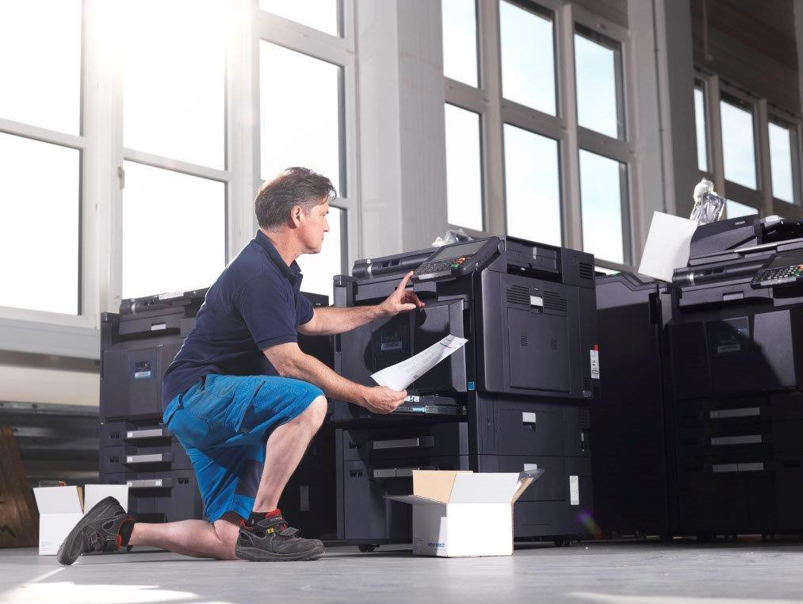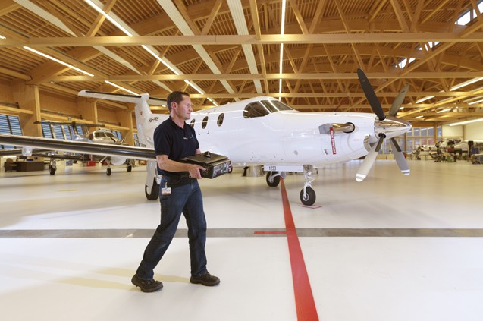
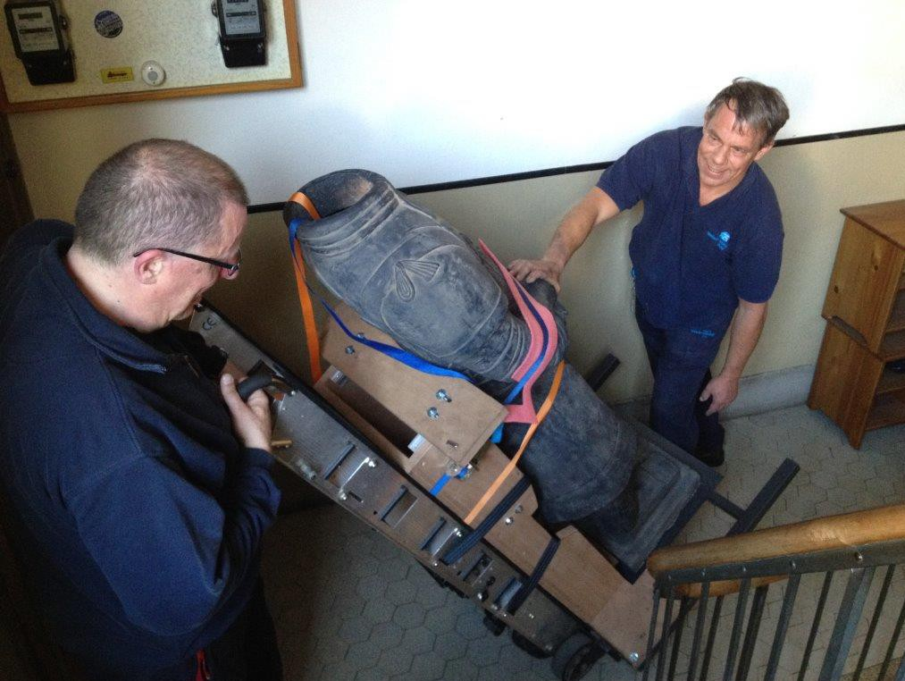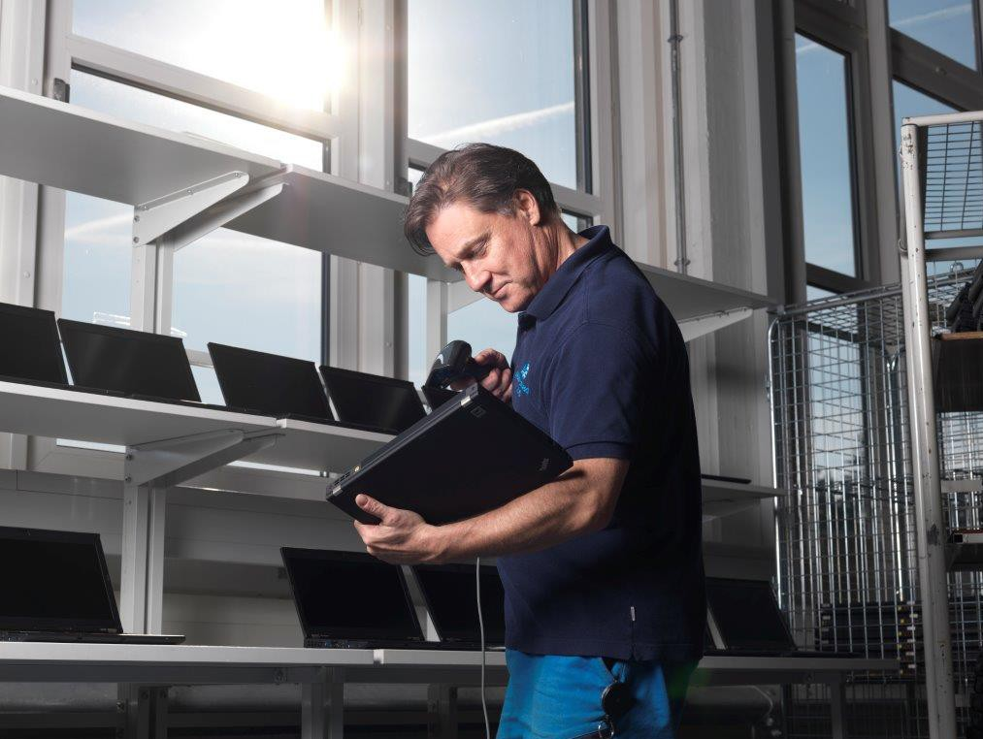

WEBER-VONESCH TRANSPORT AG HEAD OFFICE ADDRESS
Weber-Vonesch Transport AG
Chollerstrasse 3
CH-6300 Zug
Switzerland
Website URL
www.weber-vonesch.ch

FRANCO LUCIANI
Sales Manager Logistics
Tel: +41 (0)41 747 44 72
Email: franco.luciani@weber-vonesch.ch

URS WEBER
CEO
Tel: +41 (0)41 747 44 44
Email: urs.weber@weber-vonesch.ch

