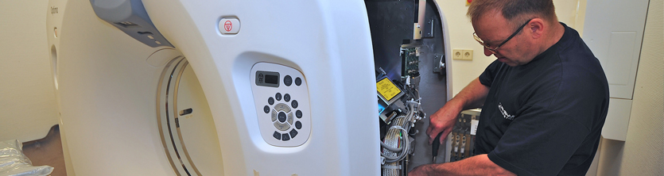
Also in the sensitive Healthcare market the TecDis partners are experienced experts. Relevant product knowledge but also appropriate certifications in the local markets are the prerequisites to be an efficient and accredited logistics partner. Within the Dental sector TecDis organises pick-up and consolidation of shipments from different suppliers for customers and perform exact on-time deliveries including the positioning and assembling of devices and medical furniture.
Further focus areas are sensitive devices in the optical sector. Project coordination, transport, positioning, installation and functional tests complement the service portfolio in this area.
For the Diagnostic Imaging and Therapy sector the specialists of the TecDis network make an important contribution in health service and research with the safe and punctual delivery and installation of the devices.
A central project management team defines and coordinates services, identifies optimal transport routes and requirements as well as special equipment.
For transport services mostly dedicated vehicles are used by TecDis. On board are mechanics “merged” with separate teams of electricians with appropriate technical experience and certifications, who install and cable all system components on site and handover the operational devices to the staff of the customer or manufacturer.
Products such as CT scanners, MRTs, x-ray units and linear accelerators are handled on a daily basis.
This comprises also laboratory diagnostic and analytical products. The spectrum reaches from the transport of medical freezers through to the on-site delivery and installation of workplaces to laboratories, surgeries and hospitals.
If necessary, used devices are returned, dismantled and forwarded into recycling or disposed environmentally friendly.

- Loan and demo equipment management
- In house technical centres
- Full installation capabilities
- Data clean down and clinical clean areas
- Technical storage facilities
- Magnet cold storage areas
- In field engineering
- First line fix programs
- Distribution program management
